**EXPERIMENT-1**

LAB EXERCISE: To understand DDL and DML commands

OBJECTIVE: To understand the concept of designing issue related to the database with creating, populating the tables. Also familiarize students with different ways of manipulation in database.

EXERCISE:

-- create a table

CREATE TABLE CLIENT_MASTER (

CLIENTNO VARCHAR(6),

NAME VARCHAR(20),

ADDRESS1 VARCHAR(30) NOT NULL, ADDRESS2 VARCHAR(30) NOT NULL,

CITY VARCHAR(15) NOT NULL, PINCODE INT,

STATE VARCHAR(15), BALDUE Number(10,2)

);

CREATE TABLE PRODUCT_MASTER (

PRODUCTNO VARCHAR(6),

DESCRIPTION VARCHAR(15),

PROFITPERCENT DECIMAL(4,2), UNIT MEASURE VARCHAR(10),

QTYONHAND INTEGER, REORDERRL VL INTEGER,

SELLPRICE NUMBER(8,2), COSTPRICE NUMBER(8,2)

);

CREATE TABLE SALESMAN_MASTER (

SALESMANNO VARCHAR(6),

SALESMANNAME VARCHAR(20),

ADDRESS1 VARCHAR(30) NOT NULL, ADDRESS2 VARCHAR(30) NOT NULL,

CITY VARCHAR(20) NOT NULL, PINCODE INT,

STATE VARCHAR(20),SALAMT REAL, TGTTOGET DECIMAL,

YTDSALES DOUBLE(6,2), REMARKS VARCHAR(60)

);

CREATE TABLE CLIENT_MASTER

(

"CLIENTNO" varchar(6),

"NAME" varchar(20),

"ADDRESS1" varchar(30),

"ADDRESS2" varchar(30),

"CITY" varchar(15),

"PINCODE" integer,

"STATE" varchar(15),

"BALDUE" number(10,2)

);

CREATE TABLE PRODUCT_MASTER

(

"PRODUCTNO" varchar(6),

"DESCRIPTION" varchar(15),

"PROFITPERCENT" decimal(4,2),

"UNIT MEASURE" varchar(10),

"QTYONHAND" integer,

"REORDERL VL" integer,

"SELLPRICE" number(8,2),

"COSTPRICE" number(8,2)

);

CREATE TABLE SALESMAN_MASTER

(

"SALESMANNO" varchar(6),

"SALESMANNAME" varchar(20),

"ADDRESS 1" varchar(30),

"ADDRESS 2" varchar(30),

"CITY" varchar(20),

"PINCODE" integer,

"STATE" varchar(15),

"SALAMT" int,

"TGTTOGET" decimal,

"YTDSALES" int,

"REMARKS" varchar(60)

);

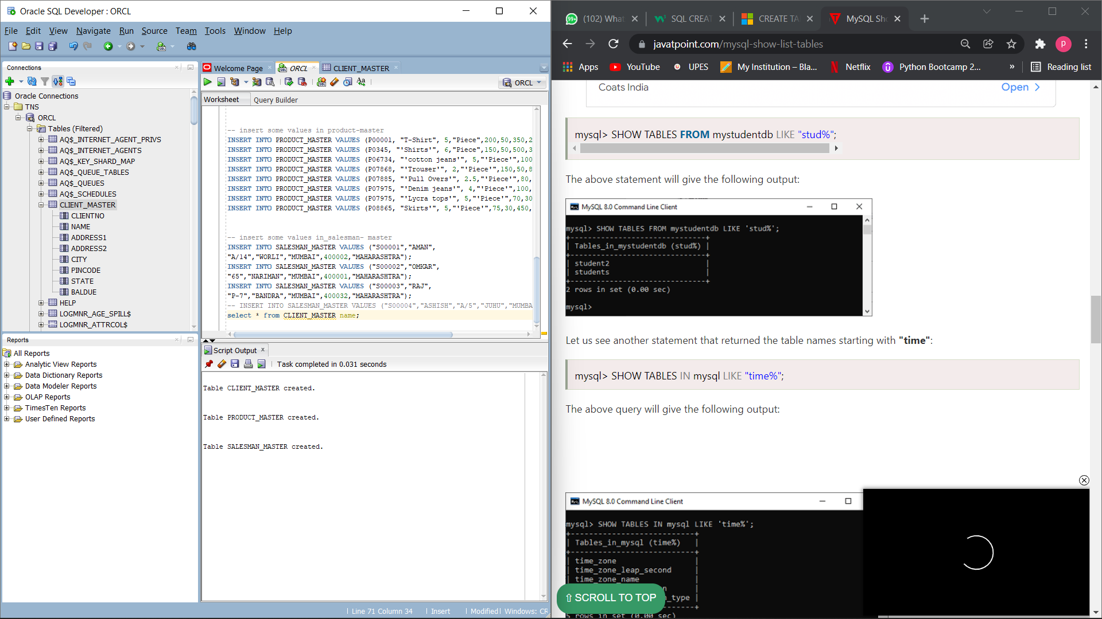

1. **Exercise on retrieving records from a table.**  
   a. Find out the names of all the clients.

select distinct Name from client_master;

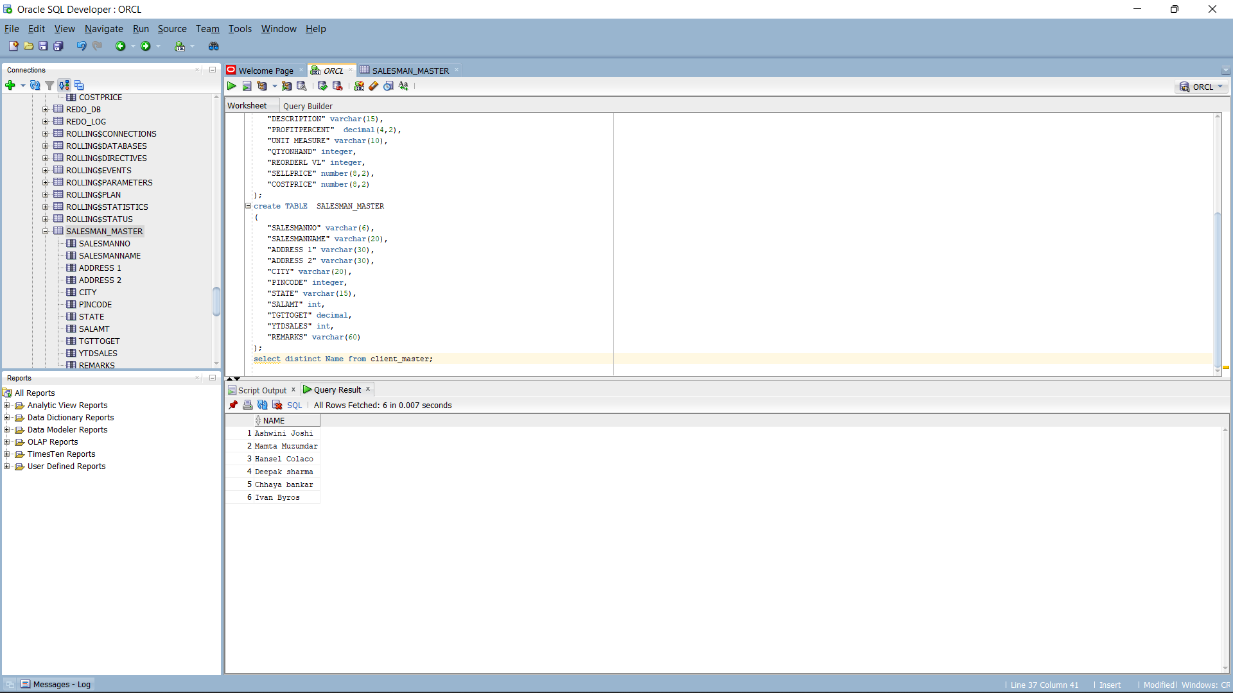

b. Retrieve the entire contents of the Client_Master table.

select * from client_master;

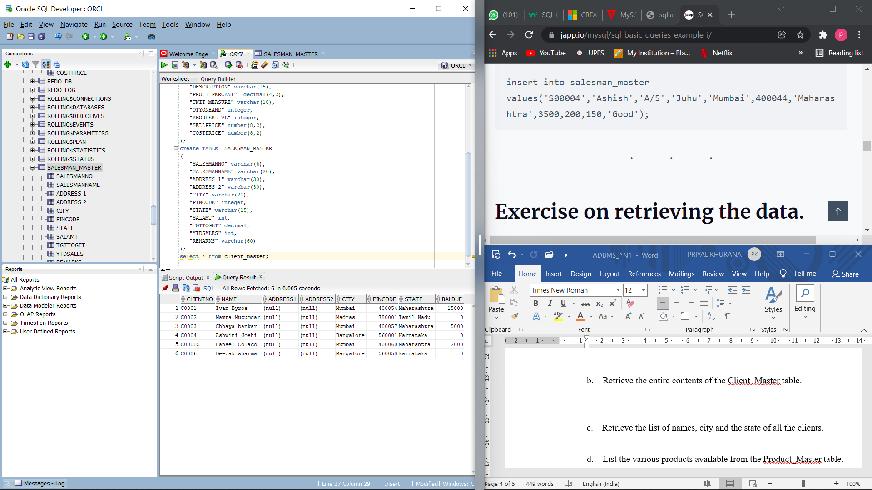

c. Retrieve the list of names, city and the state of all the clients.

select Name, City, State from client_master;

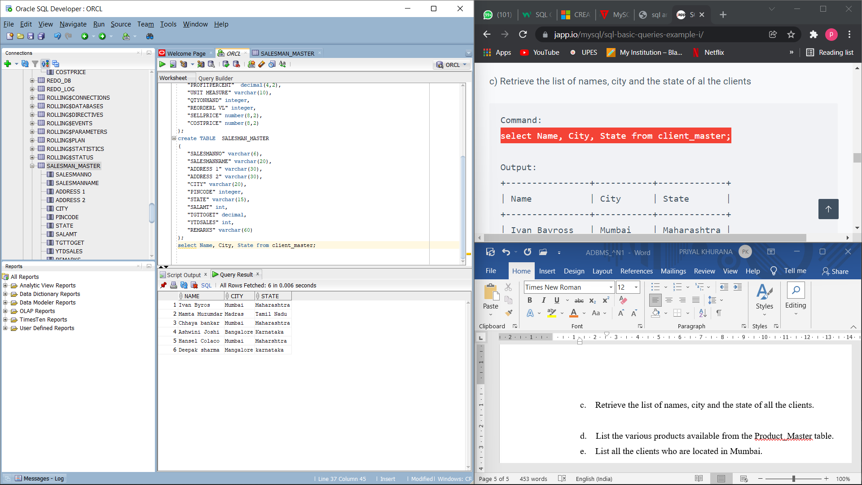

d. List the various products available from the Product_Master table.

select distinct description from product_master;

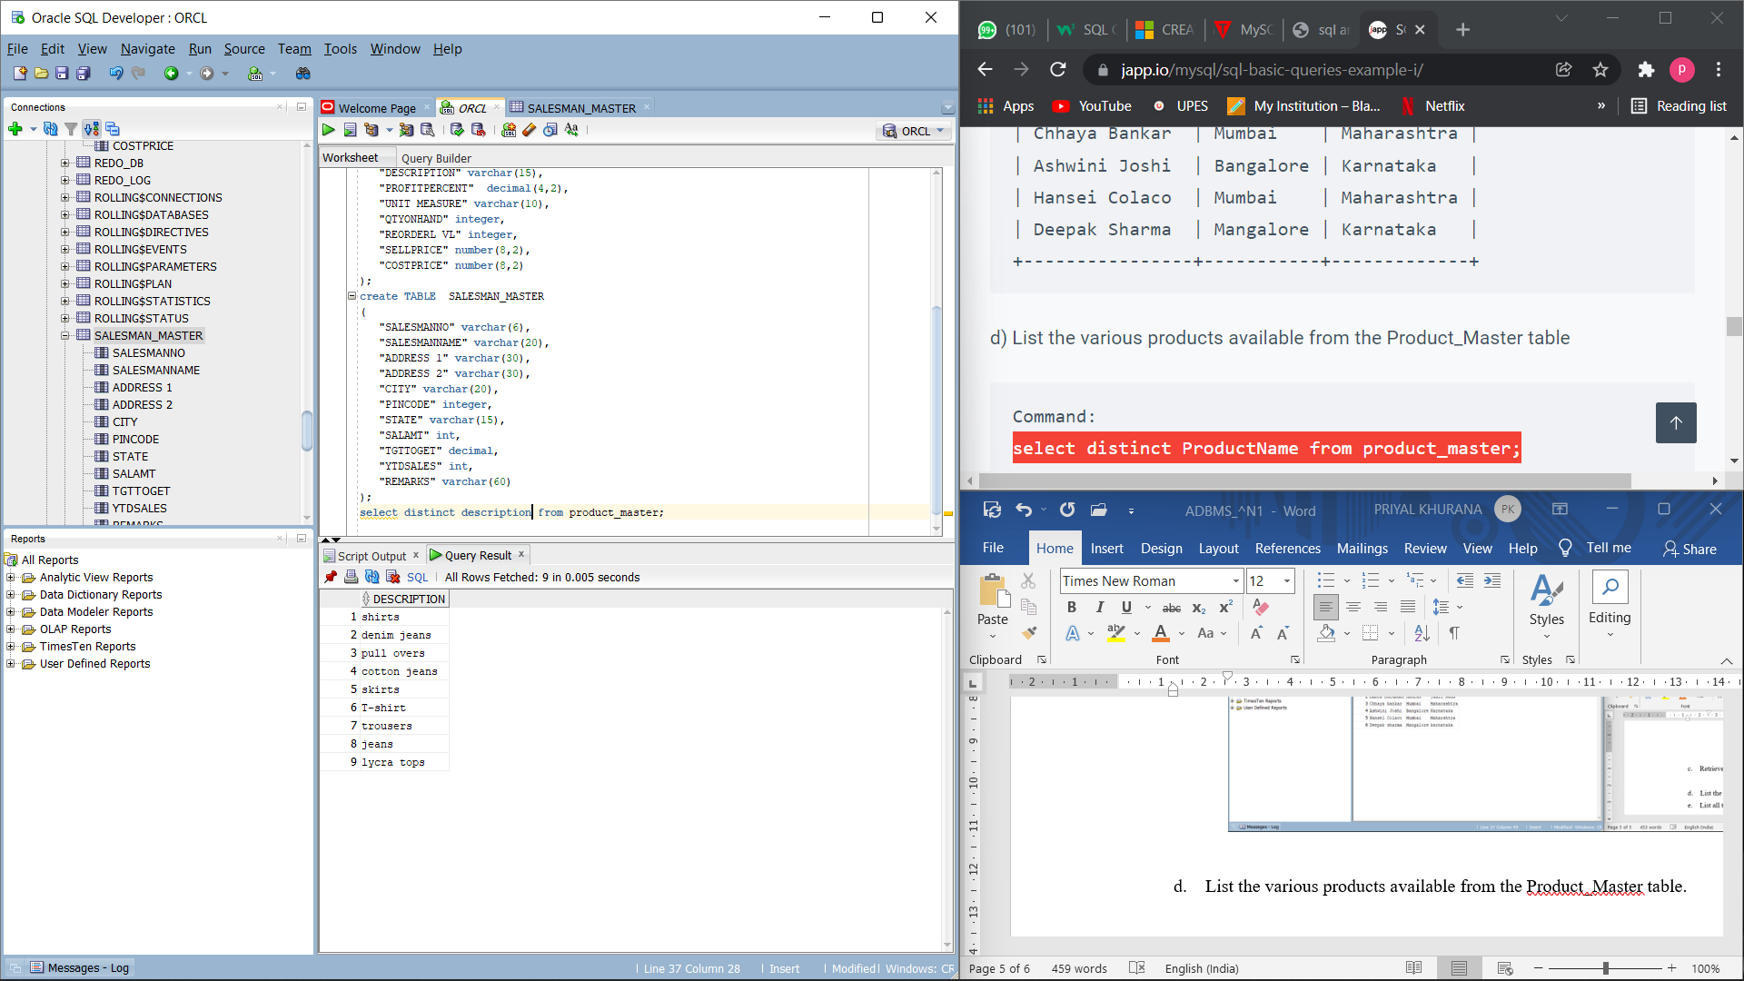  
e. List all the clients who are located in Mumbai.

select * from client_master where City = 'Mumbai';

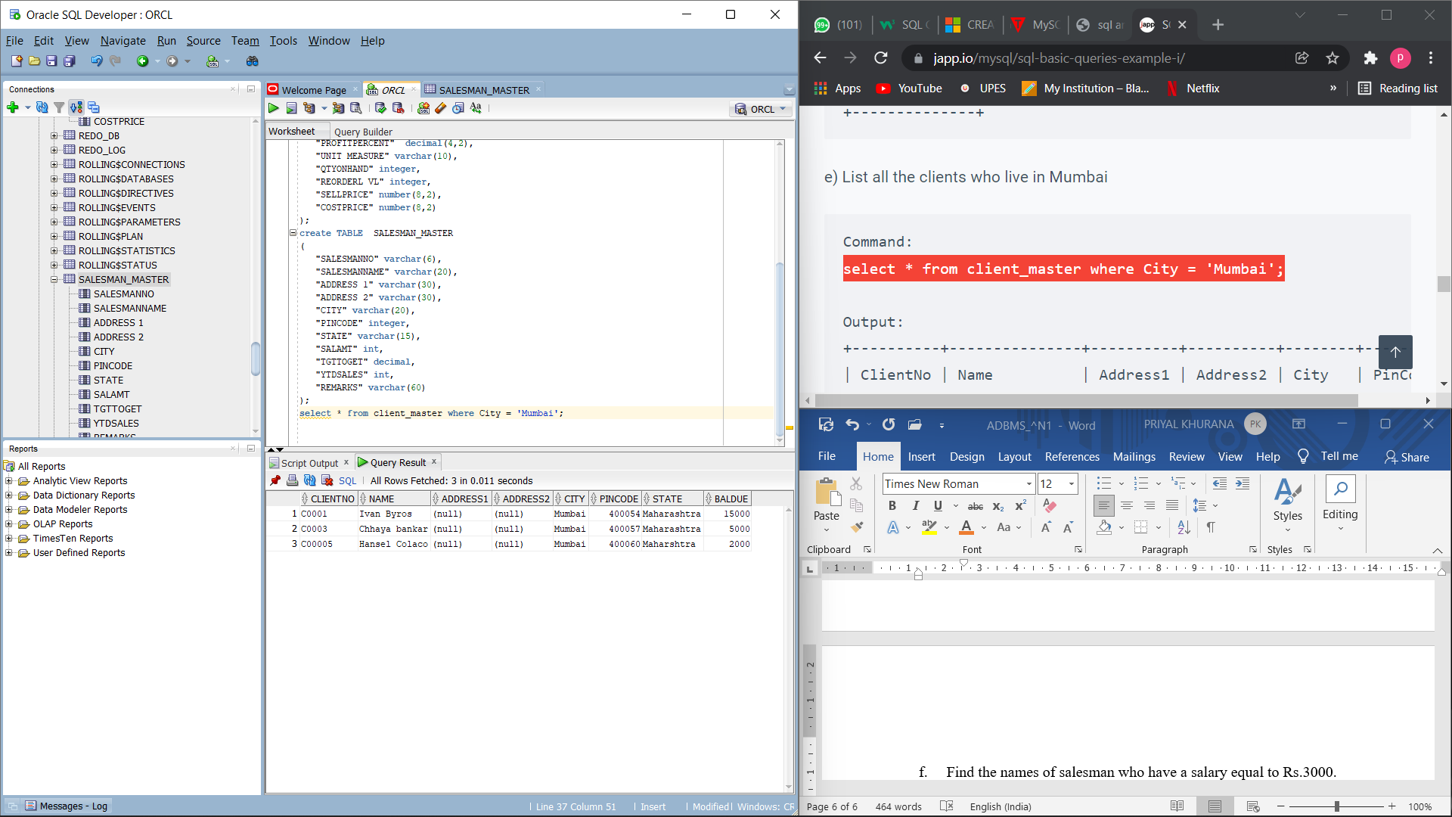  
f. Find the names of salesman who have a salary equal to Rs.3000.

select salesmanname from salesman_master where SalAmt = 3000;

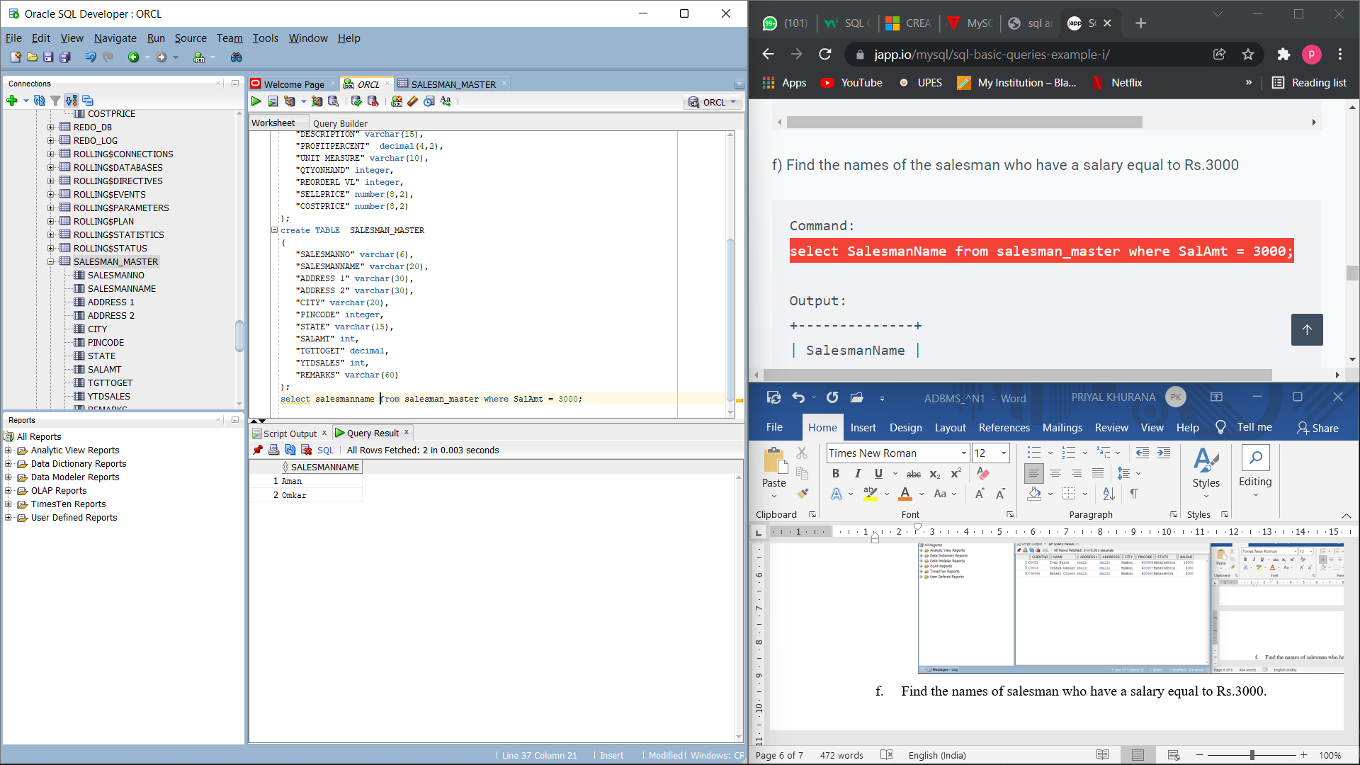

1. **Exercise on updating records in a table**  
   a. Change the city of ClientNo ‘C00005’ to ‘Bangalore’.

update client_master set City = 'Bangalore' where ClientNo = 'C00005';

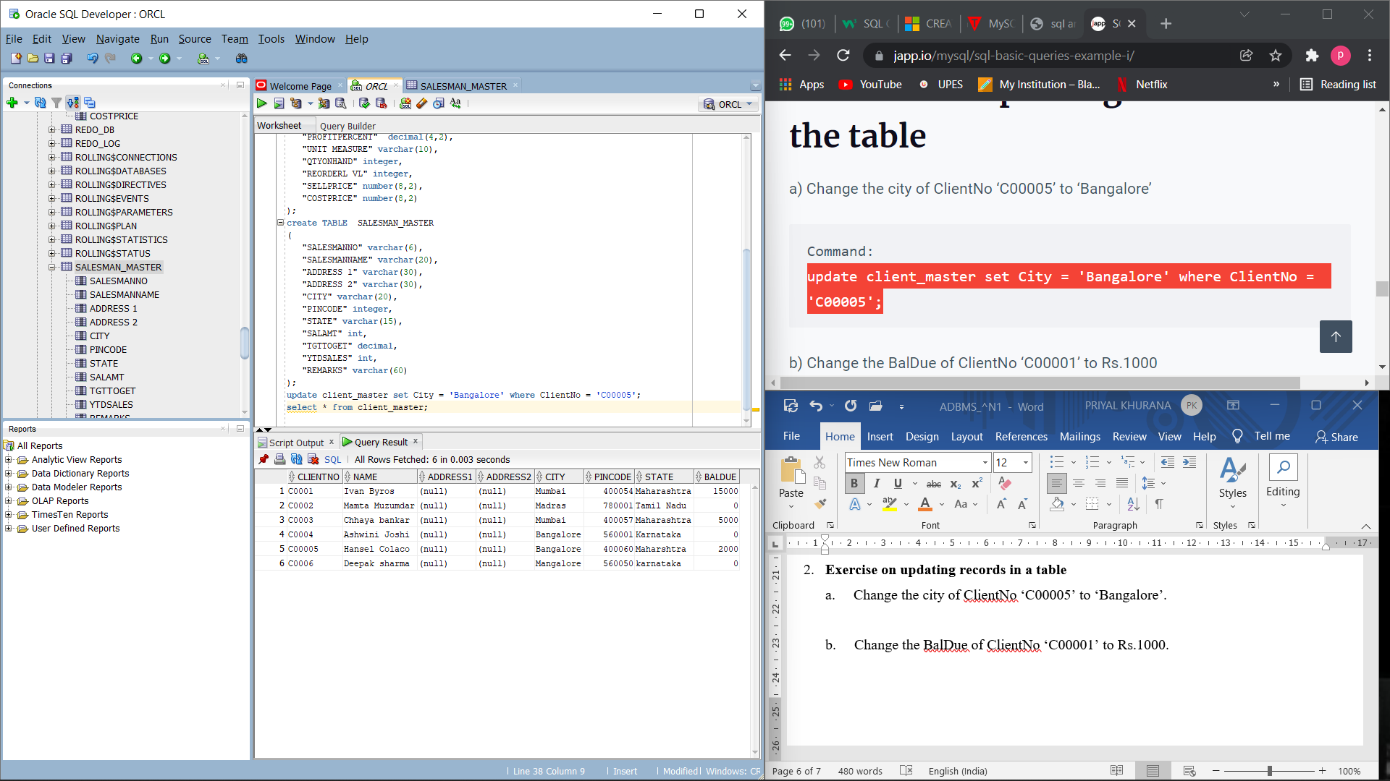  
b. Change the BalDue of ClientNo ‘C00001’ to Rs.1000.

update client_master set BalDue = 1000 where ClientNo = 'C00001';

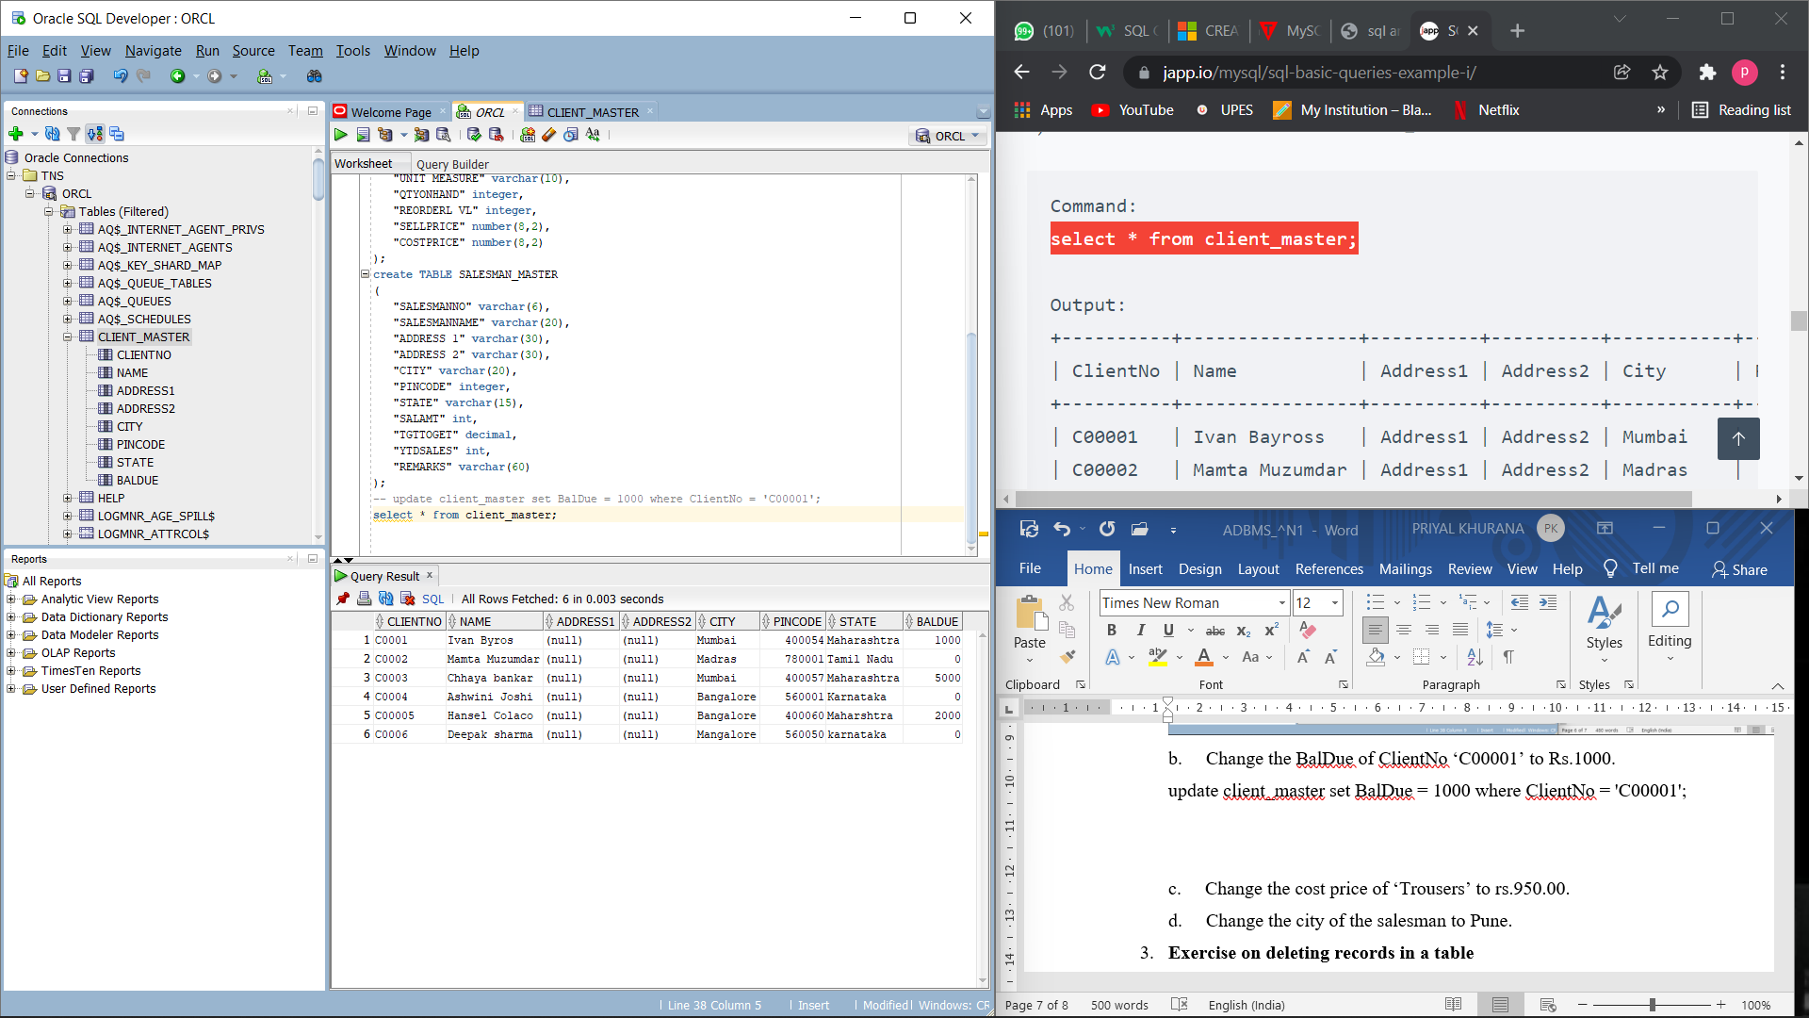

c. Change the cost price of ‘Trousers’ to rs.950.00.

update product_master set CostPrice = 950 where ProductName = 'Trousers';

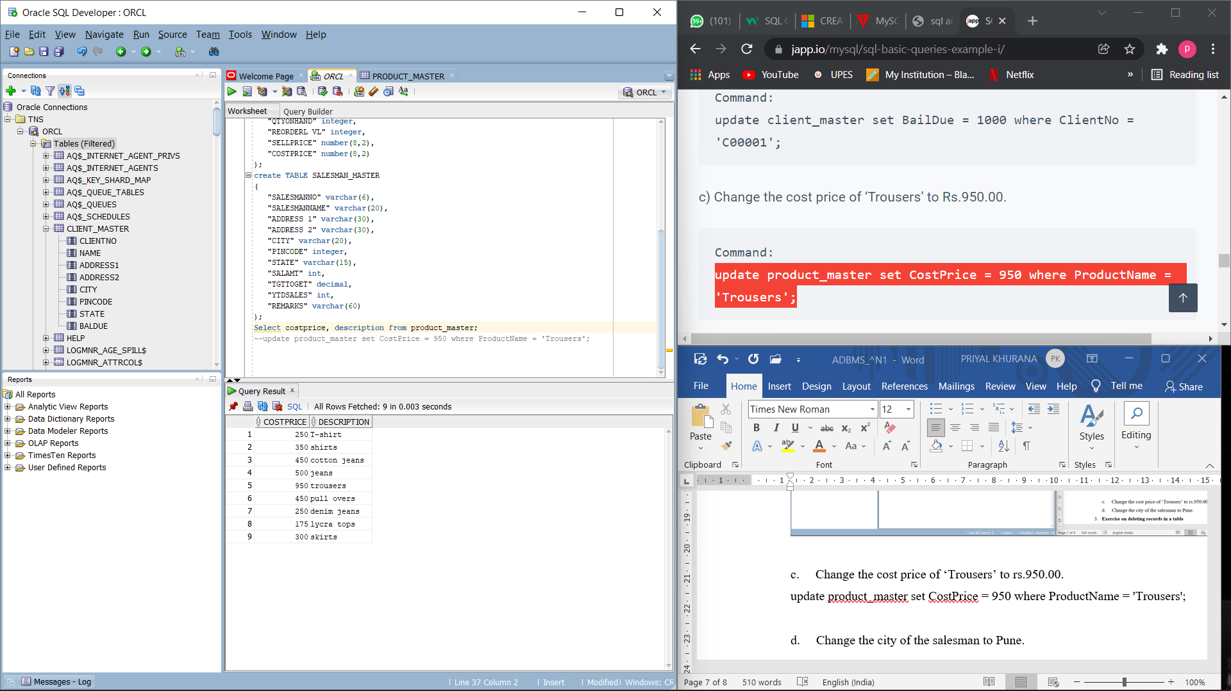  
d. Change the city of the salesman to Pune.

update salesman_master set City = 'Pune';

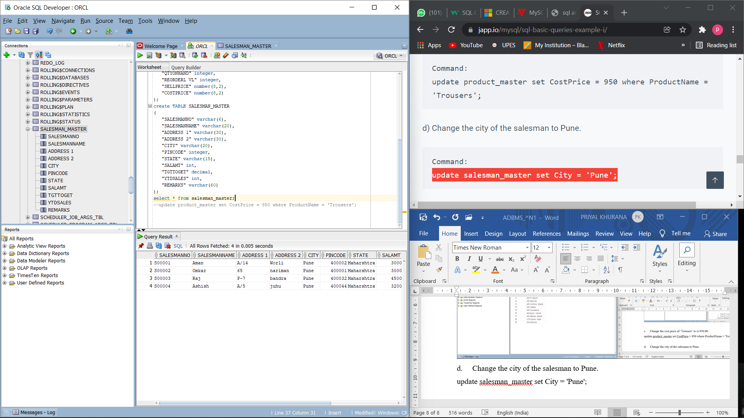

1. **Exercise on deleting records in a table**  
   a. Delete all salesman from the Salesman_Master whose salaries are equal to Rs.3500.

delete from salesman_master where SalAmt = 3000;

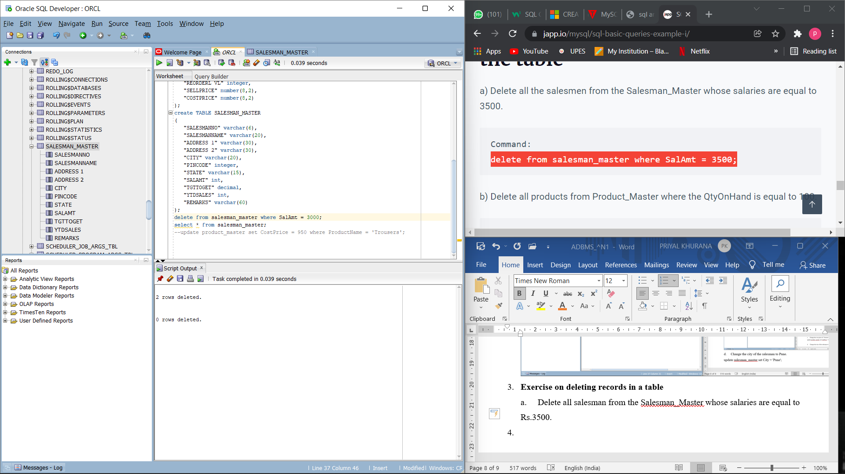

b. Delete all products from Product_Master where the quantity on hand is equal to 100.

delete from product_master where QtyOnHand = 100;

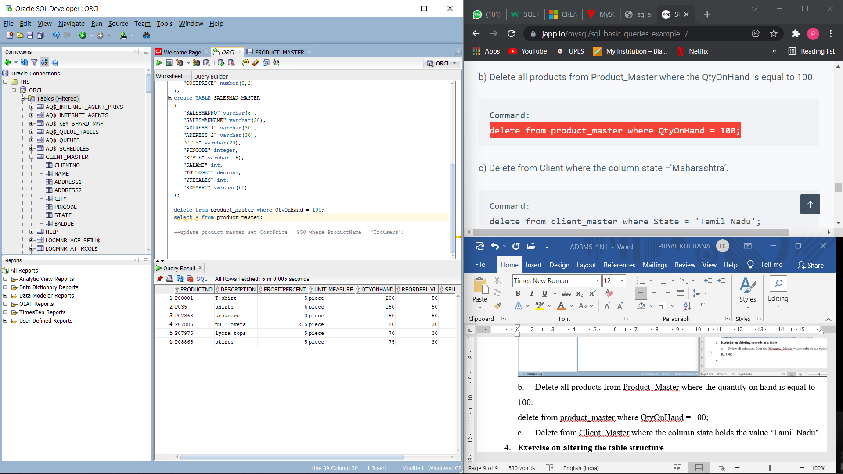  
c. Delete from Client_Master where the column state holds the value ‘Tamil Nadu’.

delete from client_master where State = 'Tamil Nadu';

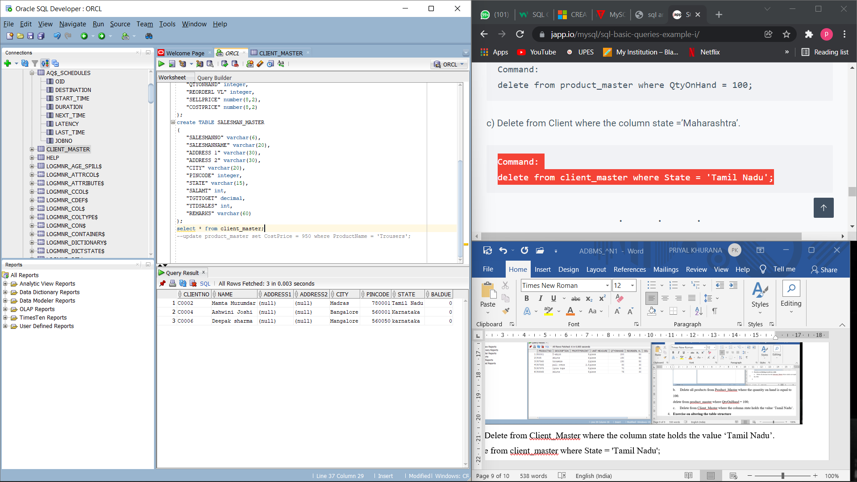

1. **Exercise on altering the table structure**  
   a. Add a column called ‘Telephone’ of data type integer to the Client_Master table.

alter table client_master add Telephone int;

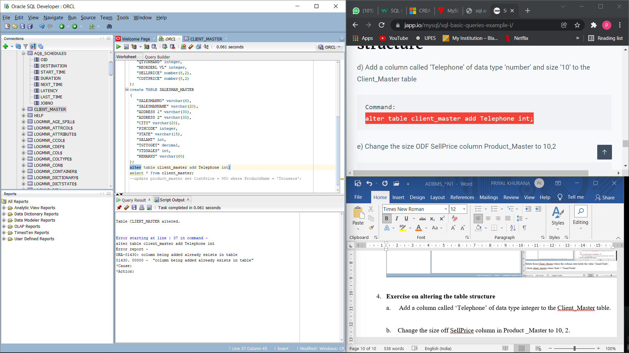  
b. Change the size off SellPrice column in Product _Master to 10, 2.

alter table product_master modify SellPrice number(10,2);

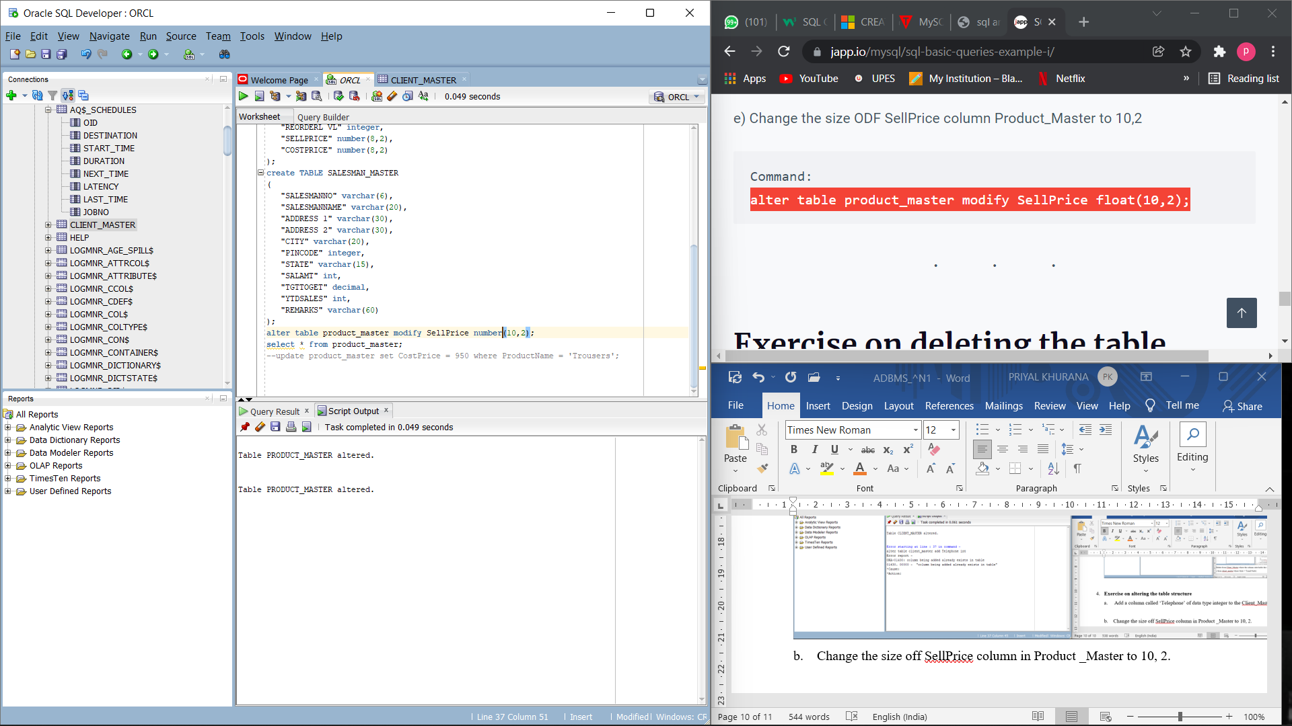

1. **Exercise on deleting the table structure along with the data**  
   a. Destroy the table Client_Master along with its data.

drop table client_master;

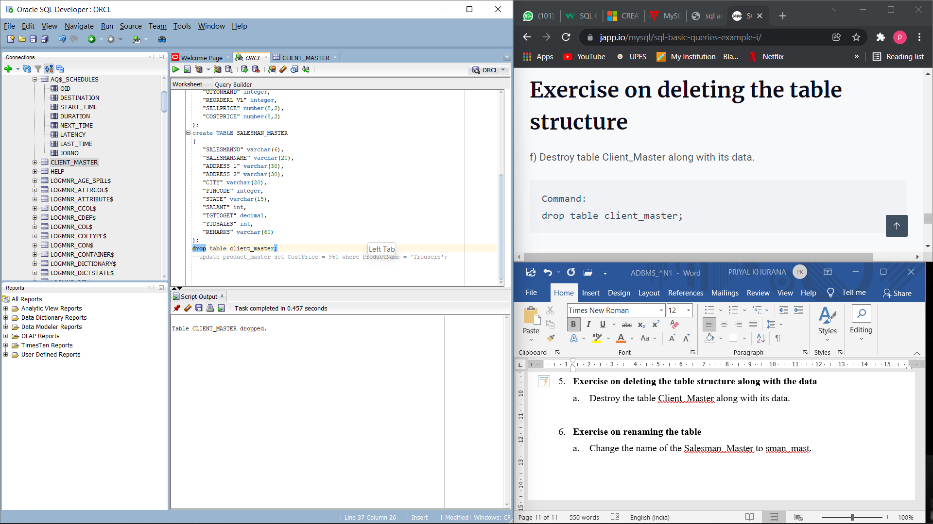

1. **Exercise on renaming the table**  
   a. Change the name of the Salesman_Master to sman_mast.

alter table salesman_master rename to sman_mast;

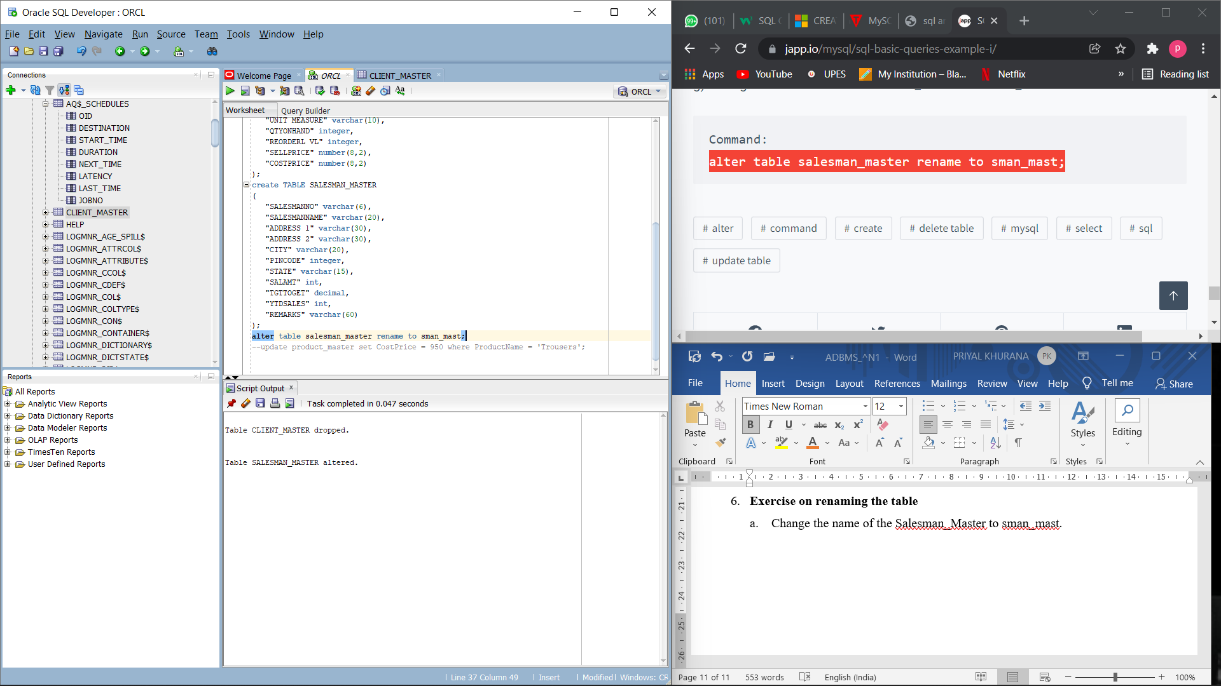

**EXPERIMENT-2**

Title: To understand and apply the concept of Constraints.

Objective: To understand the concept of data constraints that is enforced on data being stored in the table. Focus on Primary Key and the Foreign Key.

EXERCISE:

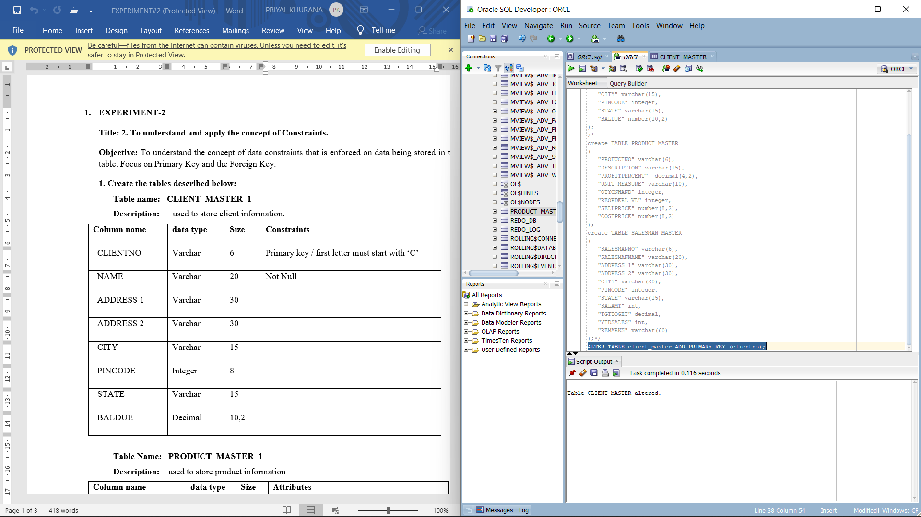

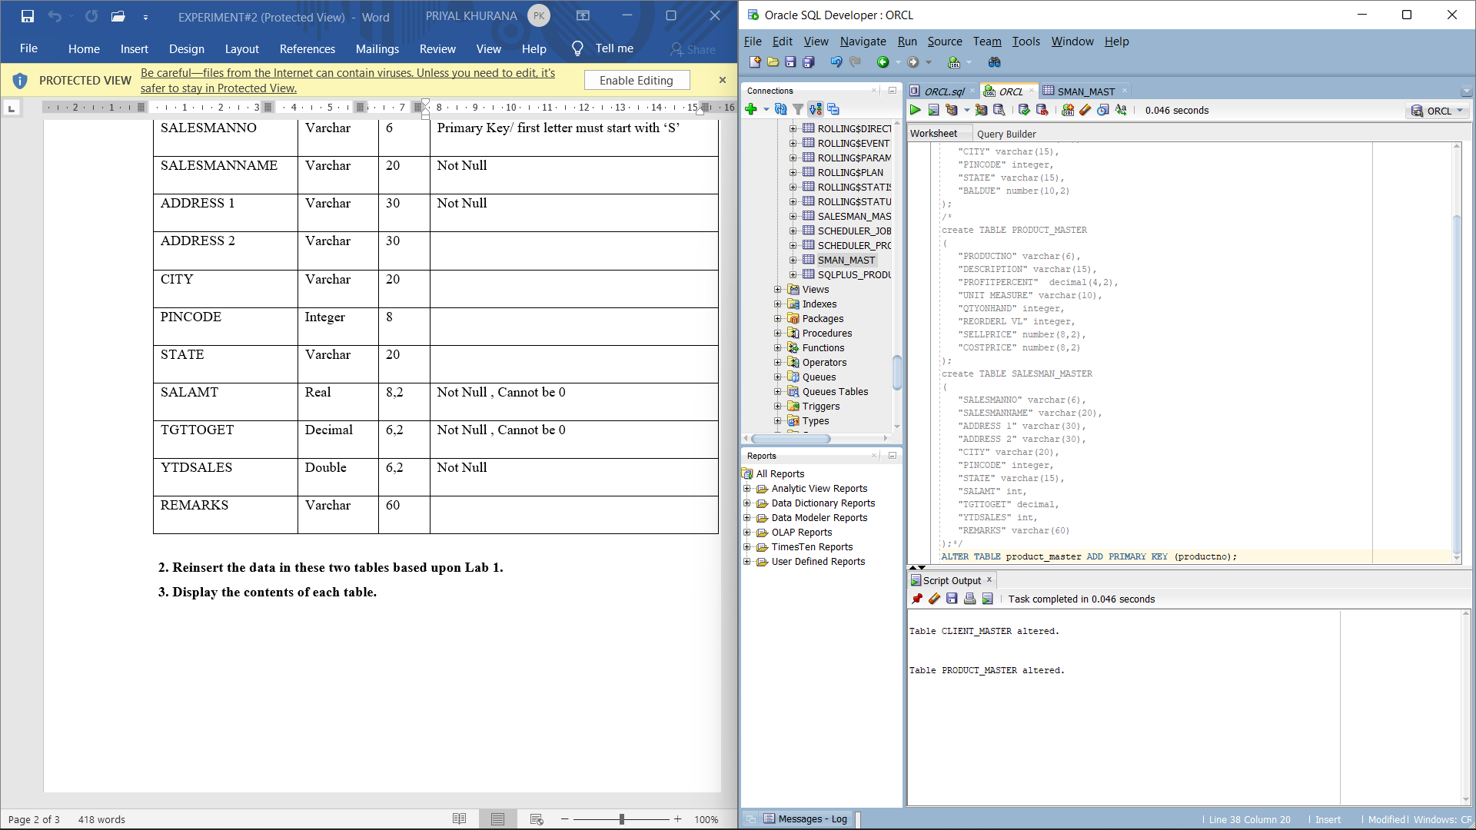

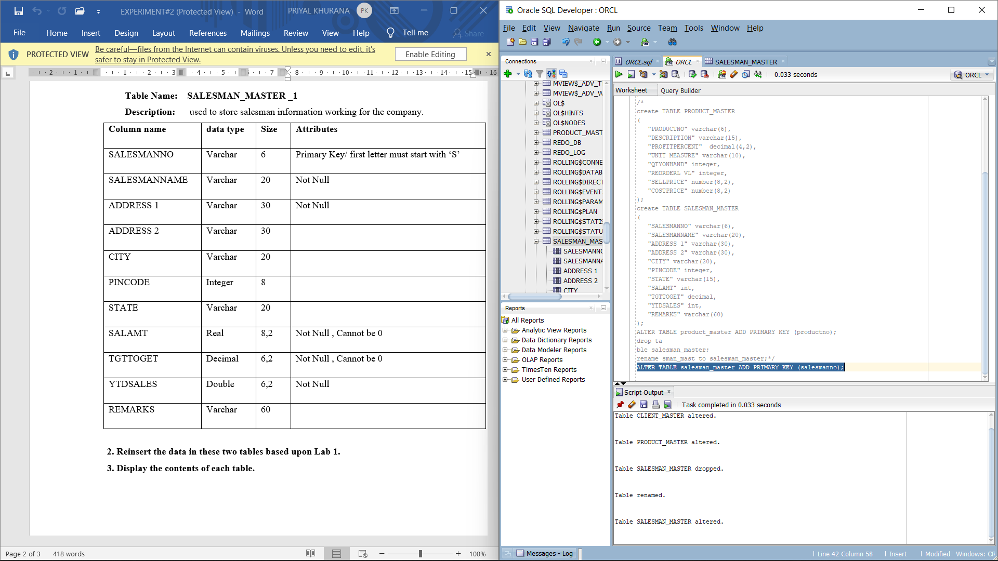

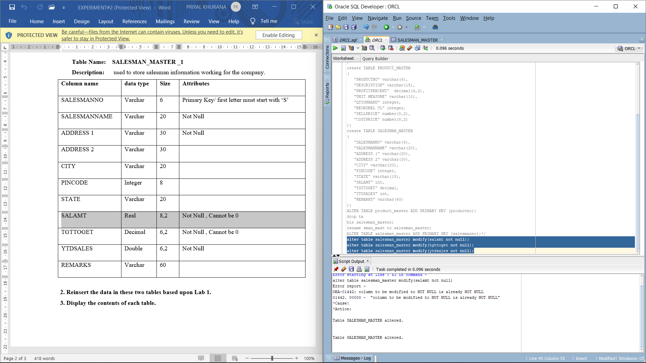

Commands:

ALTER TABLE salesman_master ADD check(salesmanno like 'S%');

ALTER TABLE product_master ADD check(productno like 'P%');

ALTER TABLE client_master ADD check (clientno like 'C%');

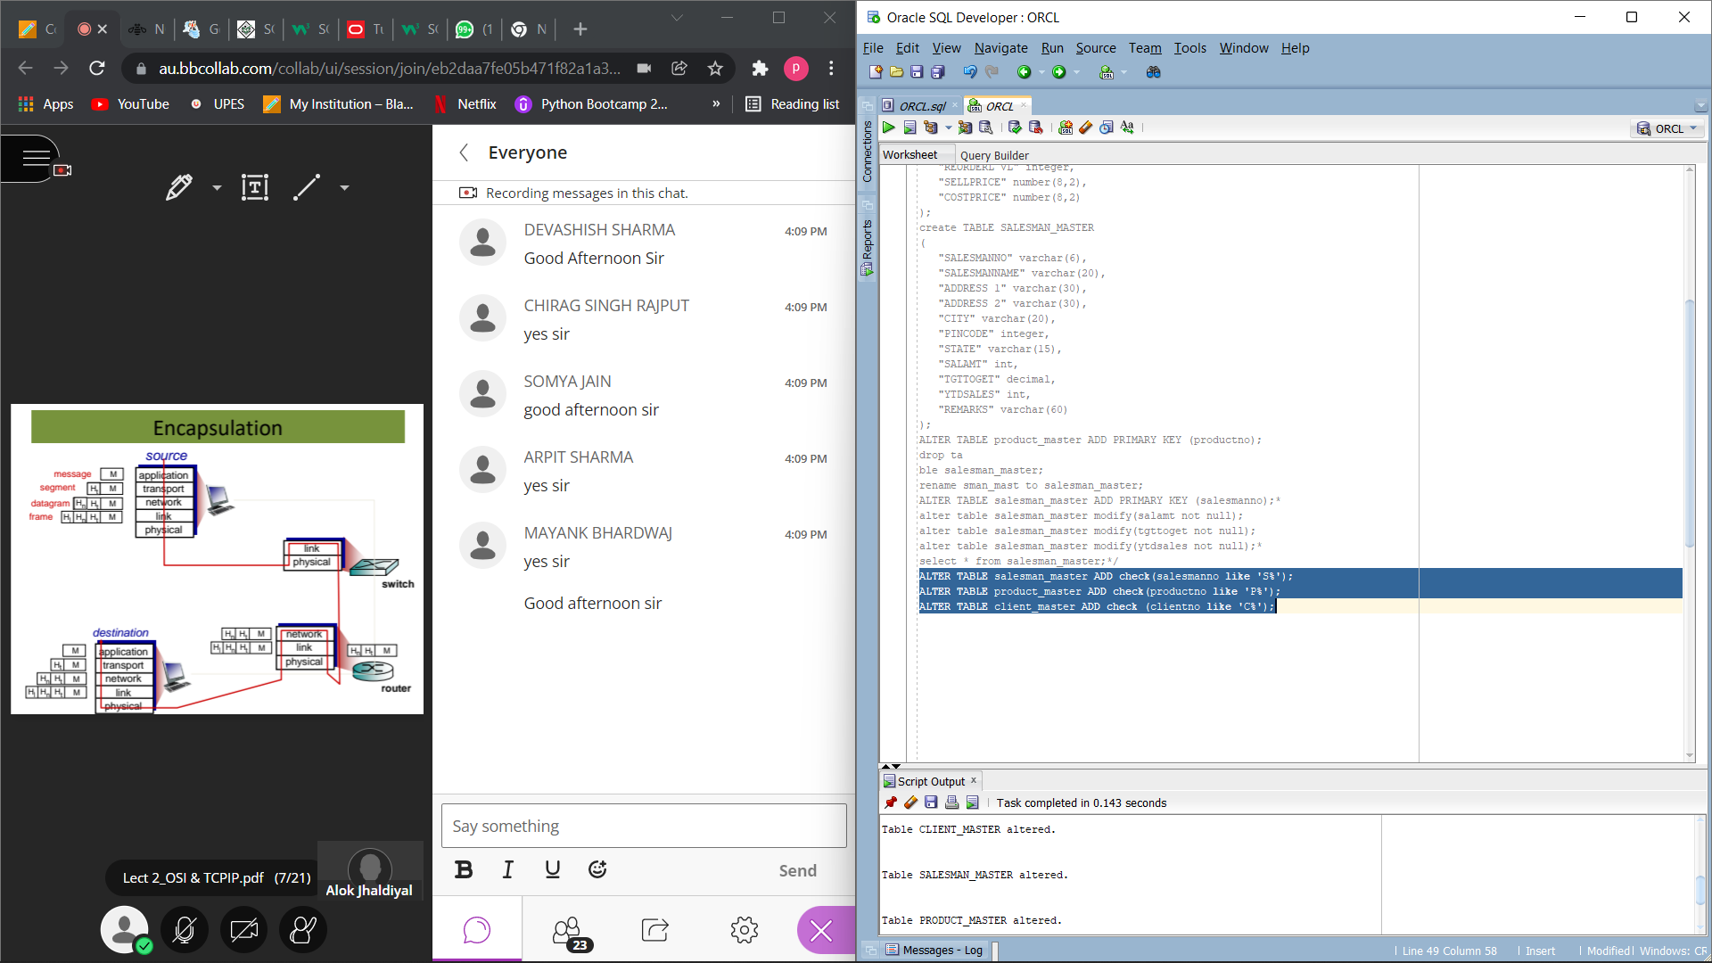

FAULTY commands:

INSERT INTO "SYSTEM"."CLIENT_MASTER" (CLIENTNO, NAME, CITY, PINCODE, STATE, BALDUE) VALUES ('P00007', 'PRIYAL', 'DELHI', '110015', 'DELHI', '0')

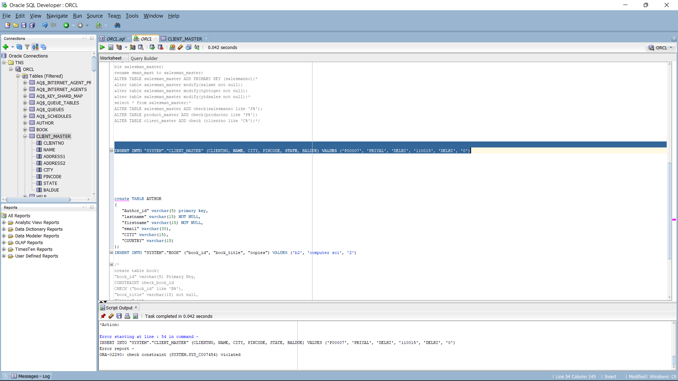

INSERT INTO "SYSTEM"."SALESMAN_MASTER" (SALESMANNO, SALESMANNAME, "ADDRESS 1",

"ADDRESS 2", CITY, PINCODE, STATE, SALAMT, TGTTOGET, YTDSALES)

VALUES ('x0005', 'priya', 'j9', 'delhi', 'delhi', '110015', 'delhi', '3488', '1', '0')

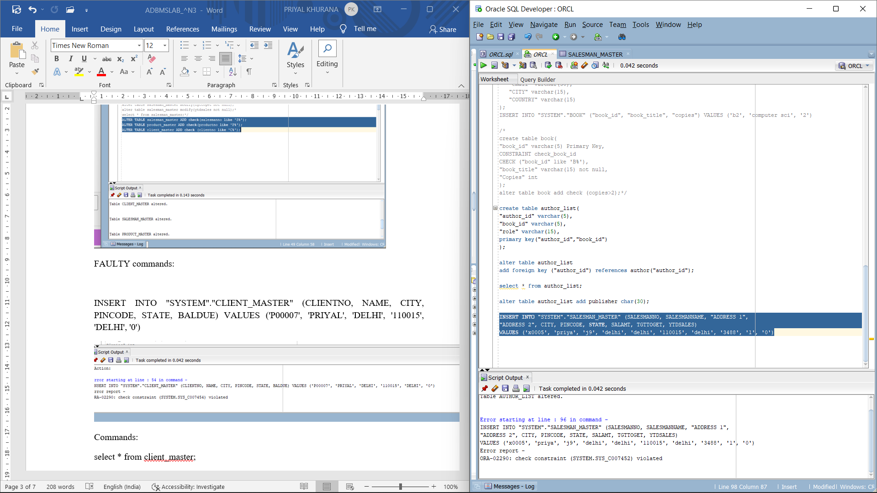

Commands:

select * from client_master;

select * from product_master;

select * from salesman_master;

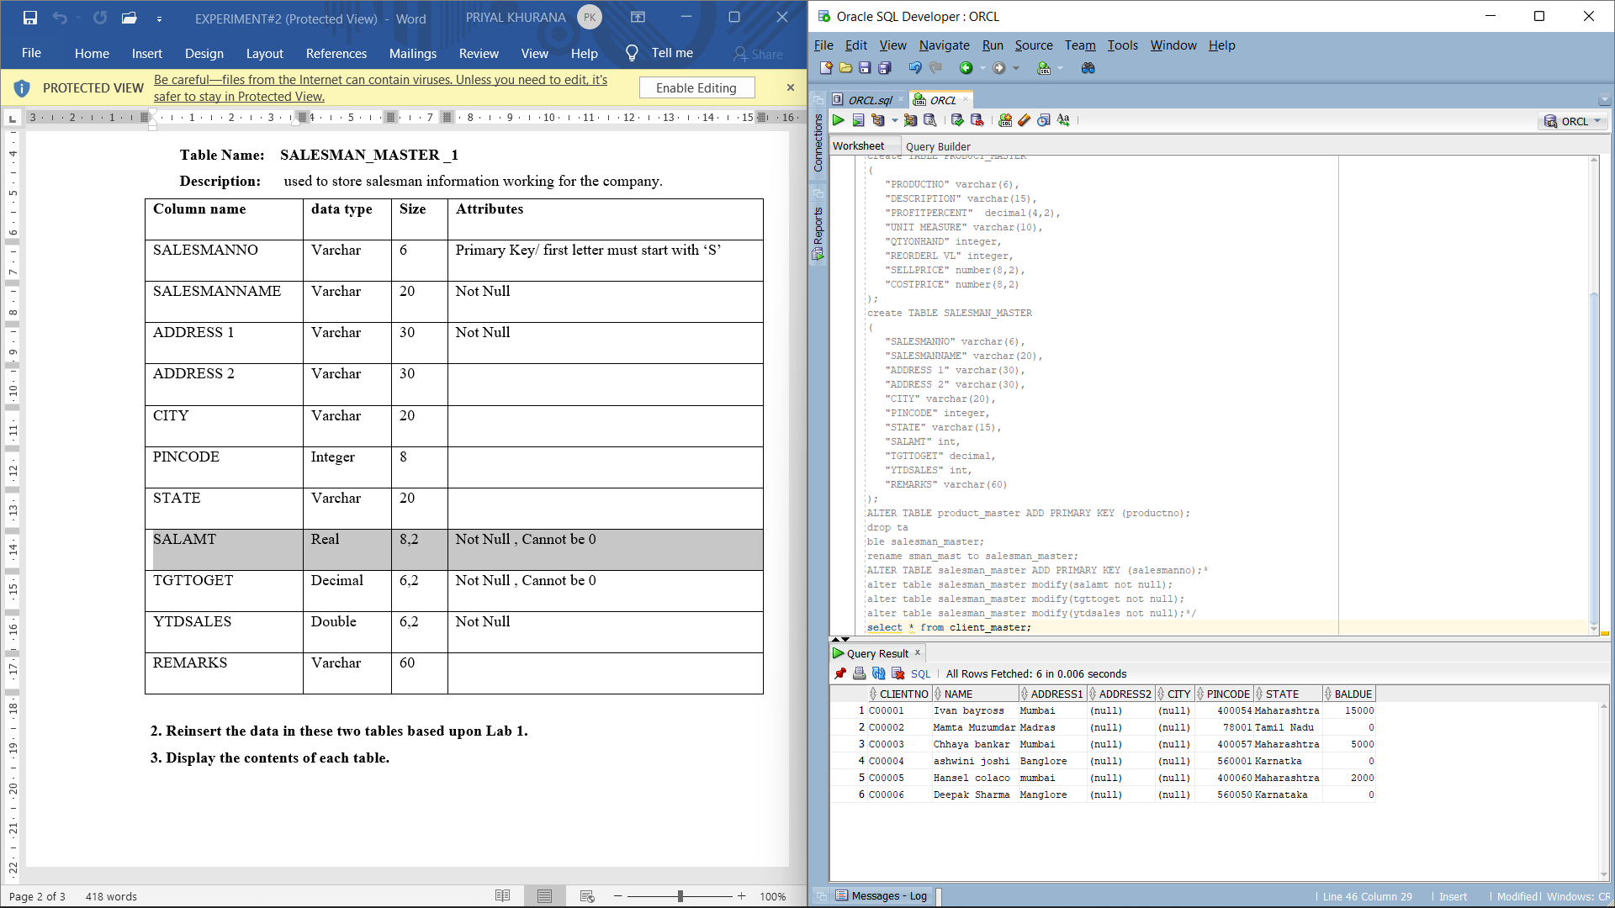

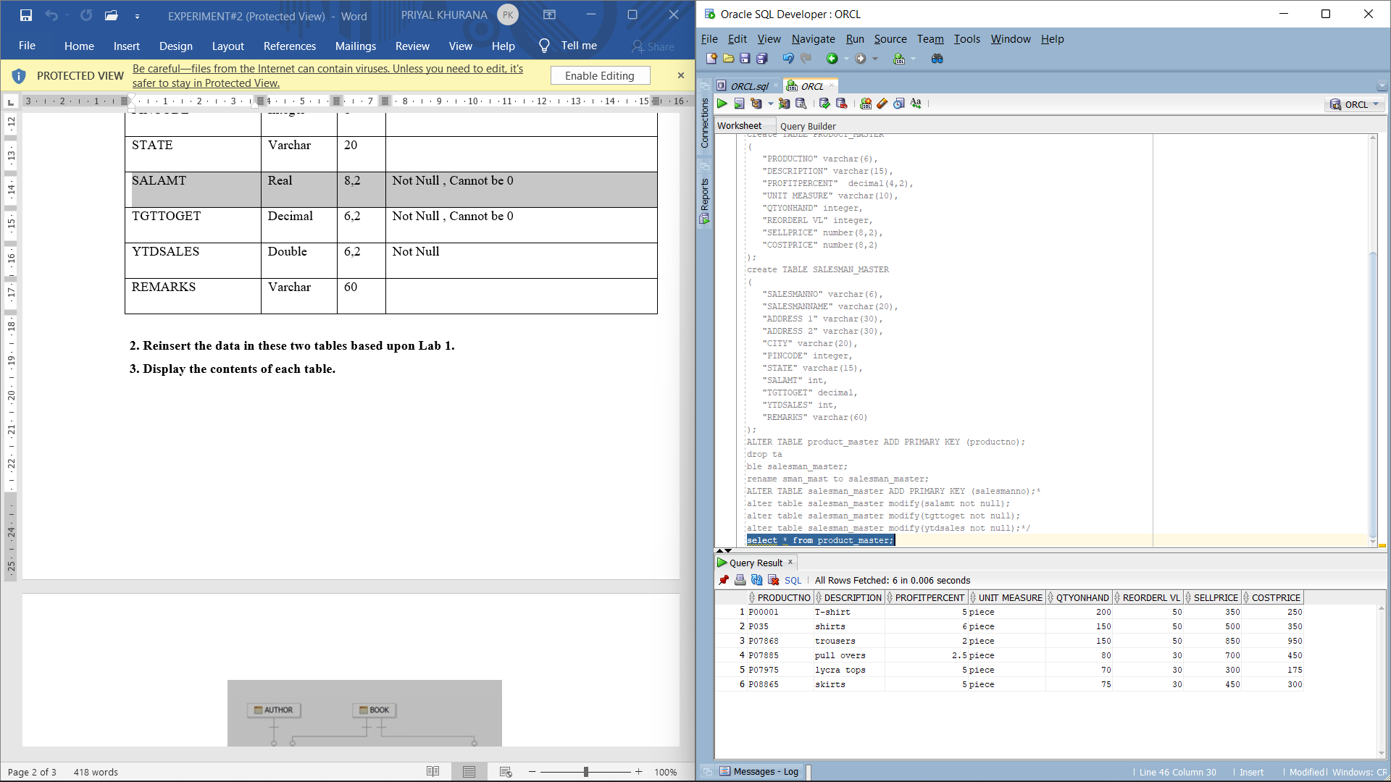

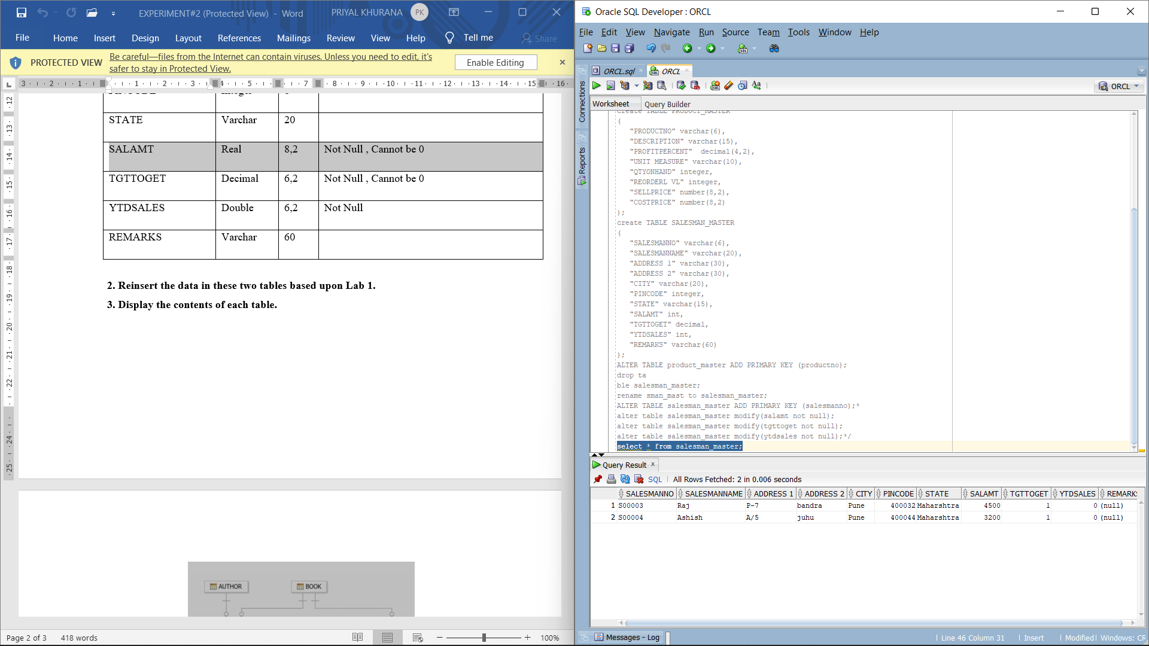

COMMAND:

create TABLE AUTHOR

(

"Author_id" varchar(5) primary key,

"lastname" varchar(15) NOT NULL,

"firstname" varchar(15) NOT NULL,

"email" varchar(30),

"CITY" varchar(15),

"COUNTRY" varchar(15)

);

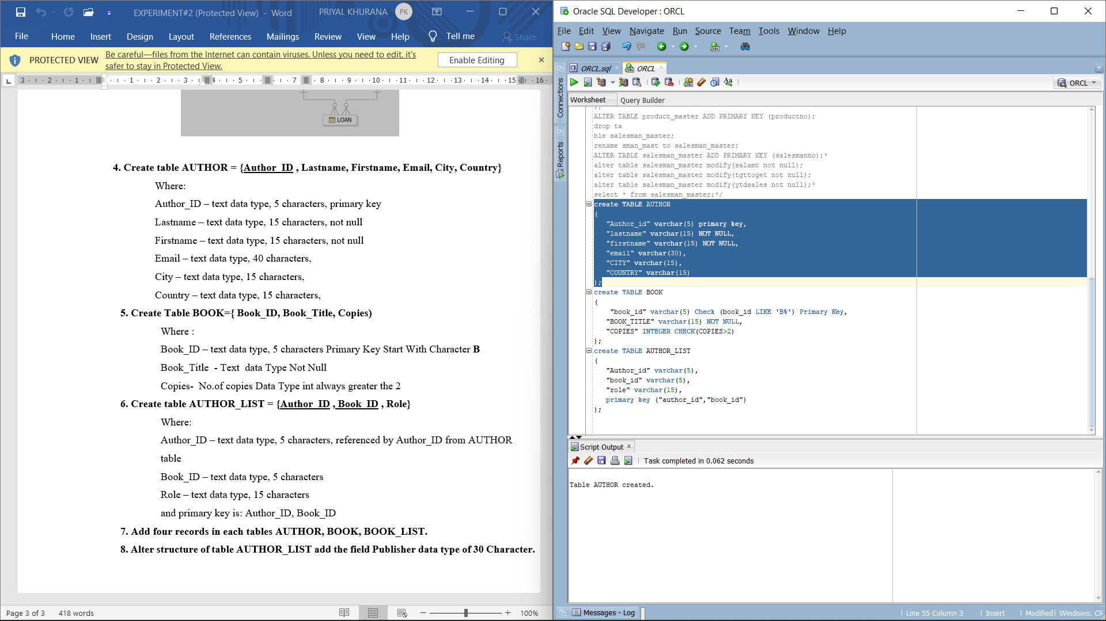

Commands:

create table book(

"book_id" varchar(5) Primary Key,

CONSTRAINT check_book_id

CHECK ("book_id" like 'B%'),

"book_title" varchar(15) not null,

"Copies" int

);

alter table book add check (copies>2);

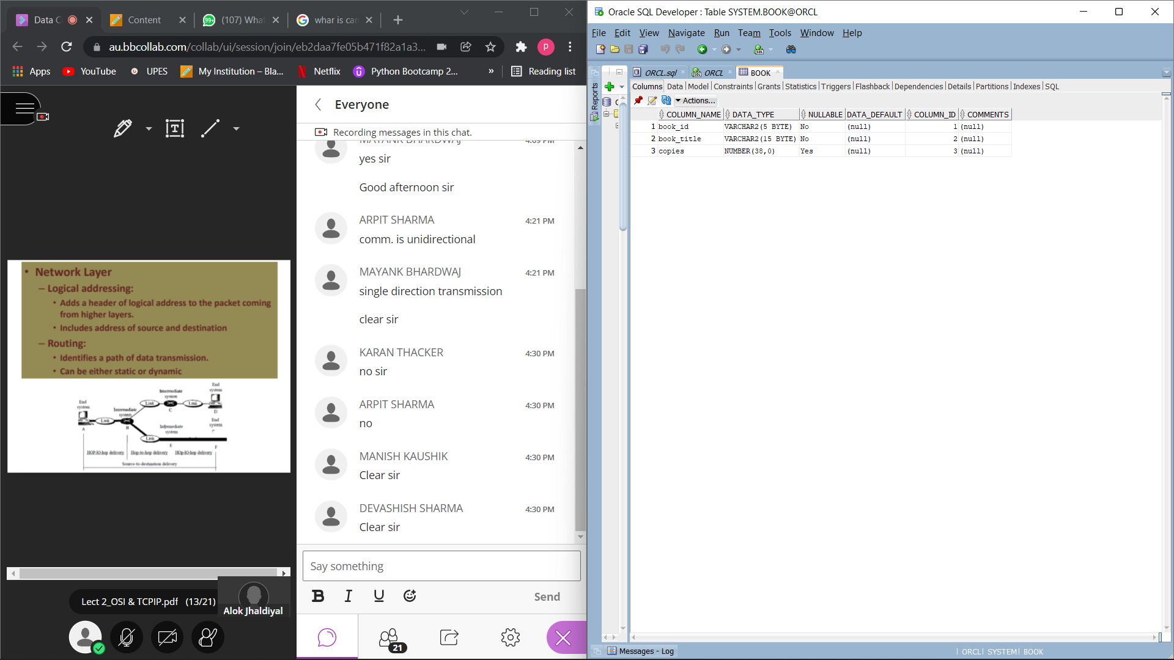

FAULTY command:

INSERT INTO "SYSTEM"."BOOK" ("book_id", "book_title", "copies") VALUES ('b2', 'computer sci', '2')

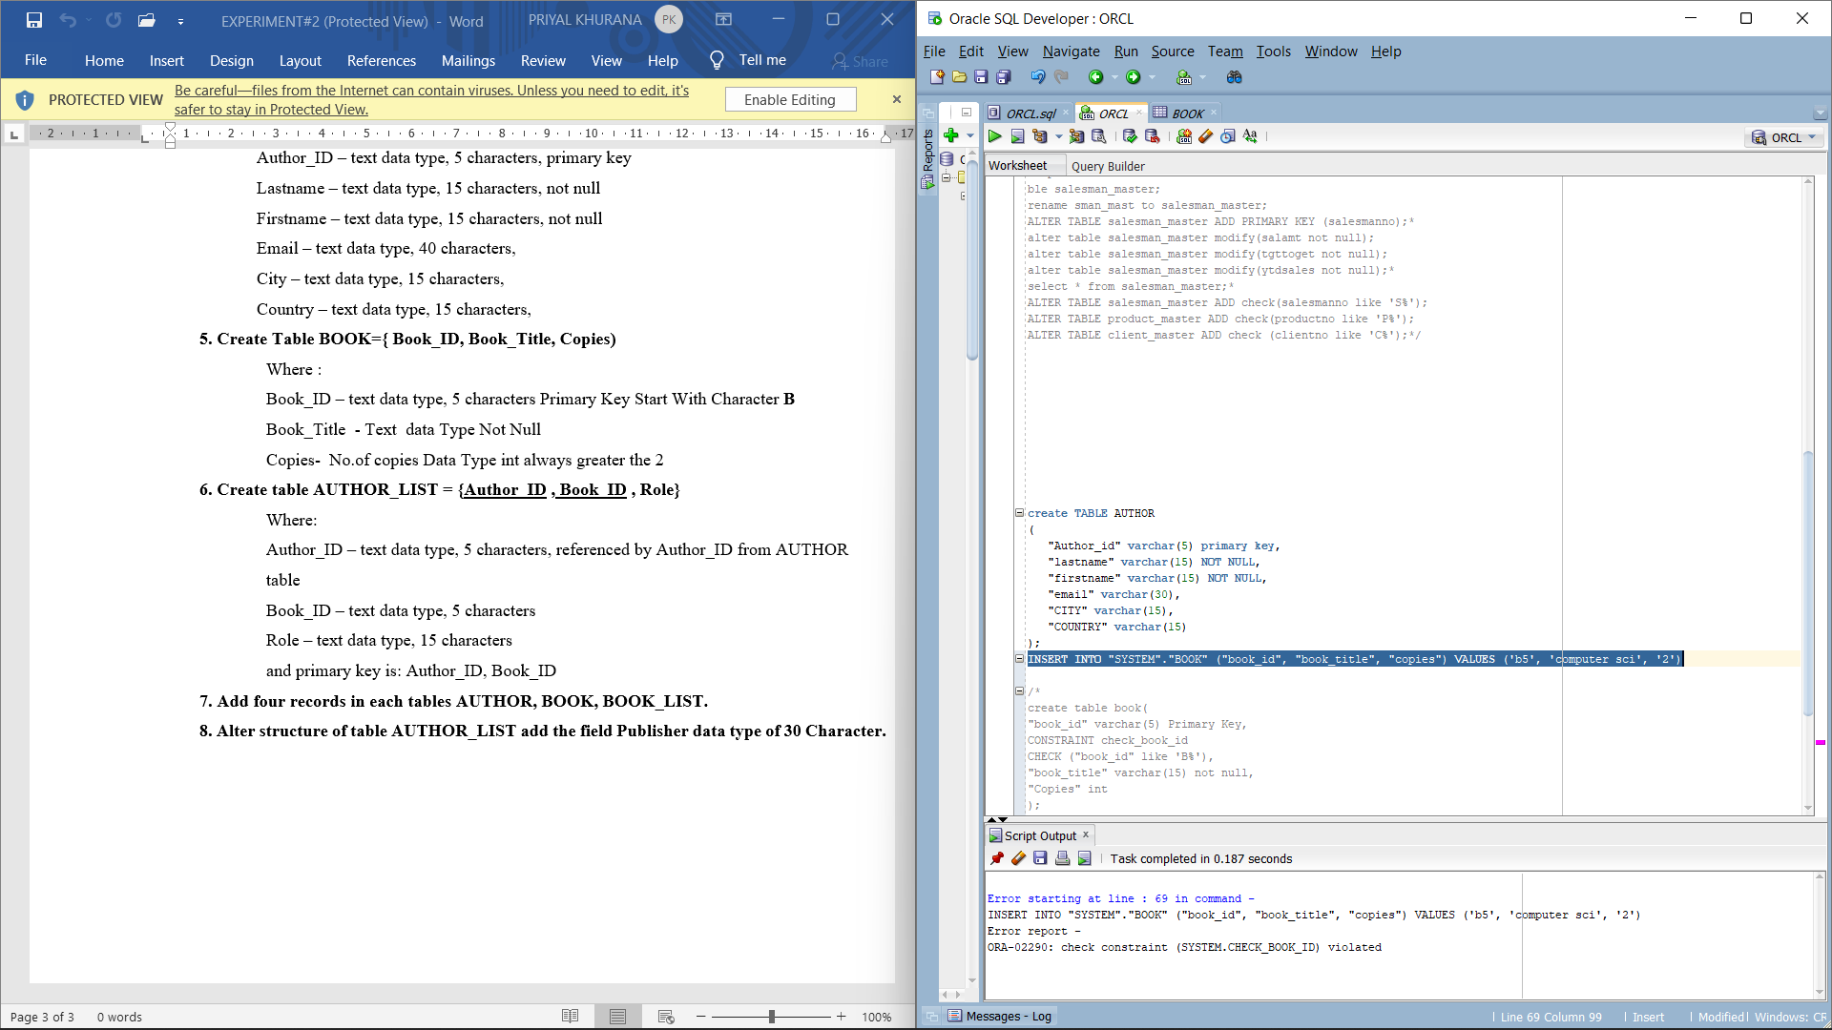

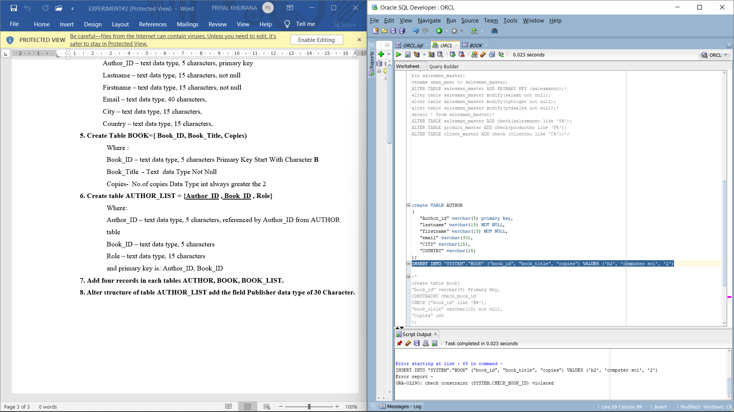

Commands:

create table author_list(

"author_id" varchar(5),

"book_id" varchar(5),

"role" varchar(15),

primary key("author_id","book_id")

);

alter table author_list

add foreign key ("author_id") references author("author_id");

Commands:

select * from author;

select * from book;

select * from author_list;

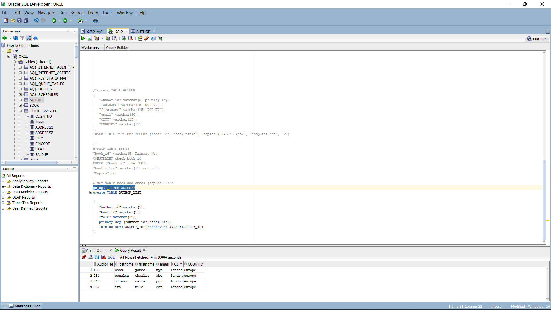

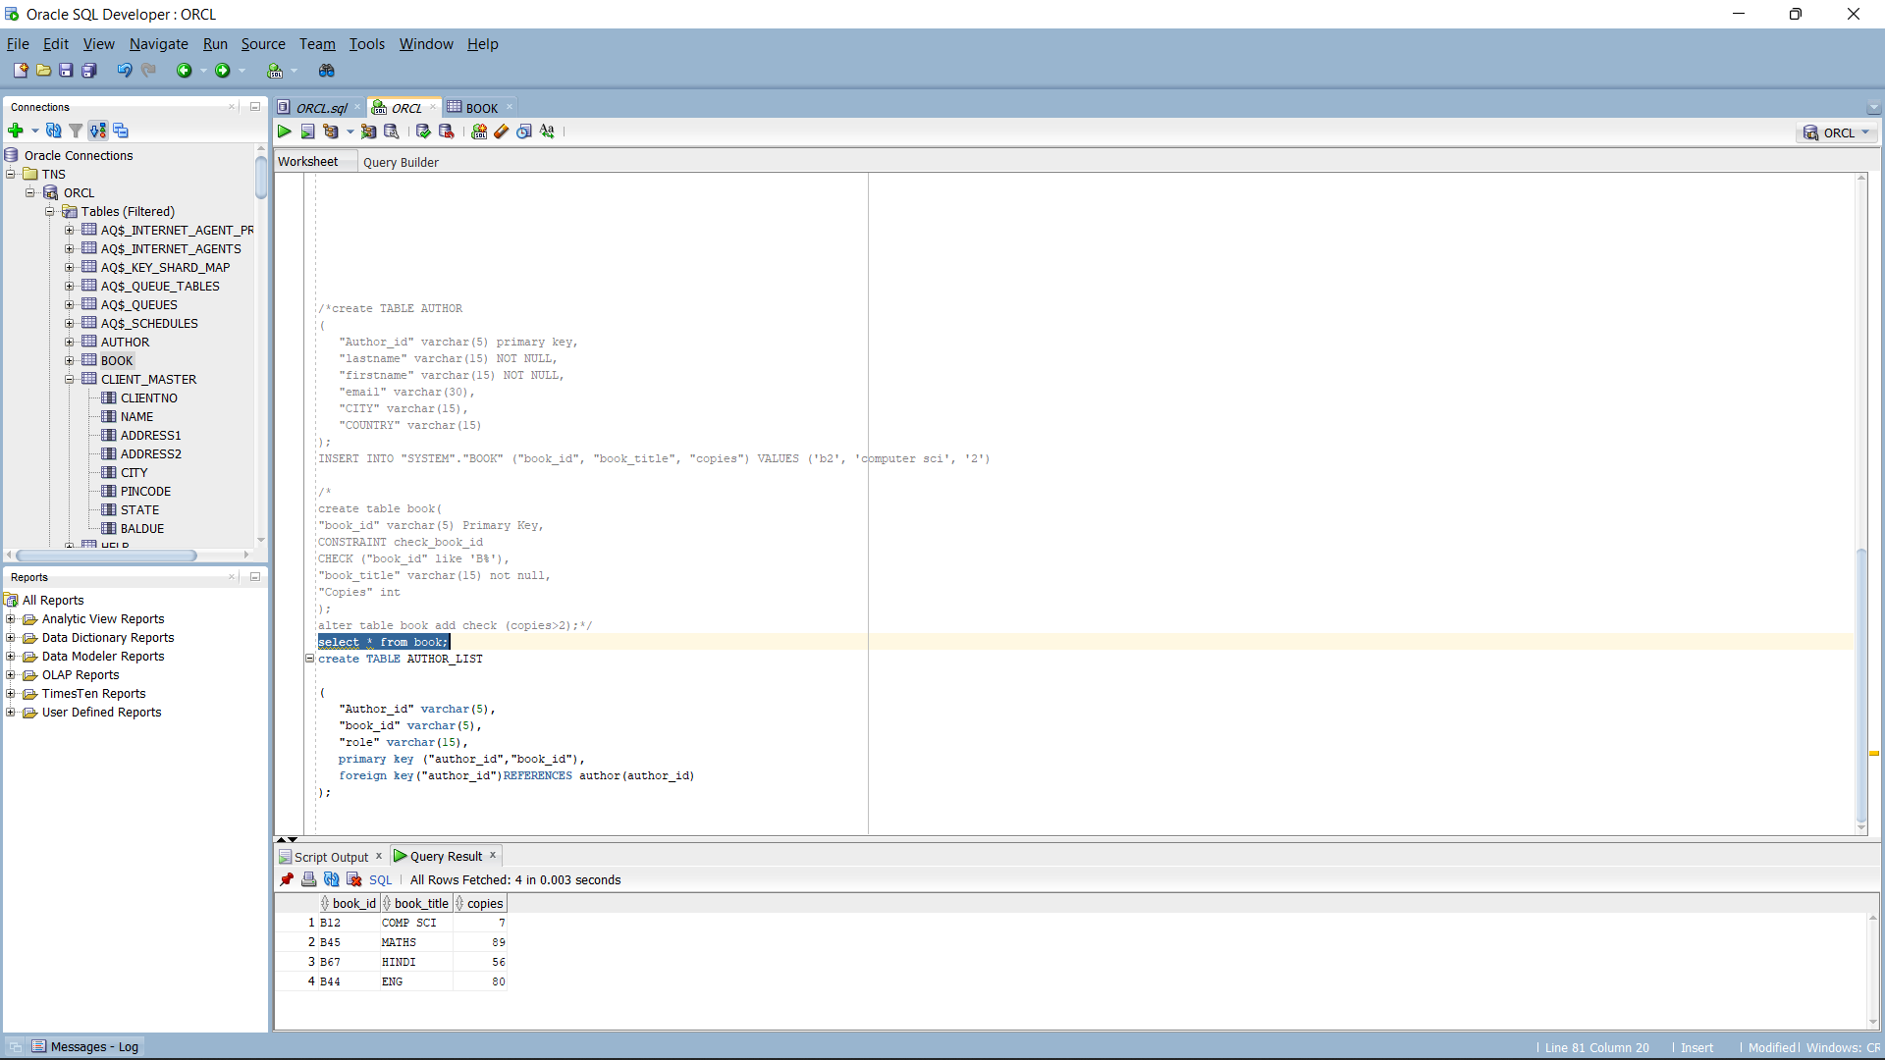

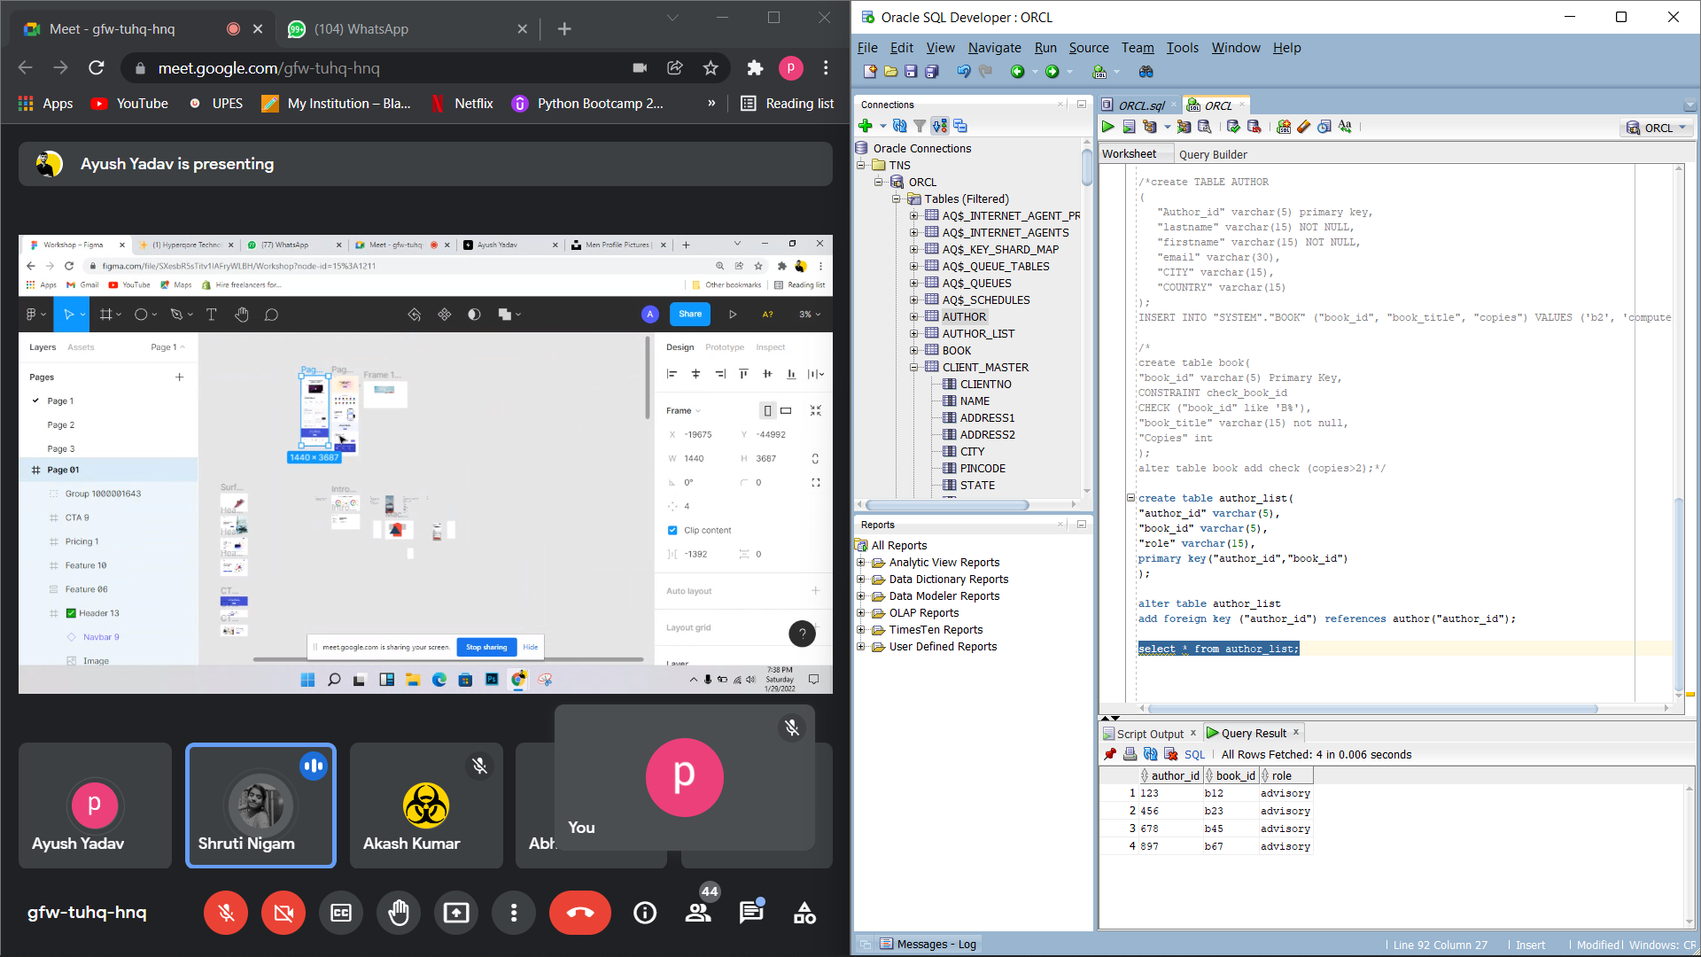

Commands:

alter table author_list add publisher char(30);

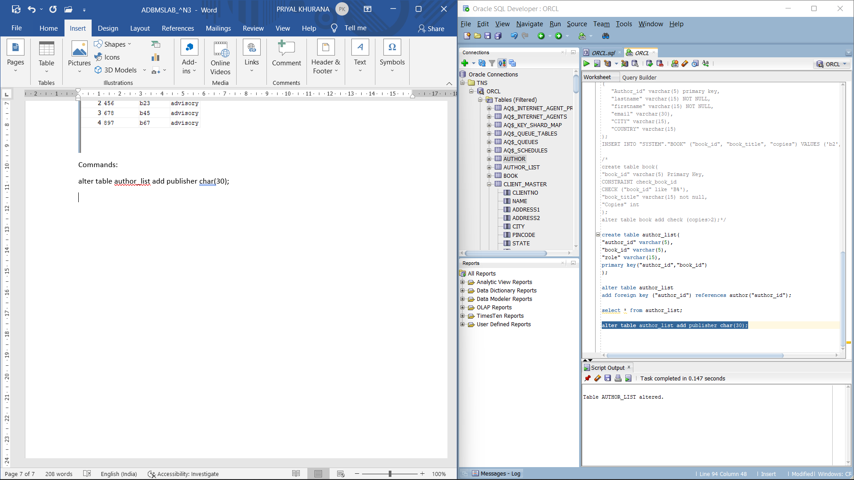

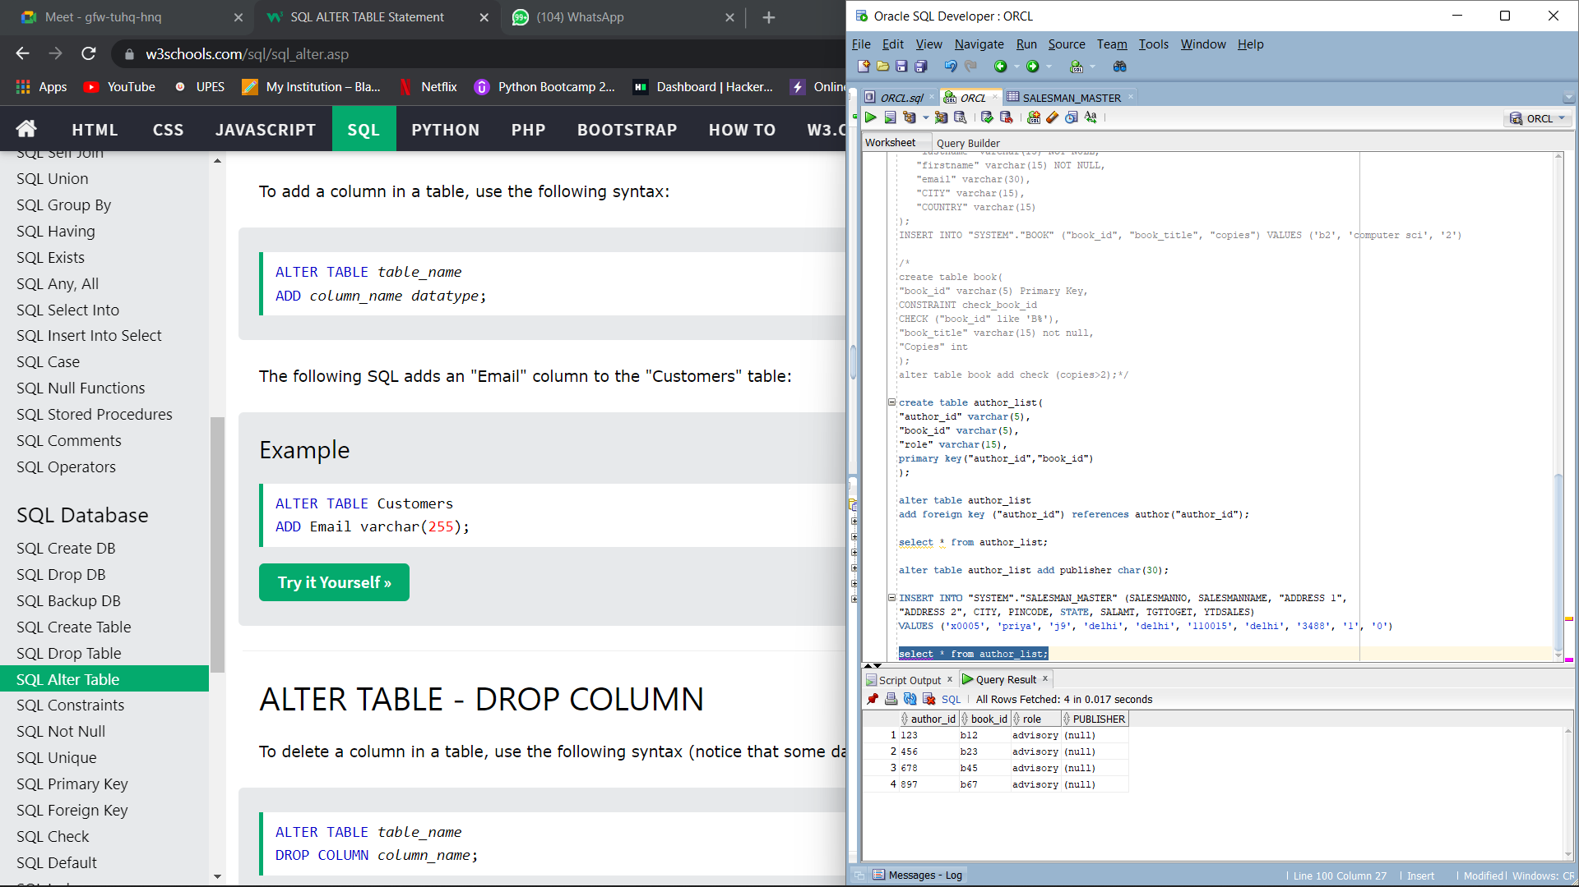

**EXPERIMENT-3**

LAB EXERCISE: To understand and use SQL Sub-Query

OBJECTIVE: To understand the use of sql subquery.

EXERCISE:

**1. Create the following table.**

create table supplier(

scode varchar(15),

sname varchar(15),

scity varchar(30),

turnover integer);

create table part(

pcode varchar(15),

weigh integer,

color varchar(15),

cost decimal,

sellingprice decimal);

create table supplier_part(

scode varchar(15),

pcode varchar(15),

qty integer);

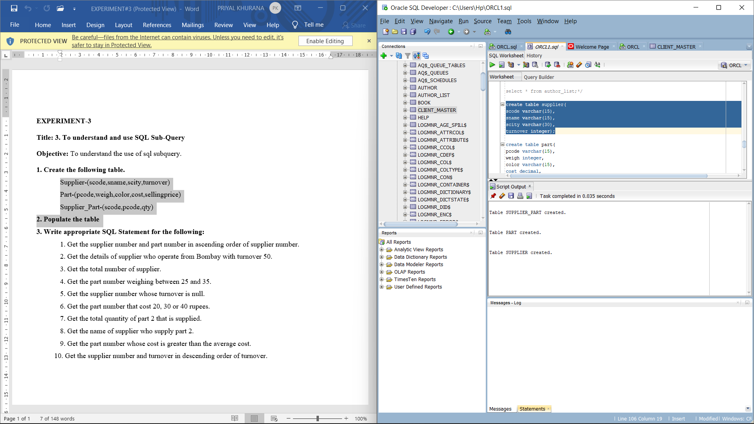

**2. Populate the table**

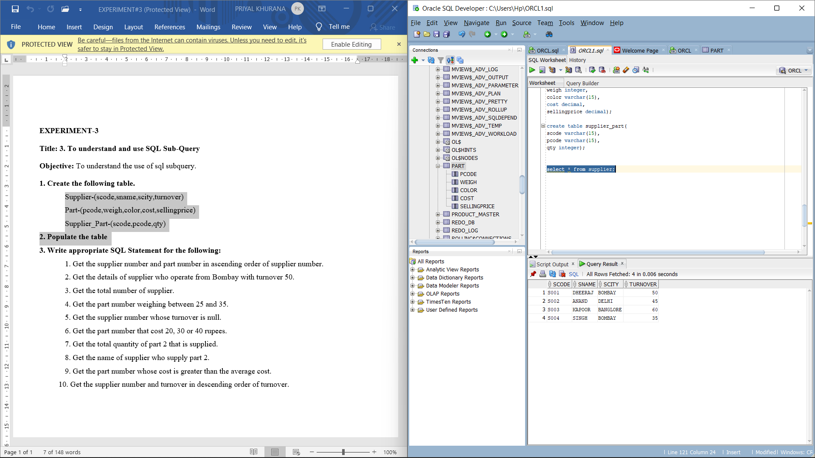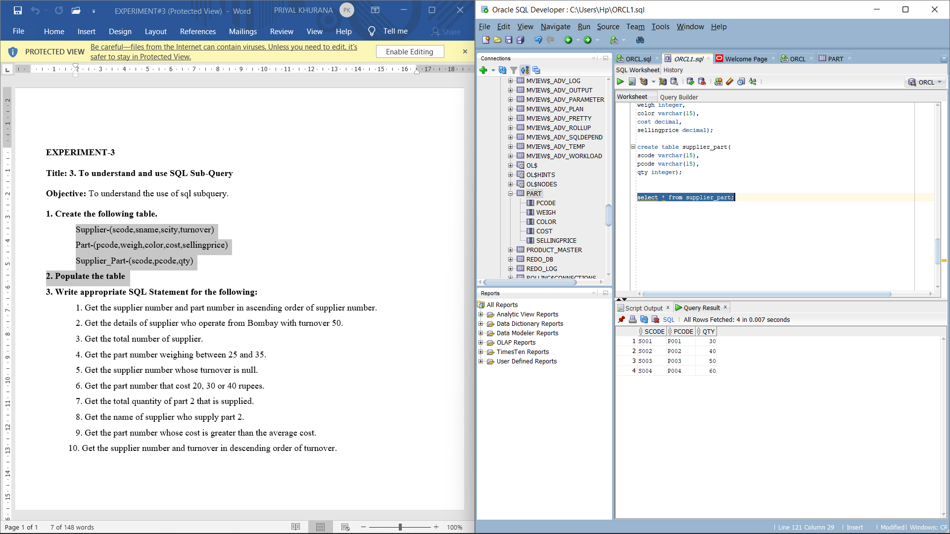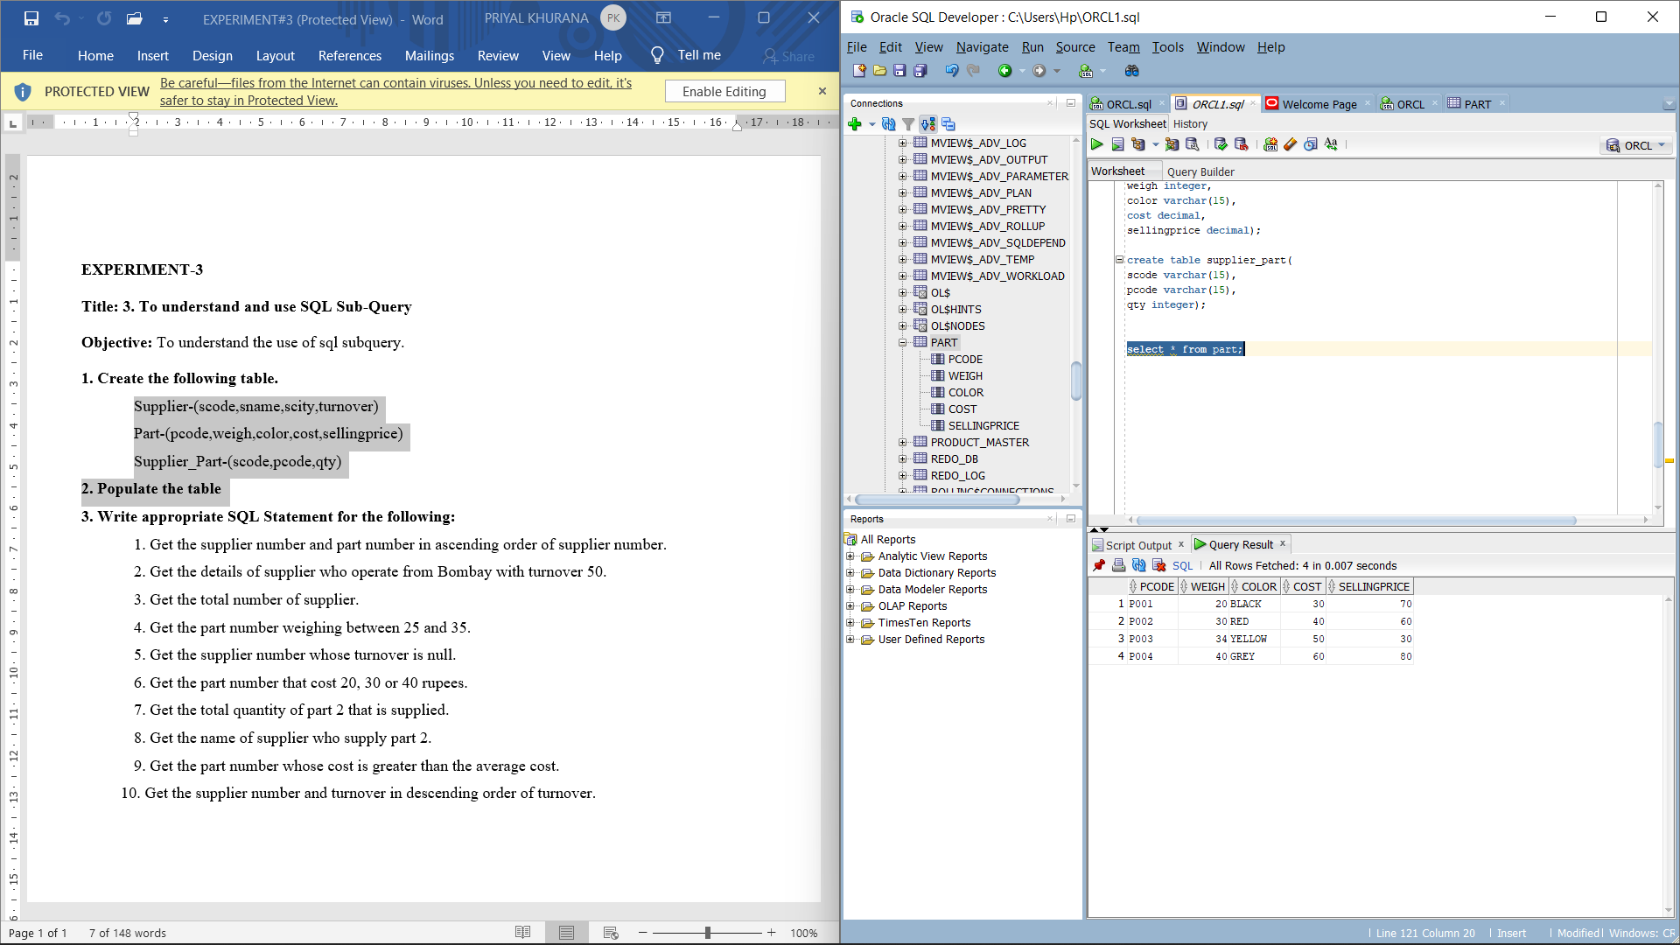

**3. Write appropriate SQL Statement for the following:**

1. Get the supplier number and part number in ascending order of supplier number.

Command: select scode, pcode from supplier_part order by scode asc;

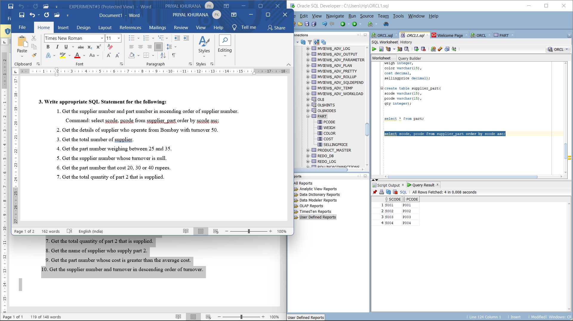

2. Get the details of supplier who operate from Bombay with turnover 50.

Command: select * from supplier where scity='BOMBAY' and turnover=50;

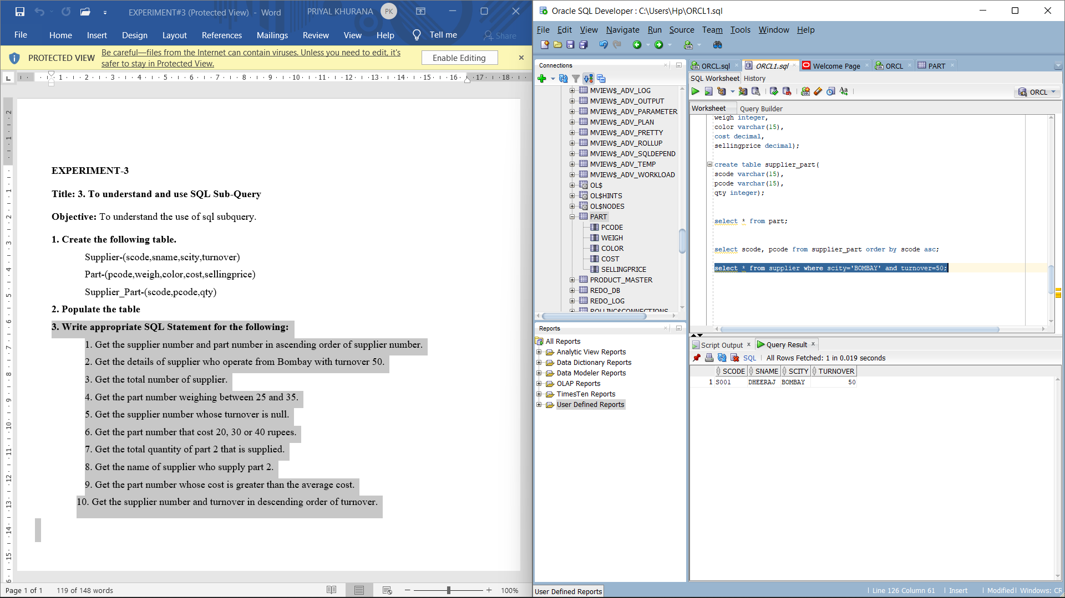

3. Get the total number of supplier.

Command: select COUNT(DISTINCT SCODE) FROM SUPPLIER;

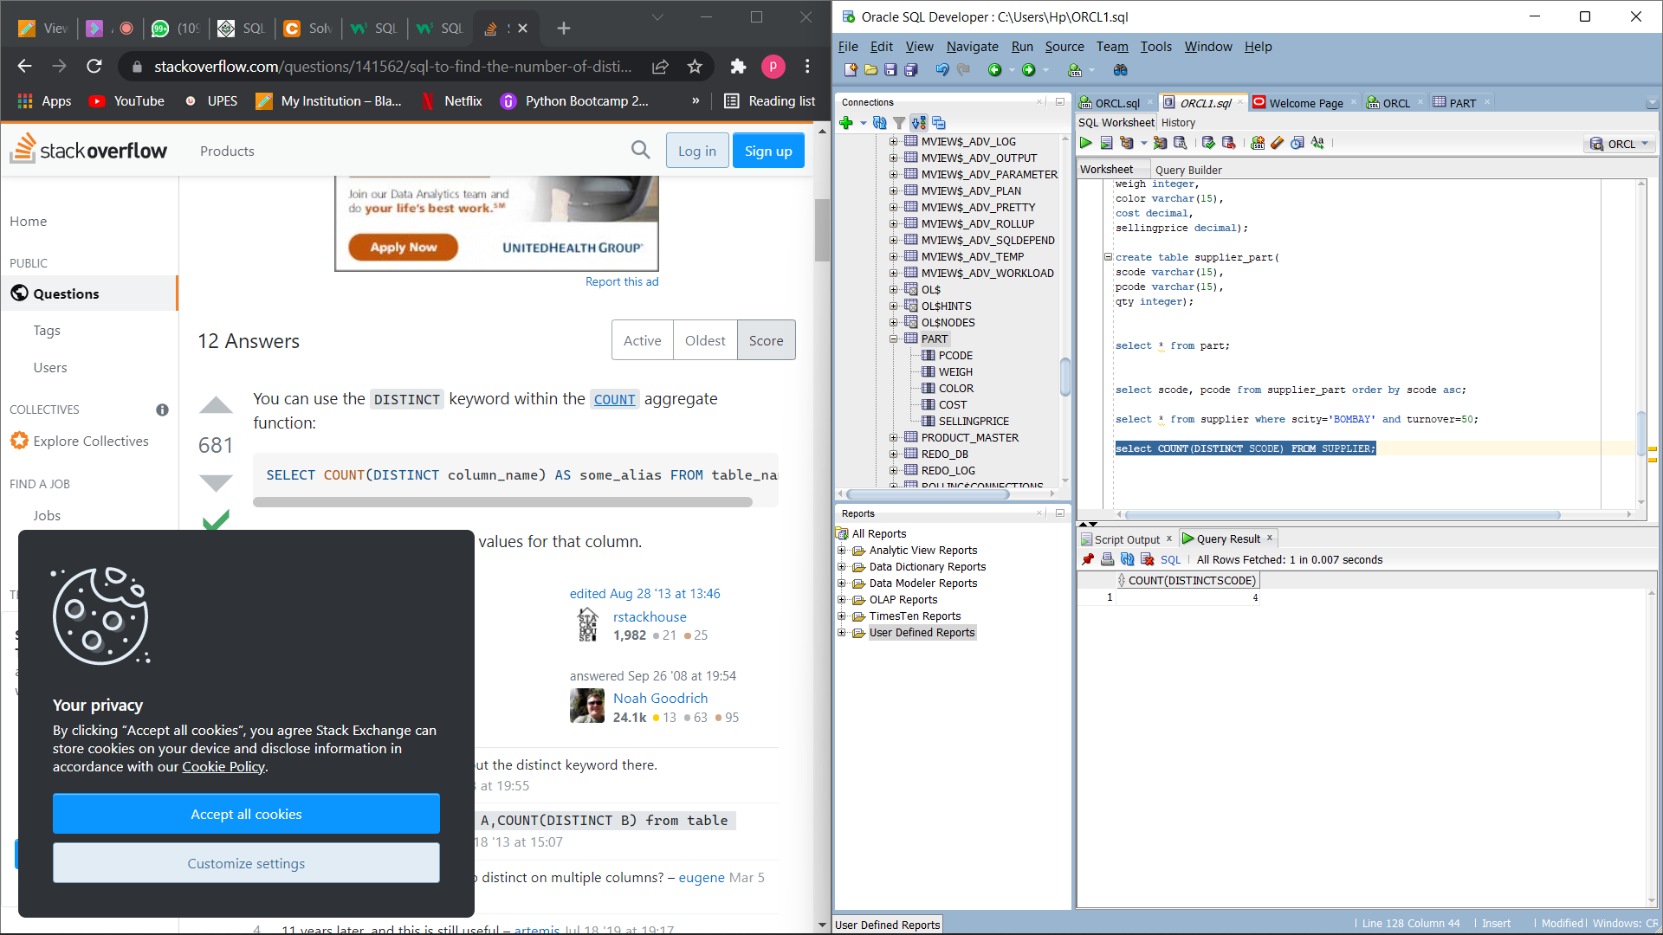

4. Get the part number weighing between 25 and 35.

Command: SELECT * FROM PART WHERE WEIGH>25 AND WEIGH<35;

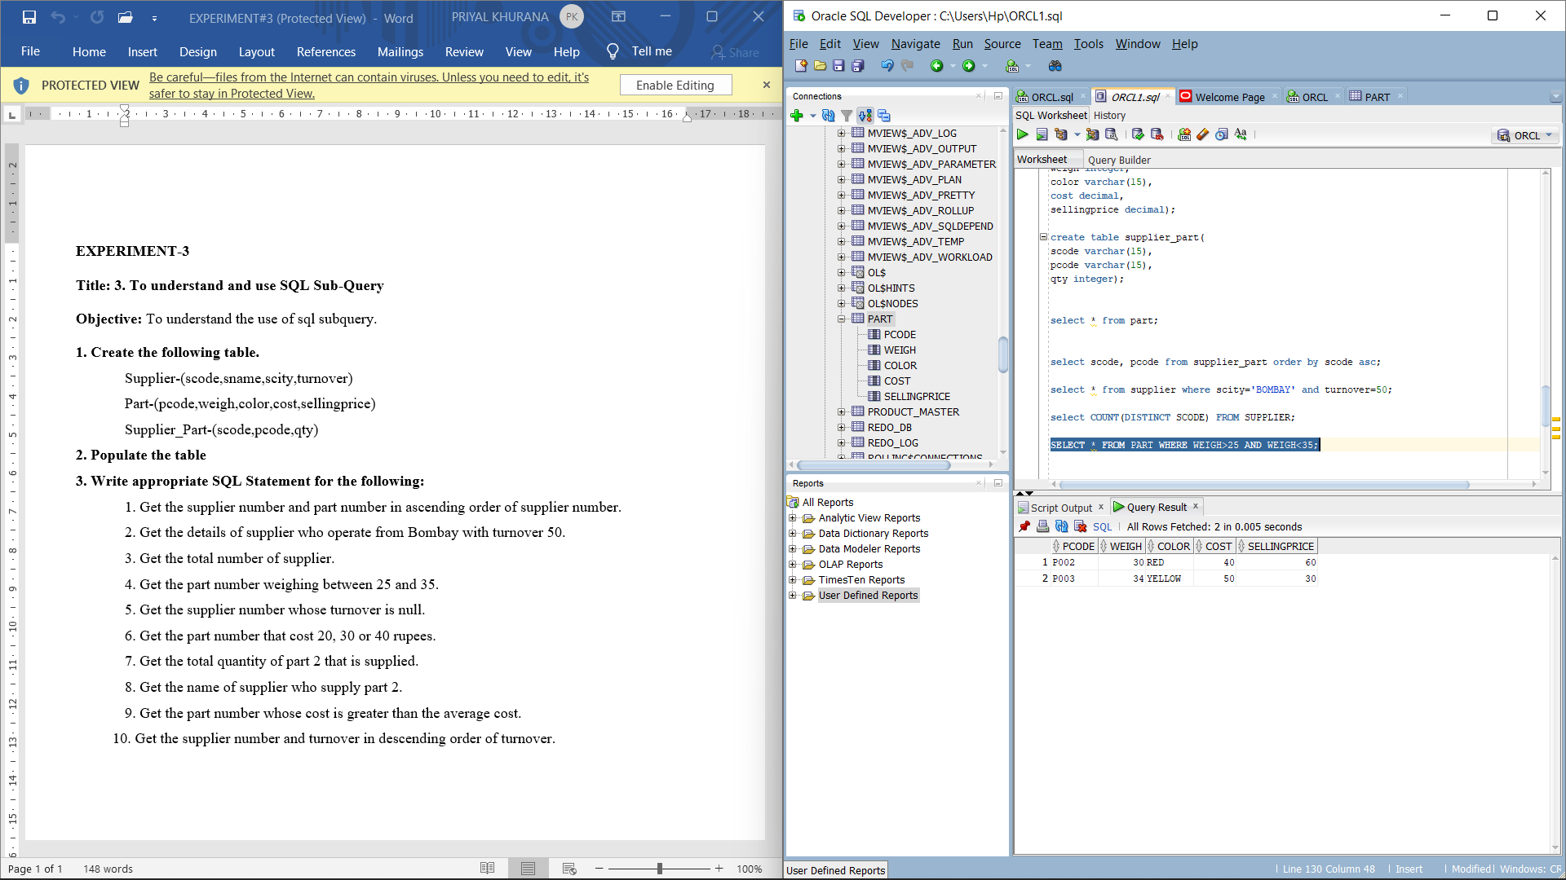

5. Get the supplier number whose turnover is null.

Command: SELECT SCODE FROM SUPPLIER WHERE TURNOVER=0;

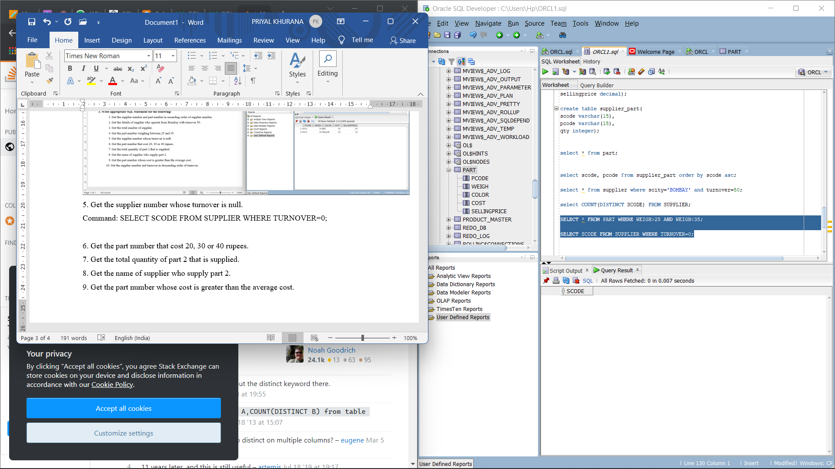

6. Get the part number that cost 20, 30 or 40 rupees.

Command: select pcode from part where cost= 20 or cost= 30 or cost=30;

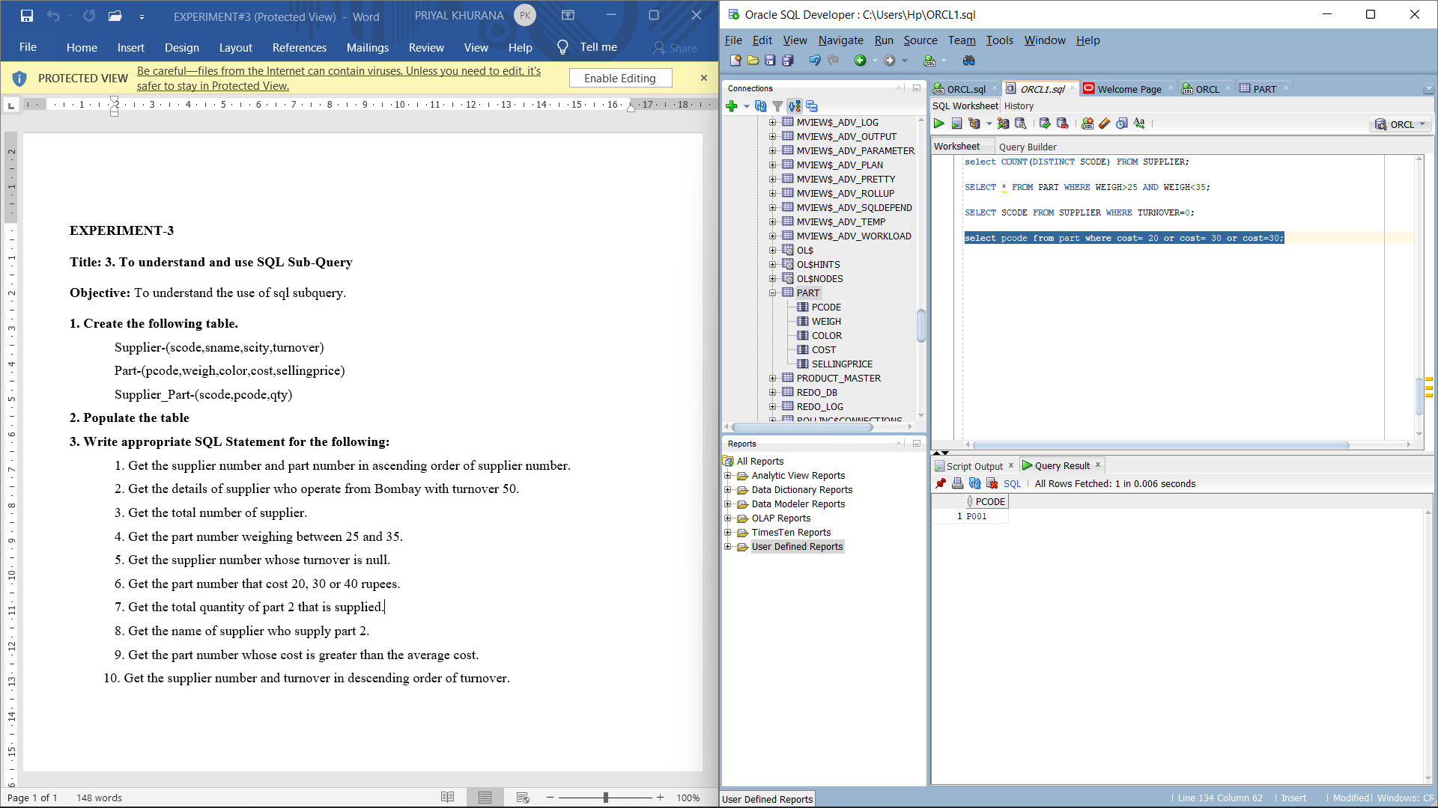

7. Get the total quantity of part 2 that is supplied.

Commands:

ALTER TABLE SUPPLIER

ADD PRIMARY KEY (SCODE);

ALTER TABLE SUPPLIER_PART

ADD CONSTRAINT SCODE

FOREIGN KEY (SCODE) REFERENCES SUPPLIER(SCODE);

select * from supplier

where scode=(select scode from supplier_part where pcode='P002');

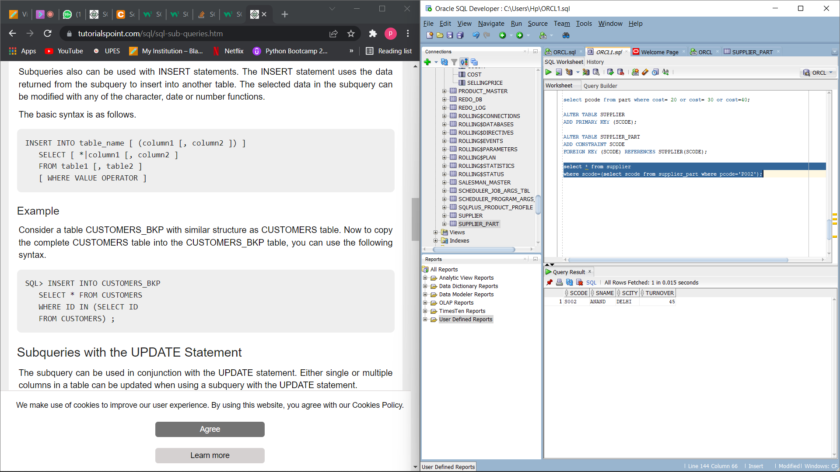

8. Get the name of supplier who supply part 2.

Command: SELECT SNAME FROM SUPPLIER

WHERE SCODE=(SELECT SCODE FROM SUPPLIER_PART WHERE PCODE='P002');

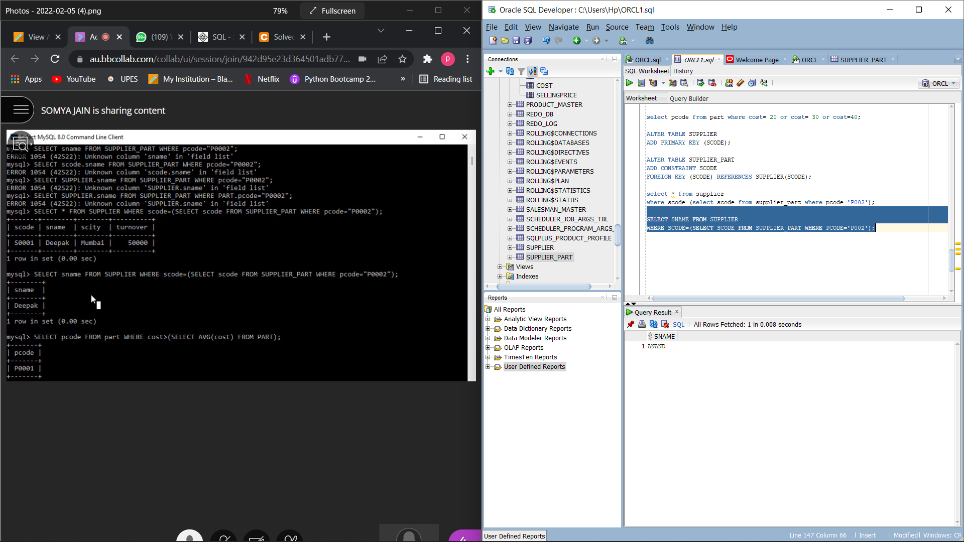

9. Get the part number whose cost is greater than the average cost.

Command: SELECT PCODE FROM PART WHERE COST>(SELECT AVG(COST) FROM PART);

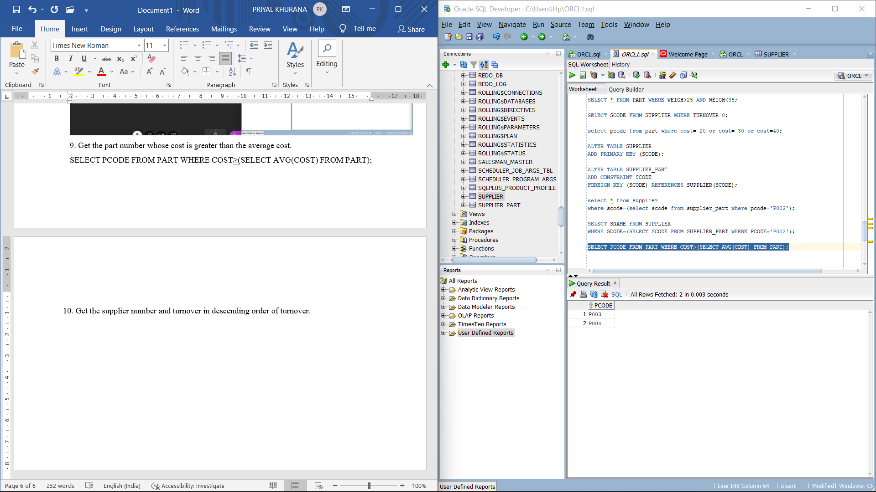

10. Get the supplier number and turnover in descending order of turnover.

Command:

SELECT SCODE,TURNOVER FROM SUPPLIER ORDER BY TURNOVER DESC;

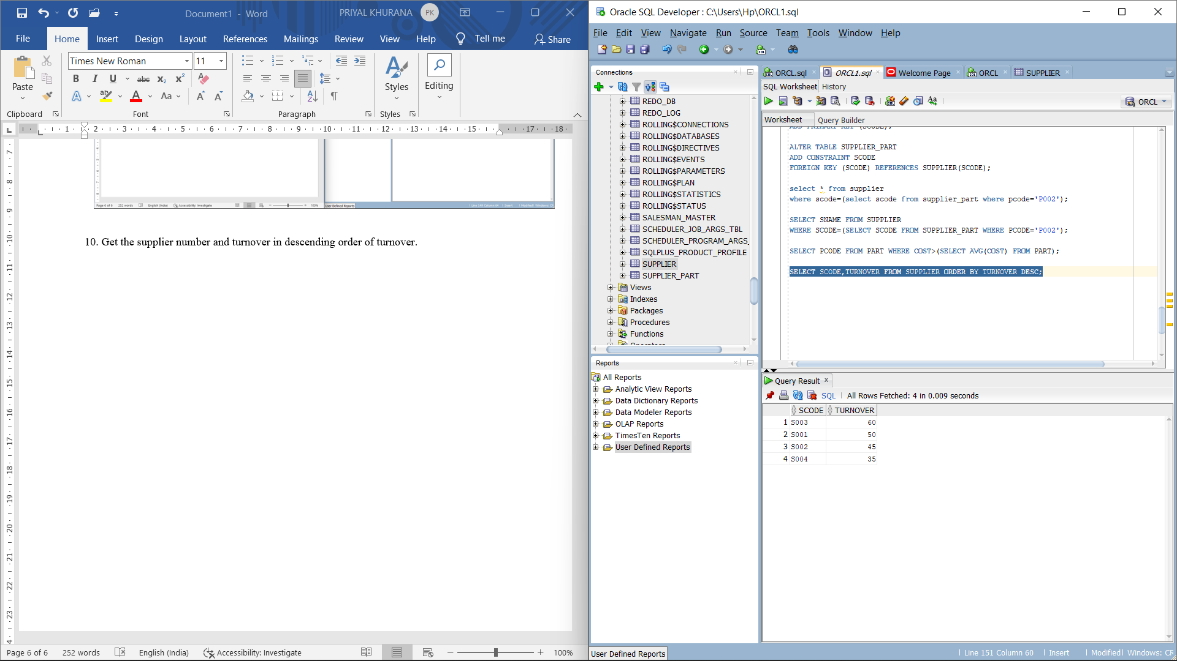

**EXPERIMENT-4**

LAB EXPERIMENT: Use of Inbuilt functions and relational algebra operation

OBJECTIVE: To understand the use of inbuilt function and relational algebra with sql query.

**Table creation:**

create table EMP(

empno integer,

ename varchar(15),

job varchar(15),

mgr integer,

hiredate date,

sal integer,

comm integer,

deptno integer primary key

);

ALTER TABLE EMP

DROP PRIMARY KEY;

SELECT * FROM EMP;

create table DEPT(

deptno integer primary key,

dname varchar(15),

loc varchar(15)

);

SELECT * FROM DEPT;

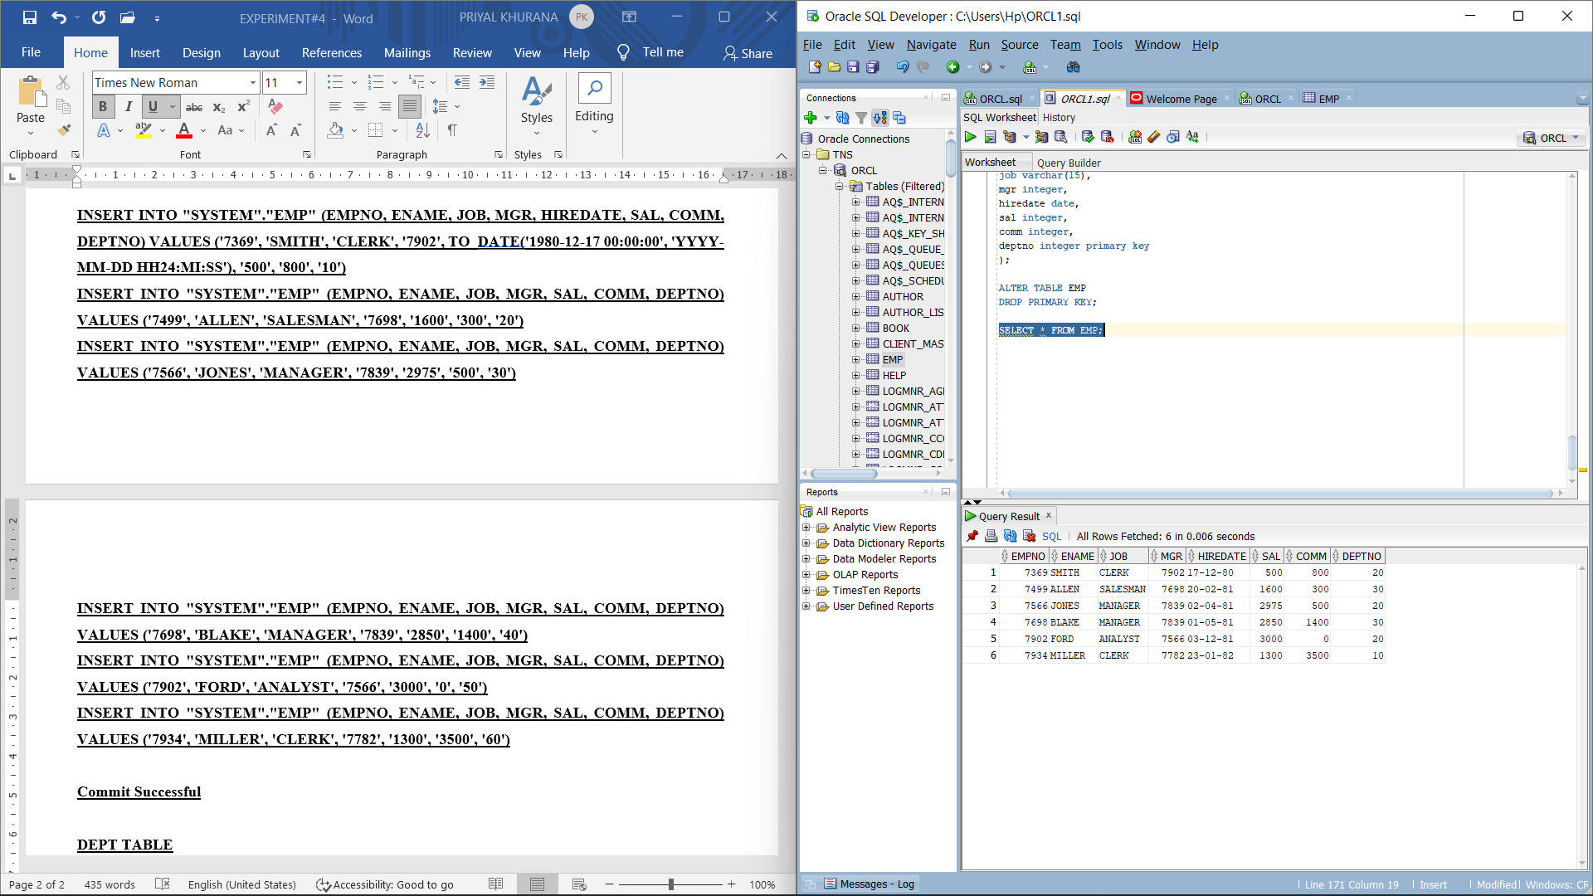

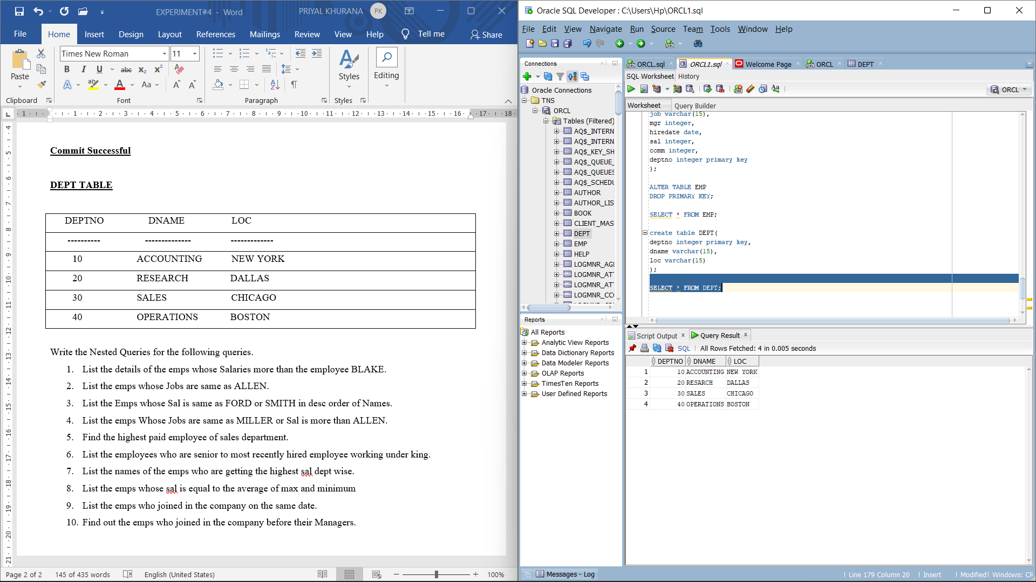

Write the Nested Queries for the following queries.

1. List the details of the emps whose Salaries more than the employee BLAKE.

Command: SELECT * FROM EMP WHERE SAL> (SELECT SAL FROM EMP WHERE ENAME='BLAKE');

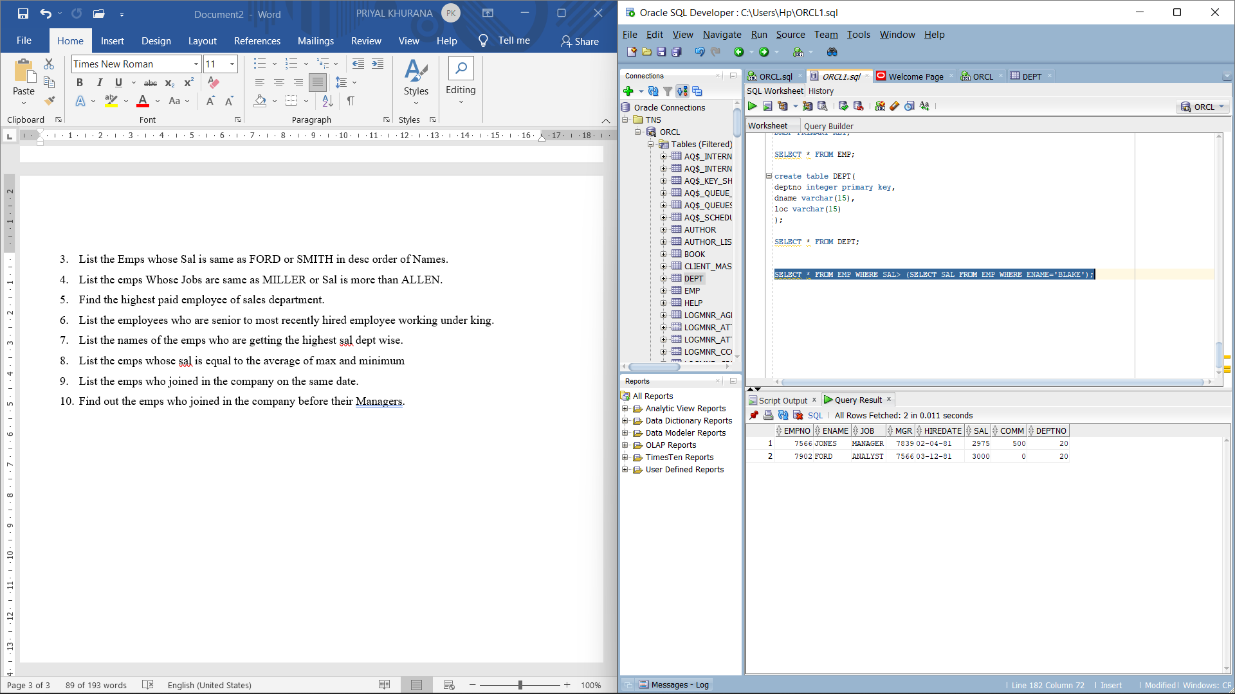

1. List the emps whose Jobs are same as ALLEN.

Command: SELECT * FROM EMP WHERE JOB IN (SELECT JOB FROM EMP WHERE ENAME='ALLEN');

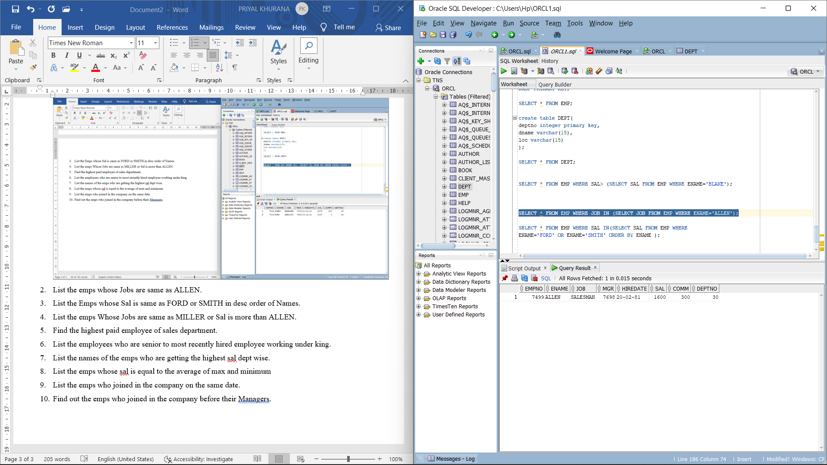

1. List the Emps whose Sal is same as FORD or SMITH in desc order of Names.

Command: select * from emp where ename='ford' or ename='smith' order by ename desc;

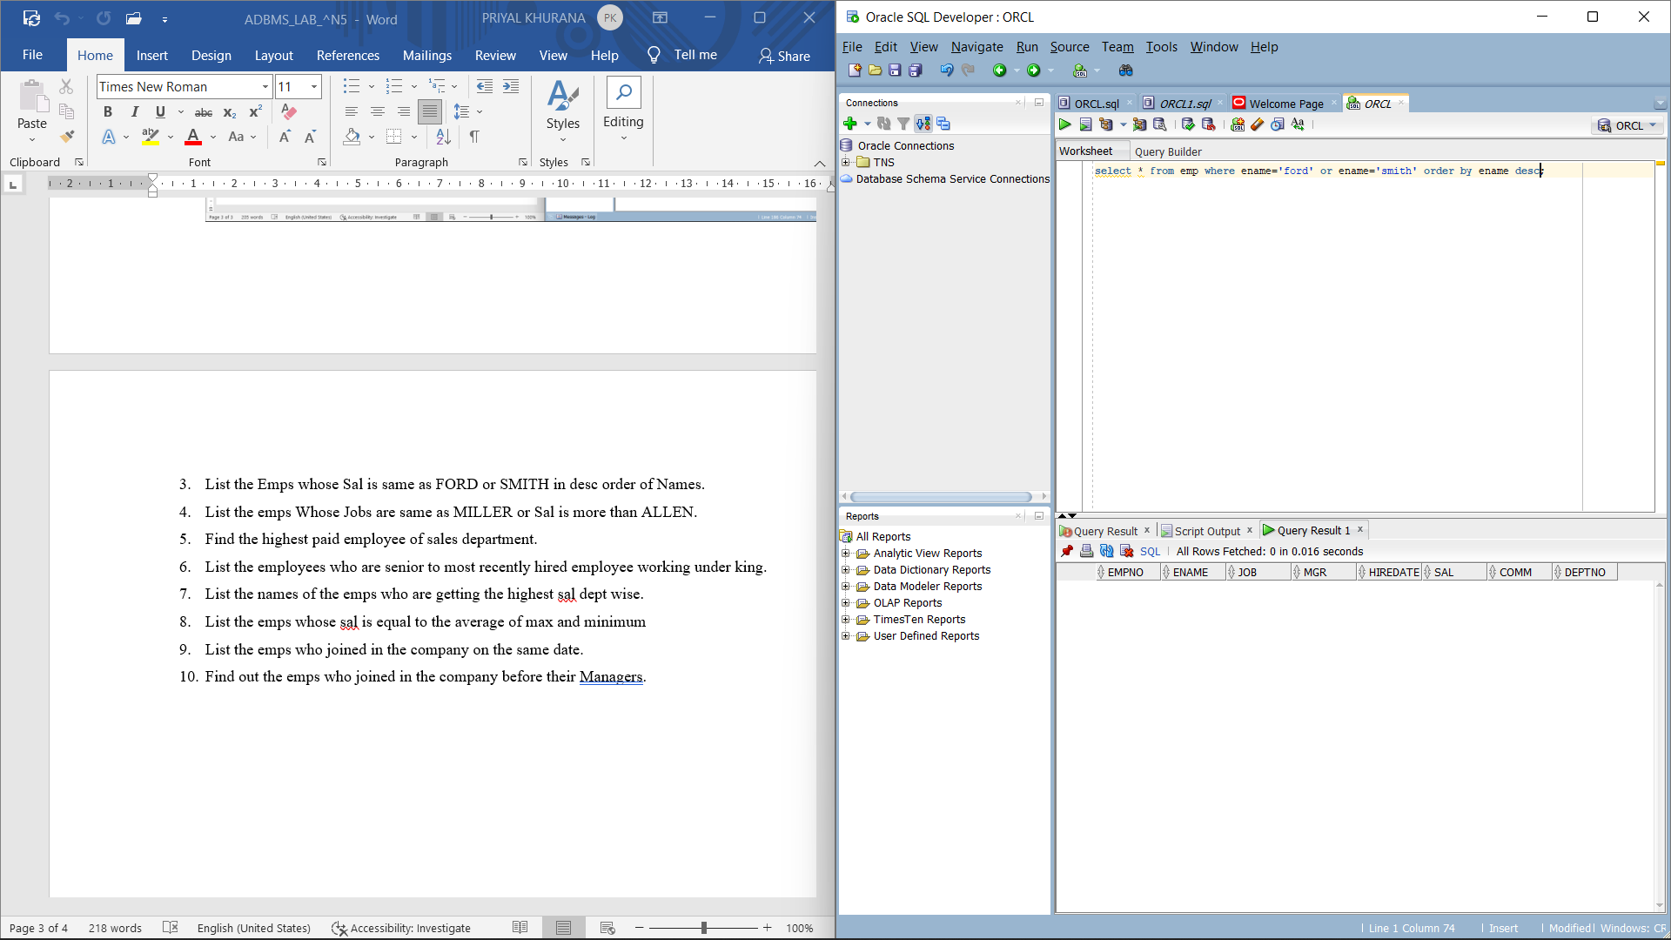

1. List the emps Whose Jobs are same as MILLER or Sal is more than ALLEN.

Command: Select * from Emp where job = (select job from emp where ename='MILLER')

OR Sal > (select sal from emp where ename ='ALLEN') ;

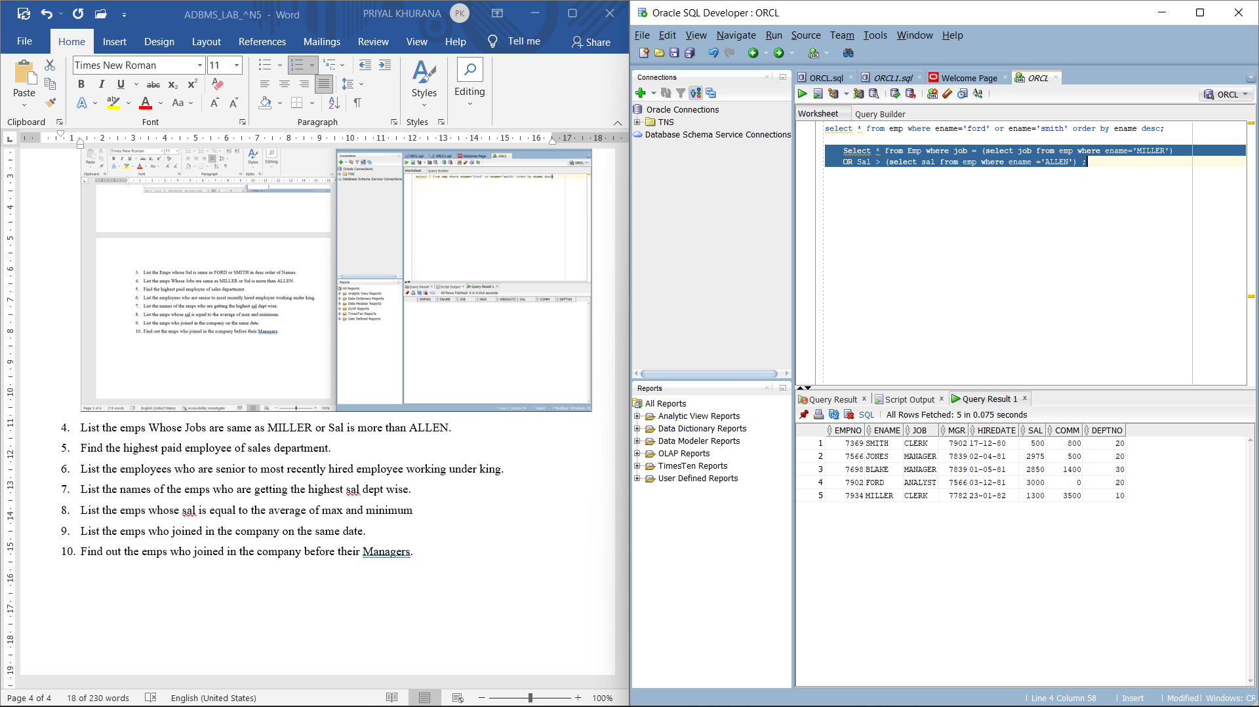

1. Find the highest paid employee of sales department.

Command: Select * from emp where sal = (select Max(sal) from emp) ;

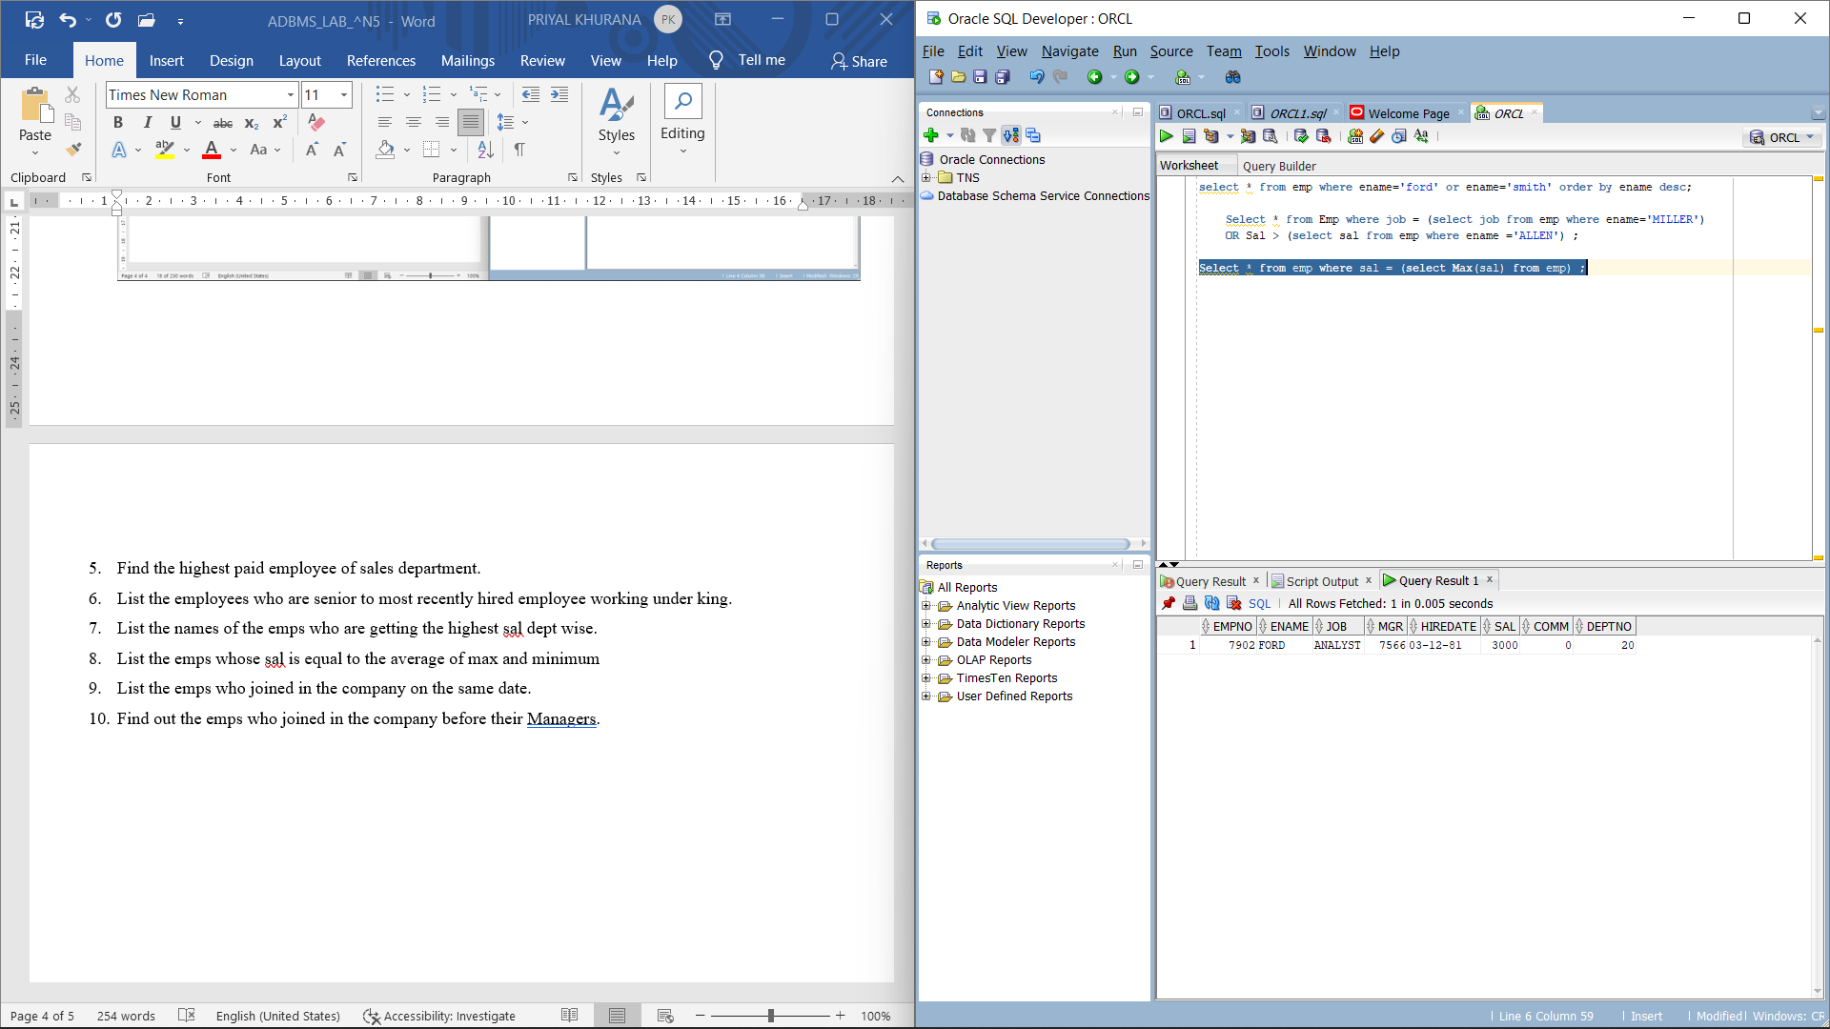

1. List the employees who are senior to most recently hired employee working under king.

Command: Select * from emp where hiredate < (Select max(hiredate) from emp) and

mgr=(select empno from emp where ename='KING') ;

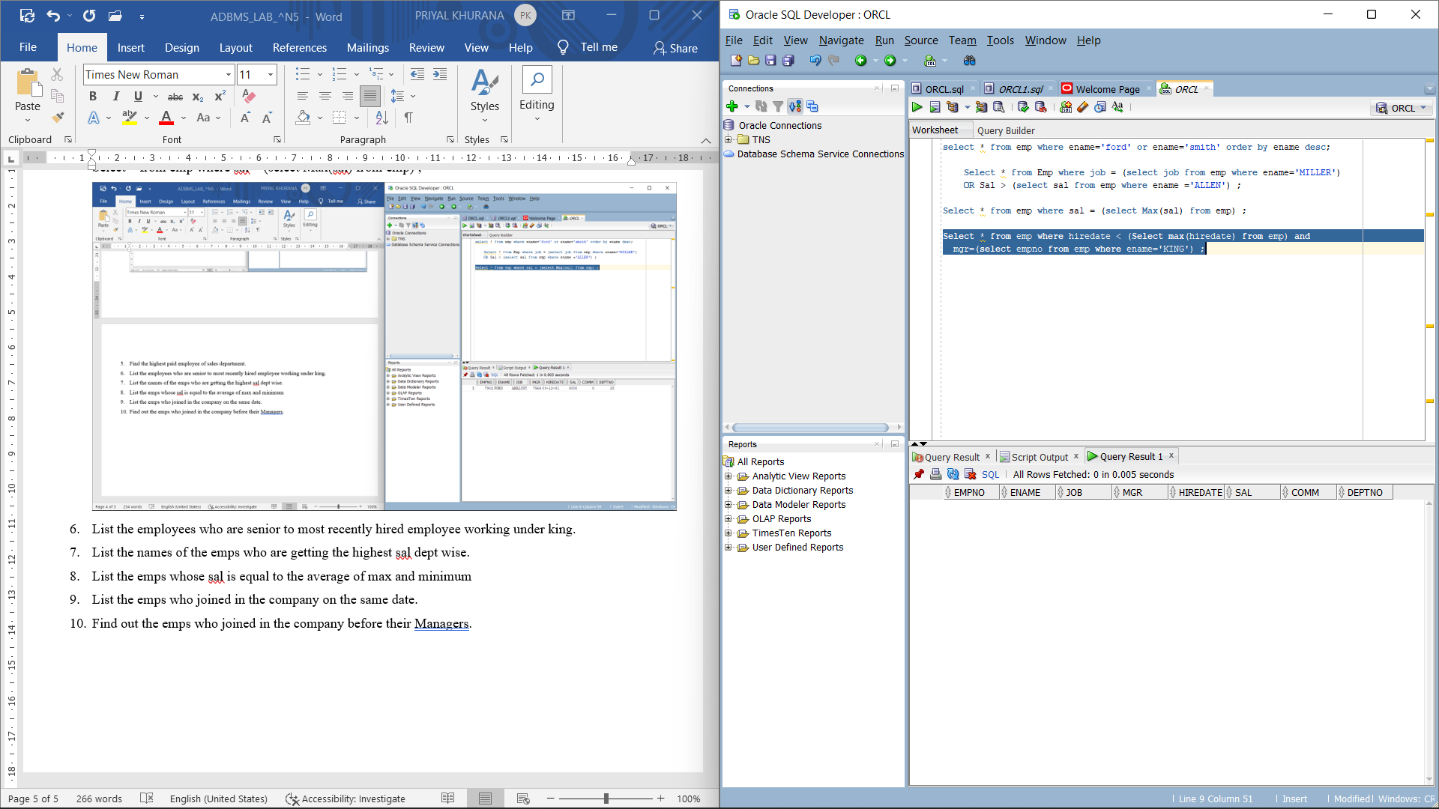

1. List the names of the emps who are getting the highest sal dept wise.

Command: select e.ename,e.deptno from emp e where e.sal in

(select max(sal) from emp group by deptno) ;

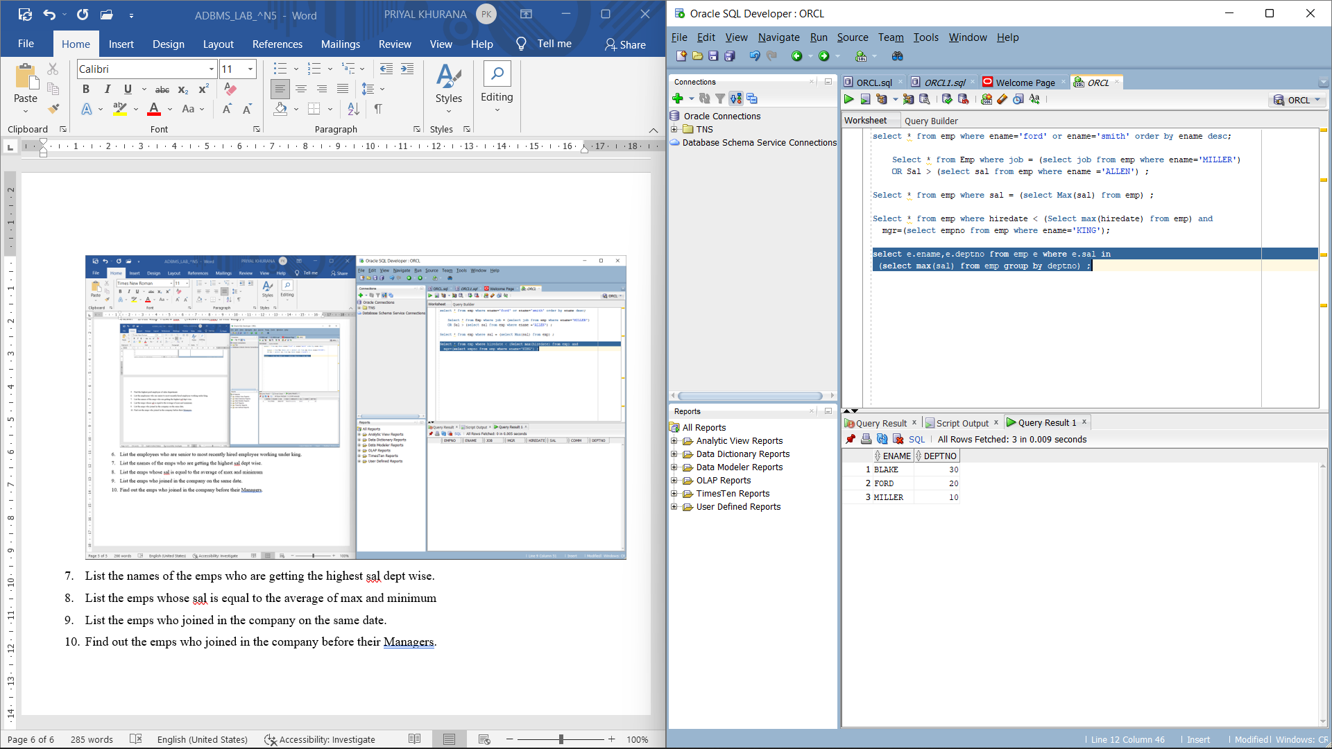

1. List the emps whose sal is equal to the average of max and minimum

Command: select * from emp where sal =(select (max(sal)+min(sal))/2 from emp);

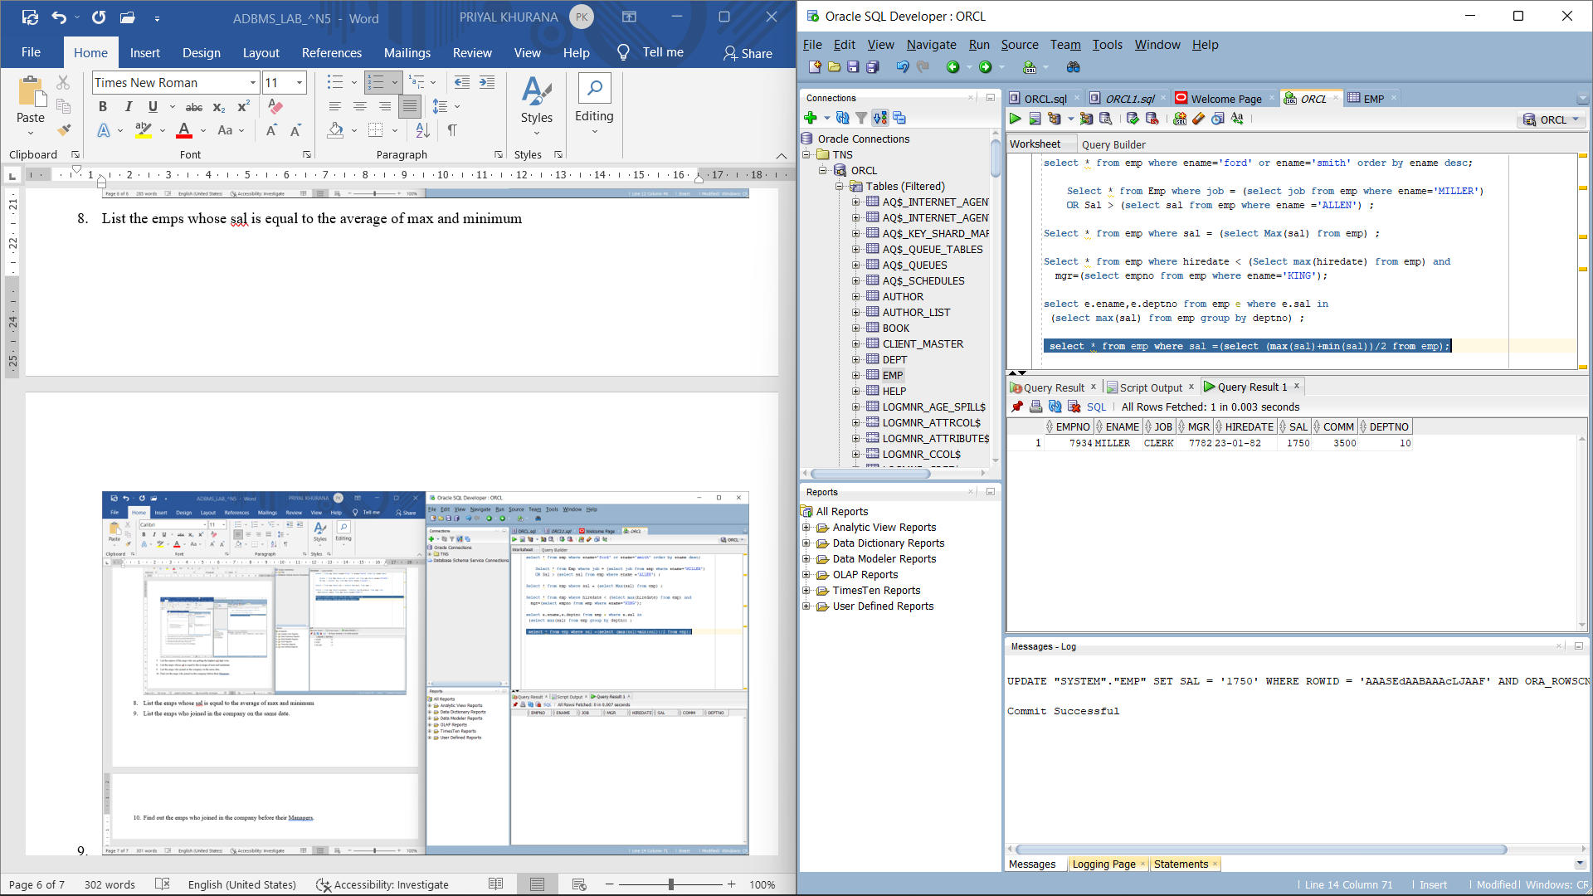

1. List the emps who joined in the company on the same date.

Command: select * from emp e where hiredate in

(select hiredate from emp where e.empno <> empno);

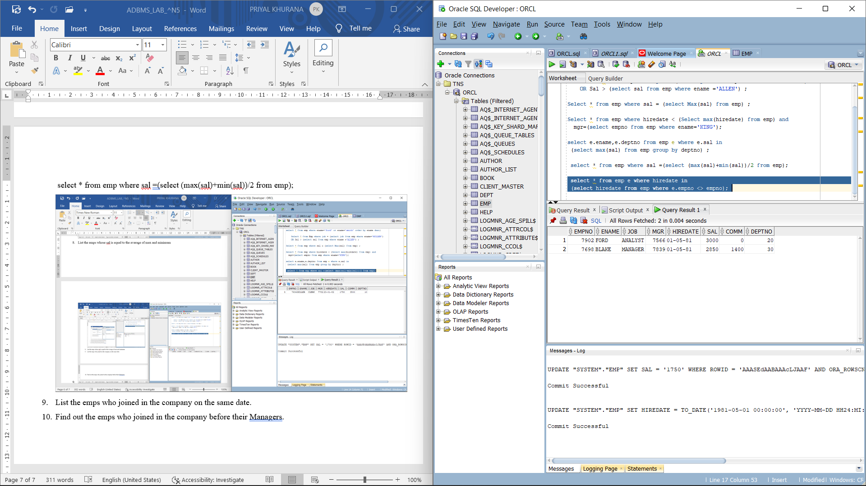

1. Find out the emps who joined in the company before their Managers.

Command: select * from emp where hiredate < (select hiredate from emp where JOB='MANAGER');

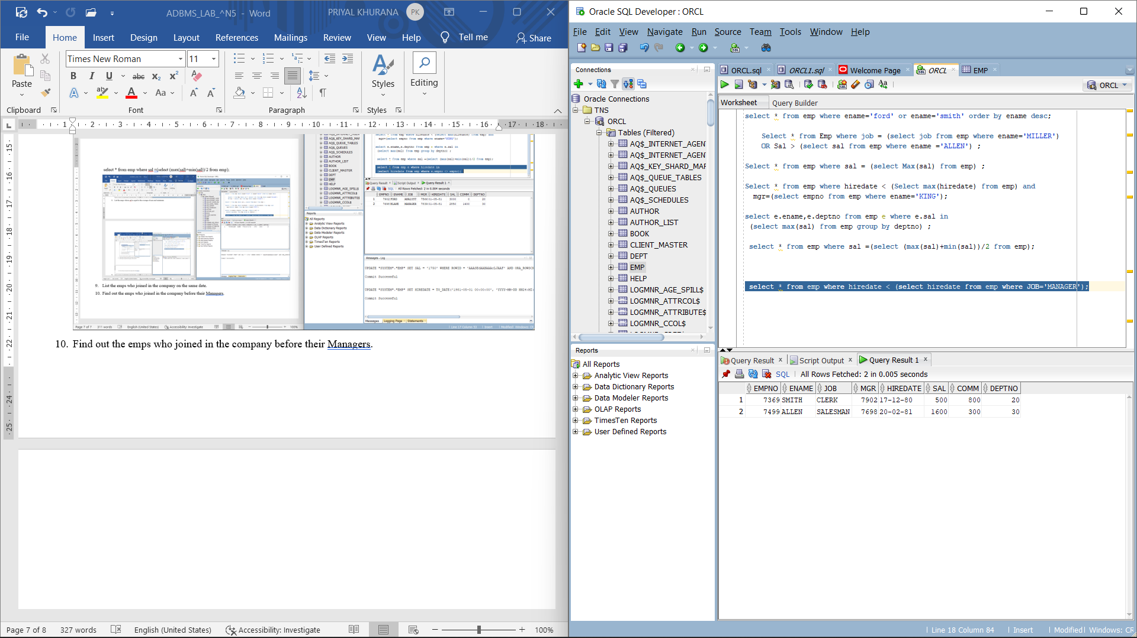

**EXPERIMENT-5**

LAB EXPERIMENT: Use of different SQL clauses and join

OBJECTIVE: To understand the use of group by and having clause and execute the SQL commands using JOIN

EXERCISE:

1. List the Deptno where there are no emps.

SELECT DNAME,DEPTNO FROM DEPT D WHERE NOT EXISTS (SELECT * FROM EMP E WHERE D.DEPTNO= E.DEPTNO);

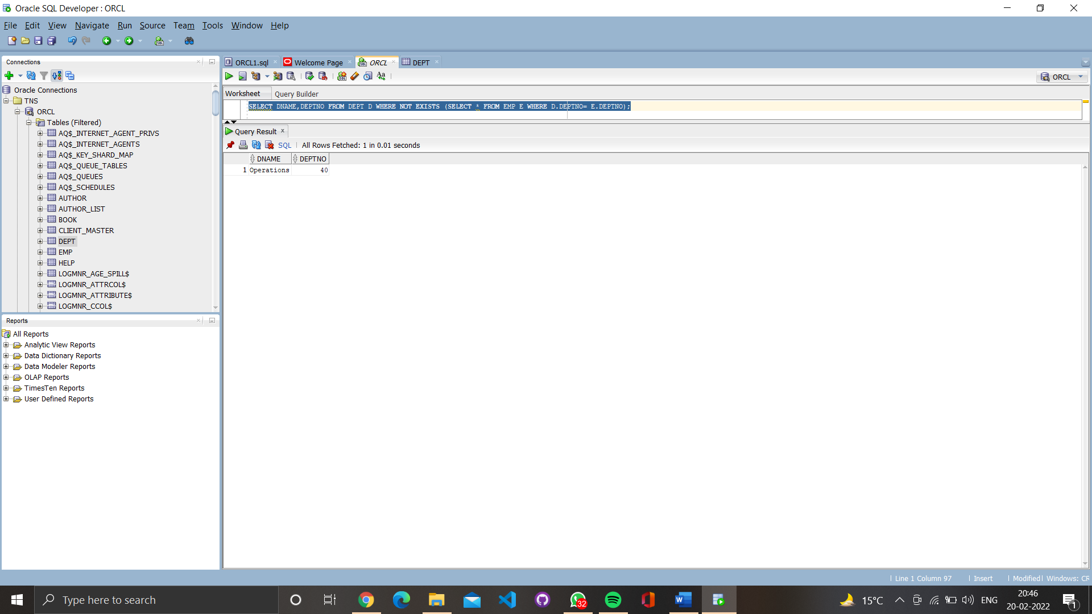

1. List the No.of emp’s and Avg salary within each department for each job.

SELECT COUNT(*), AVG(SAL), DEPTNO, JOB FROM EMP GROUP BY DEPTNO,JOB;

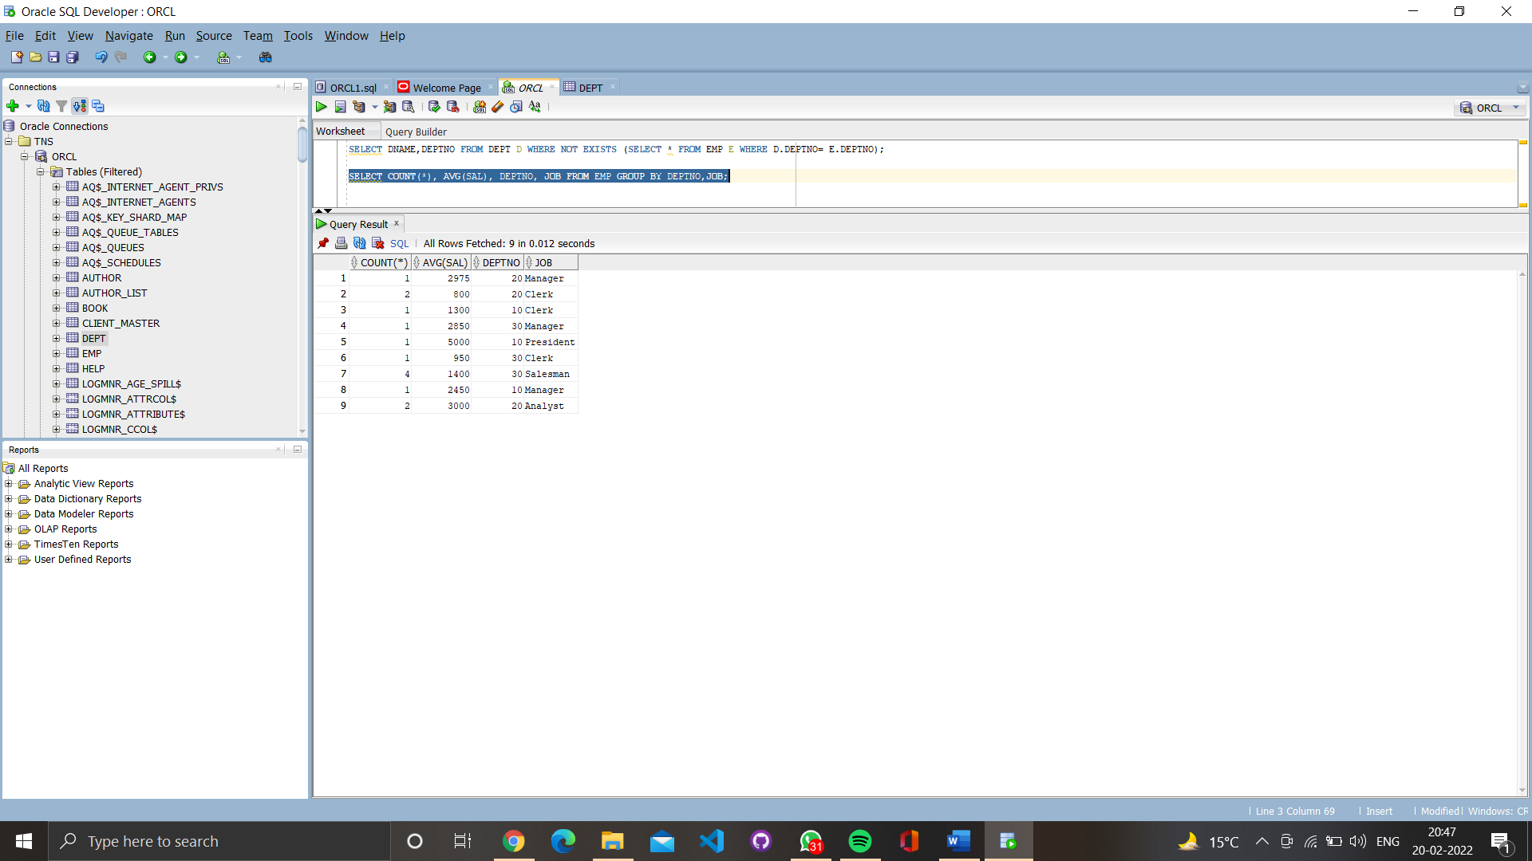

1. Find the maximum average salary drawn for each job except for ‘President’.

SELECT MAX(AVG1) FROM (SELECT AVG(SAL) AVG1 FROM EMP WHERE JOB != 'President' GROUP BY JOB) K;

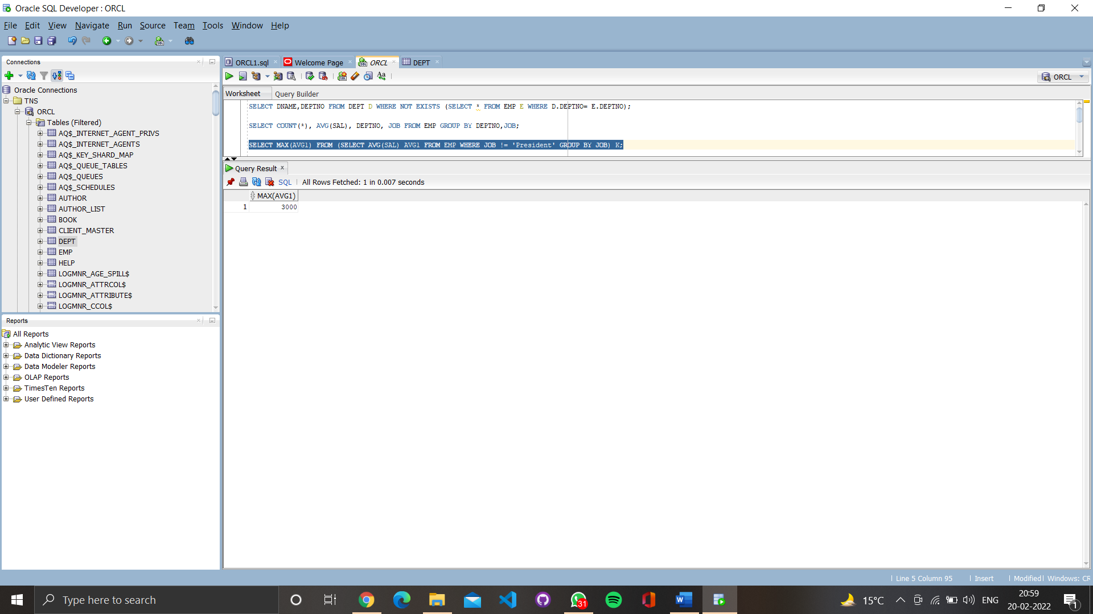

4.   List the department details where at least two emps are working.

SELECT DEPTNO, COUNT(*) FROM EMP GROUP BY DEPTNO HAVING COUNT(*) >=2;

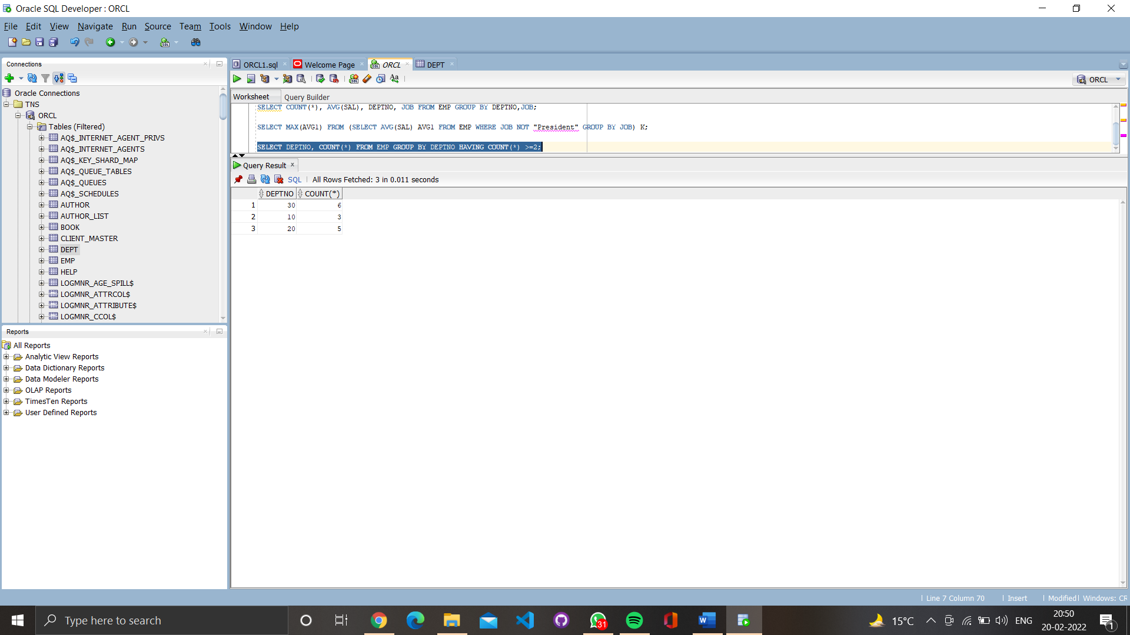

5.   List the no. of emps in each department where the no. is more than 3.

SELECT DEPTNO, COUNT(*) FROM EMP GROUP BY DEPTNO HAVING COUNT(*)>3;

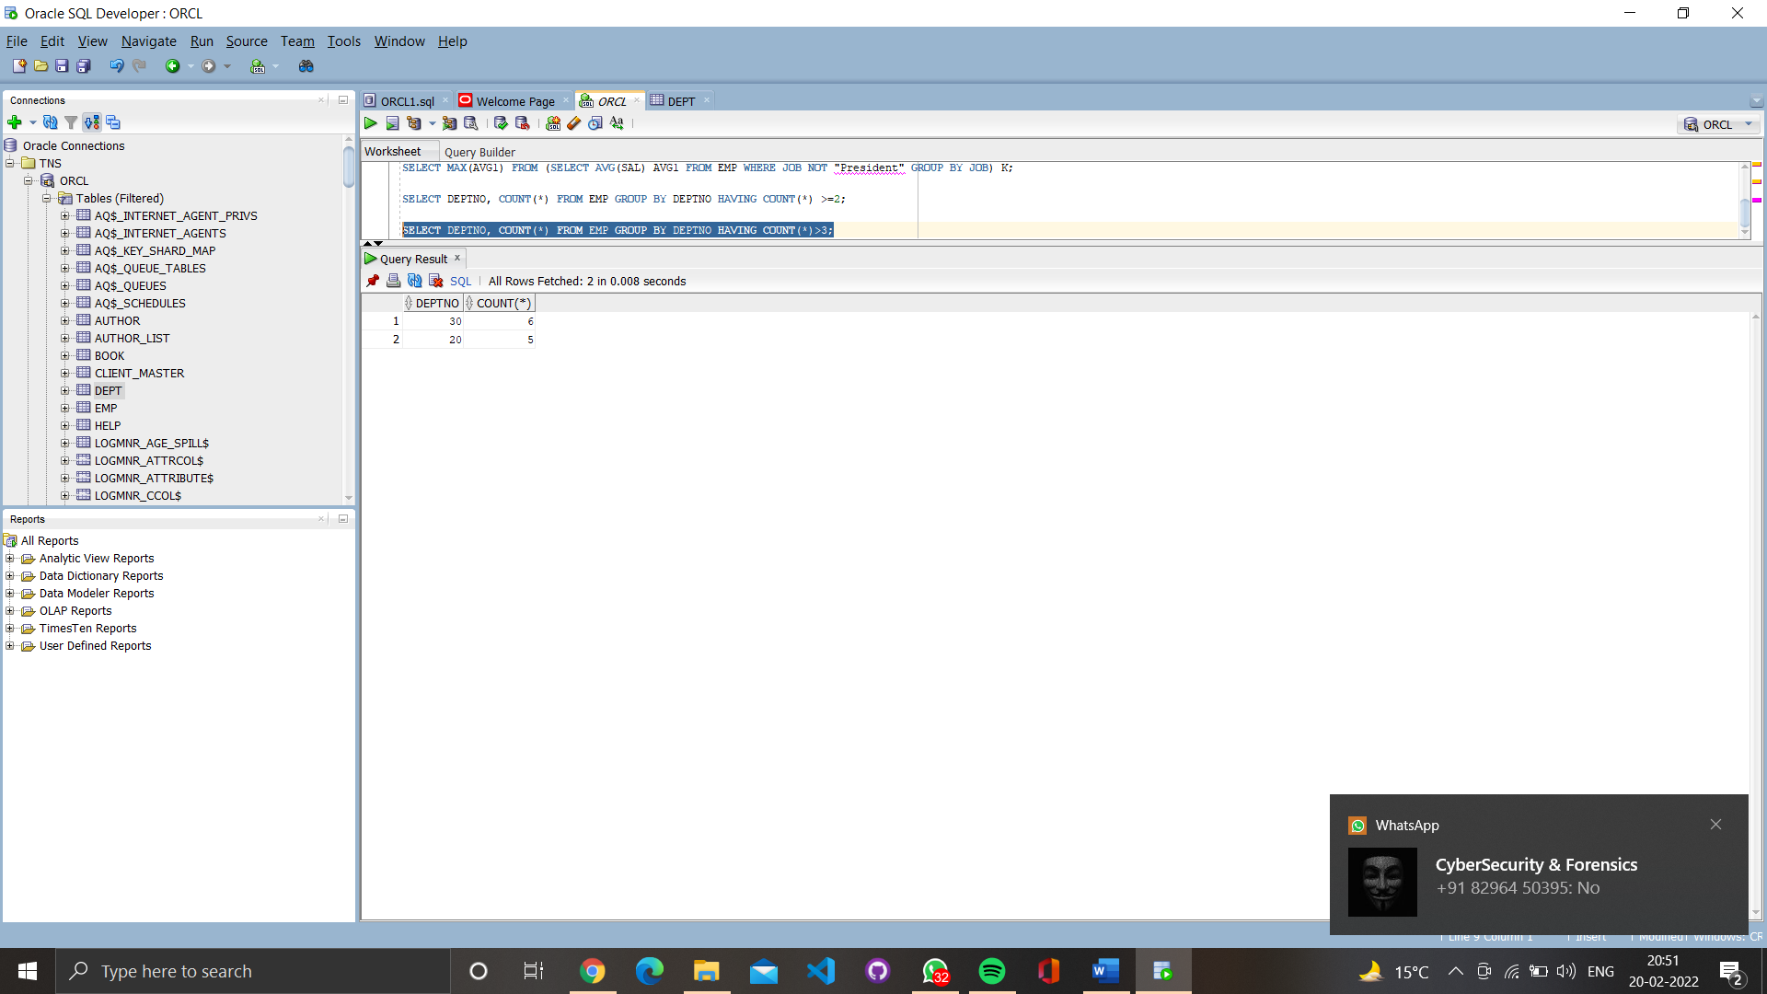

1. List the names of the emps who are getting the highest sal dept wise.

SELECT ENAME,DEPTNO FROM EMP E WHERE E.SAL IN (SELECT MAX(SAL) FROM EMP GROUP BY DEPTNO);

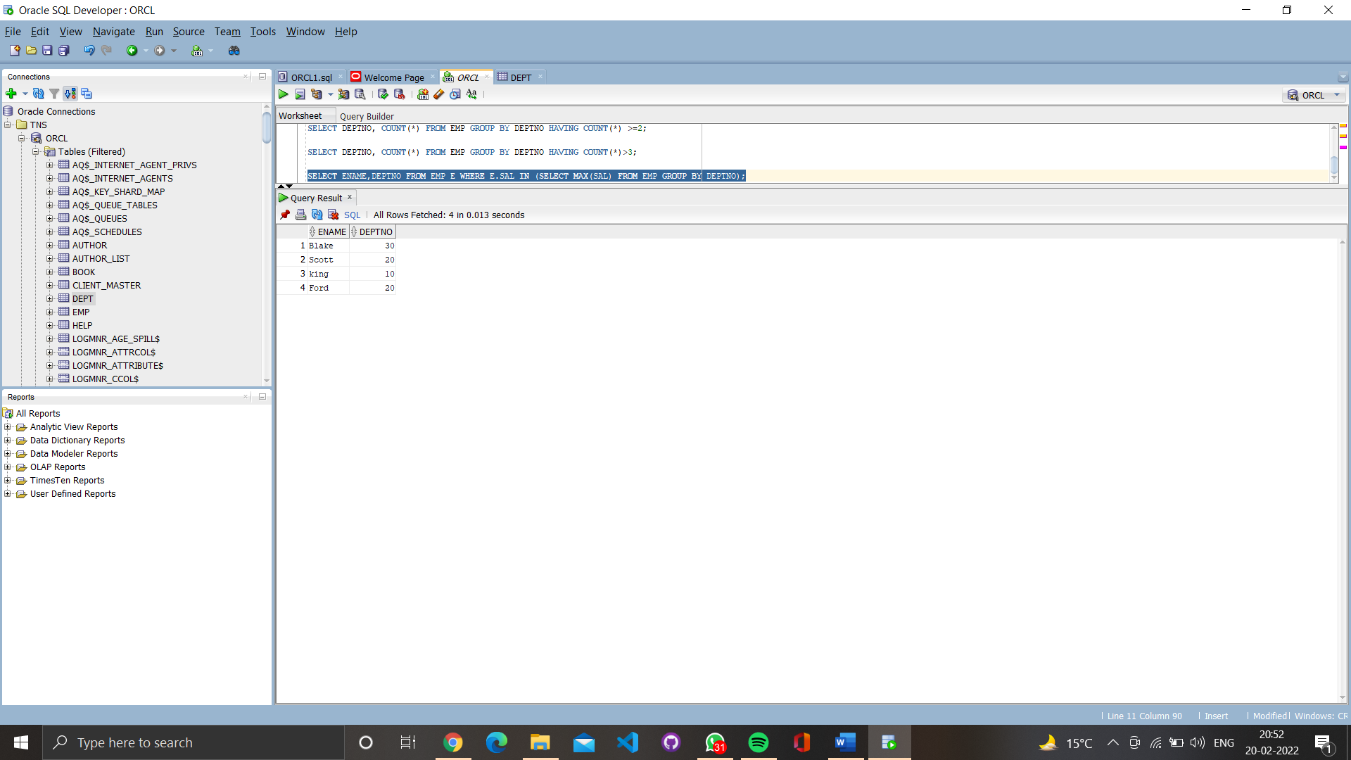

1. List the Deptno and their average salaries for dept with the average salary less than the averages for all departments.

SELECT deptno, avg(sal) FROM emp GROUP BY deptno HAVING avg(sal) < (SELECT avg(sal) FROM emp);

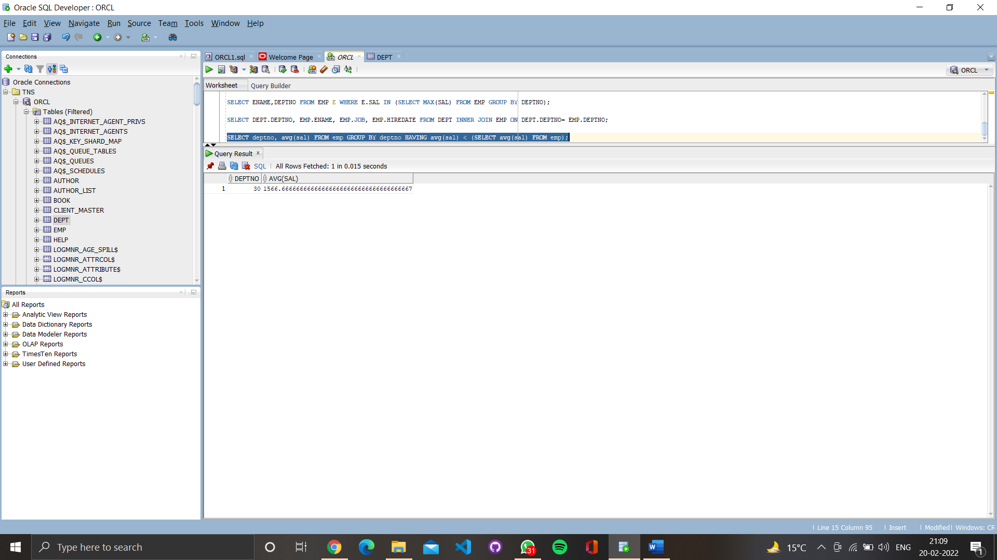

2. **Execute the experiment 4 using sql join.**

**SELECT DEPT.DEPTNO, EMP.ENAME, EMP.JOB, EMP.HIREDATE FROM DEPT INNER JOIN EMP ON DEPT.DEPTNO= EMP.DEPTNO;**

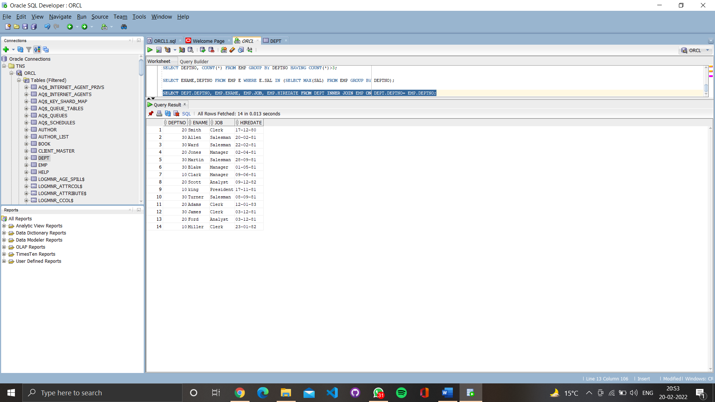

**EXPERIMENT-6**

LAB EXPERIMENT: To understand the concepts of Views.

OBJECTIVE: : Students will be able to implement the concept of views.

1. **Create table of table name: EMPLOYEES**

Command: create TABLE employees

(

"Employee_id" varchar(10) primary key,

"first_name" varchar(30) NOT NULL,

"last_name" varchar(30) NOT NULL,

"DOB" date,

"salary" integer NOT NULL,

"Cdepartment_id" varchar(10)

);

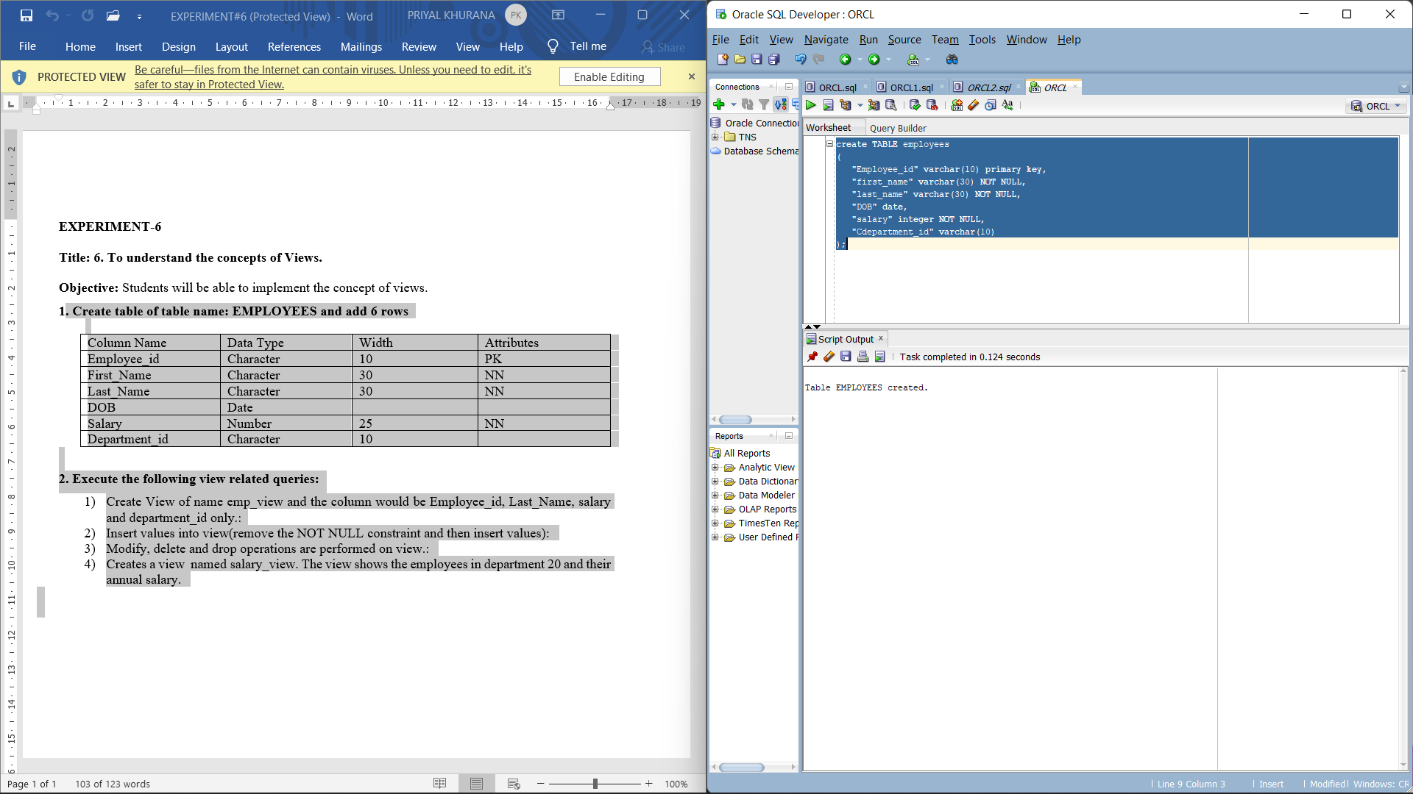

Command: SELECT * FROM EMPLOYEES;

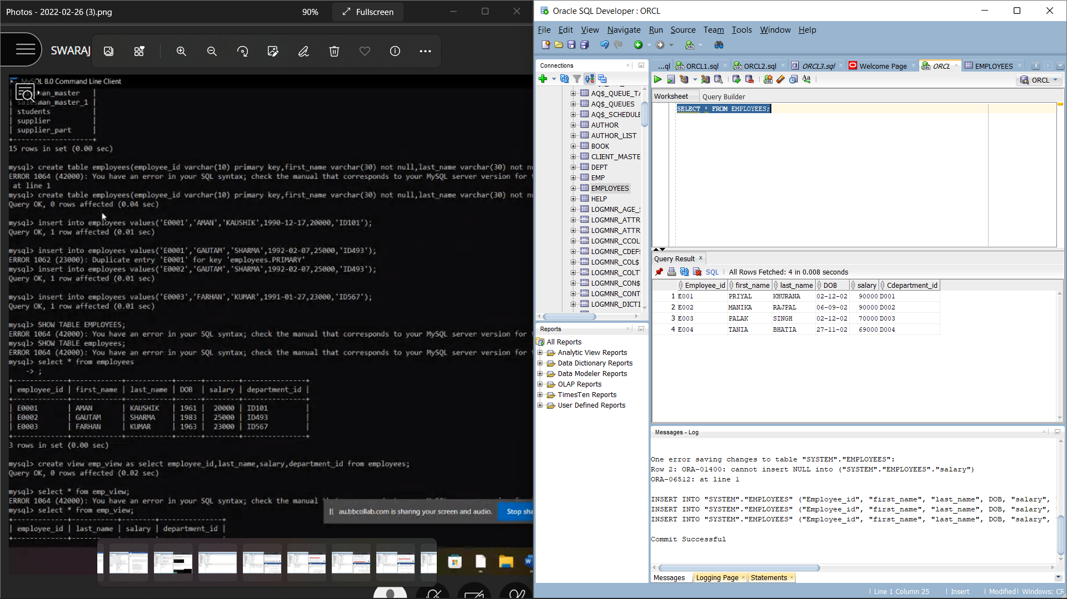

**2. Execute the following view related queries:**

1. Create View of name emp_view and the column would be Employee_id, Last_Name, salary and department_id only:

Command: CREATE VIEW EMP_VIEW AS SELECT "Employee_id", "last_name", "salary",

"Cdepartment_id" FROM EMPLOYEES;

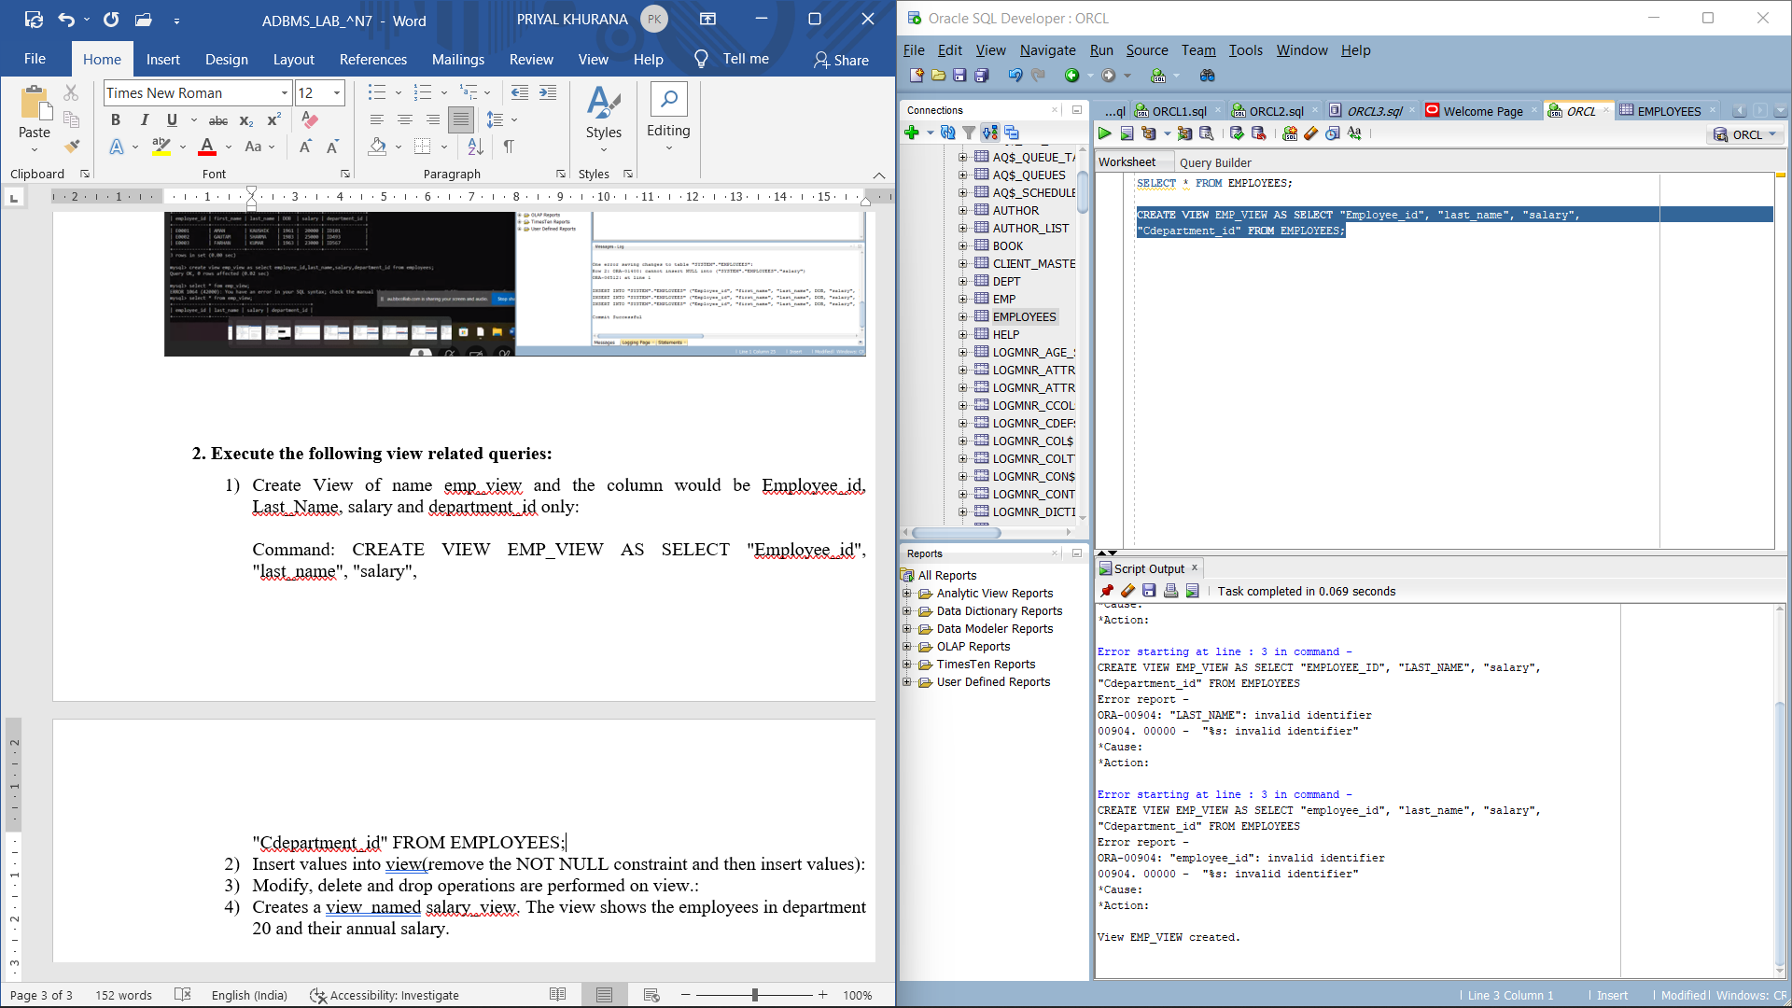

Command: select * from emp_view;

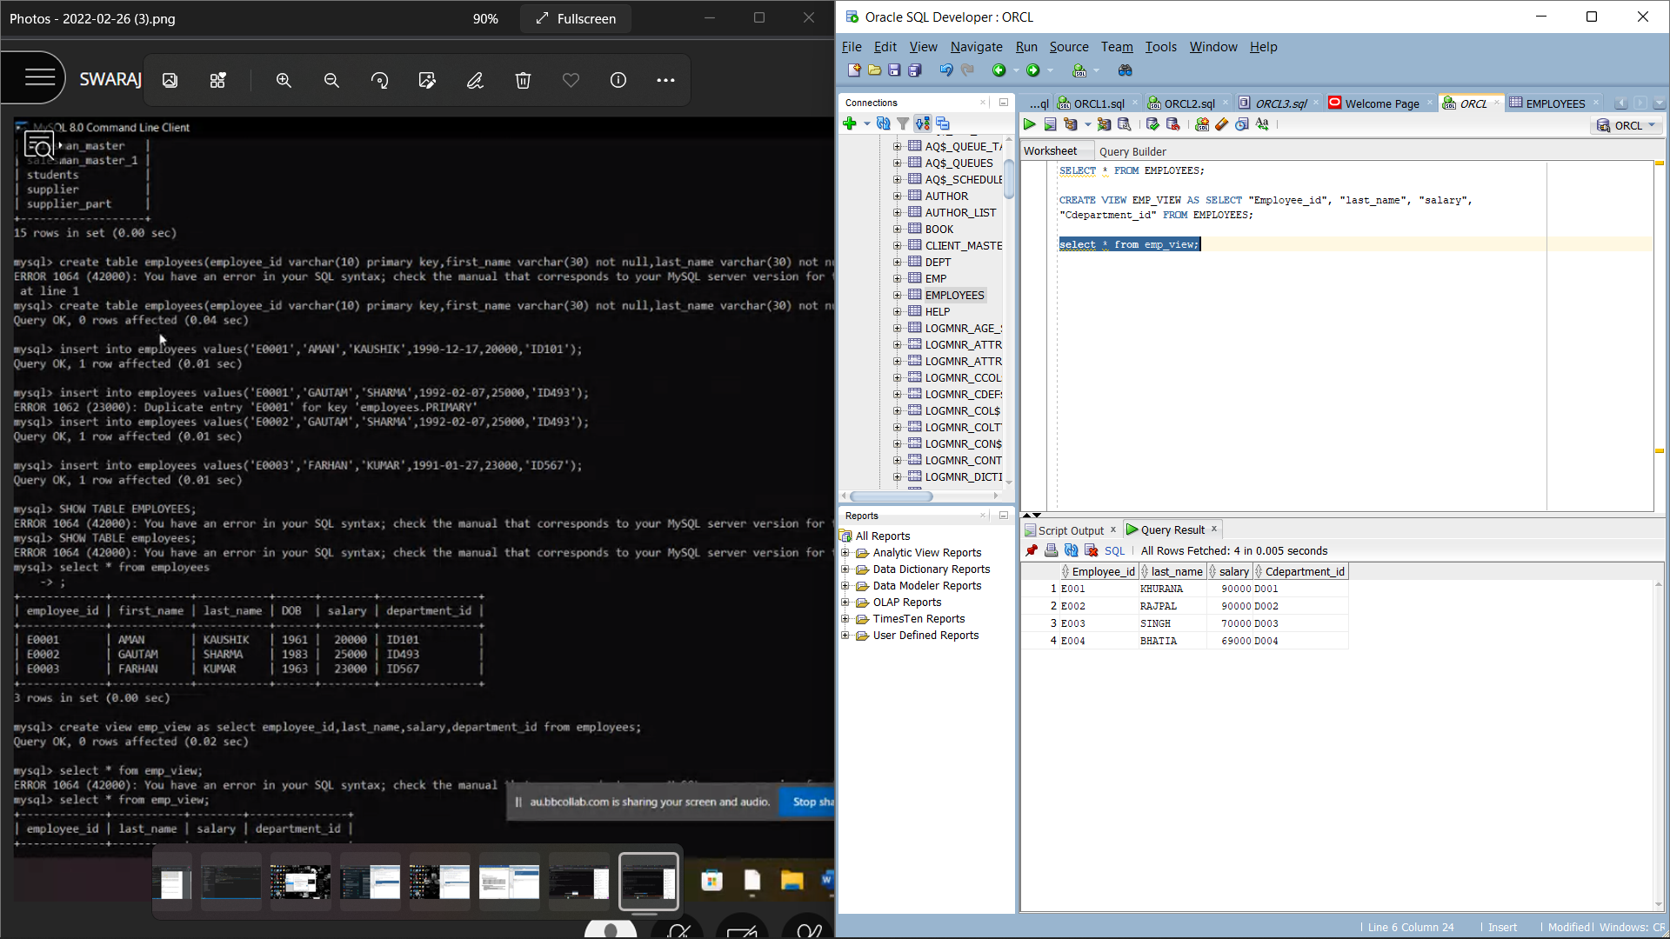

1. Insert values into view(remove the NOT NULL constraint and then insert values):

Command:

ALTER TABLE EMPLOYEES

MODIFY "first_name" VARCHAR(30) NULL;

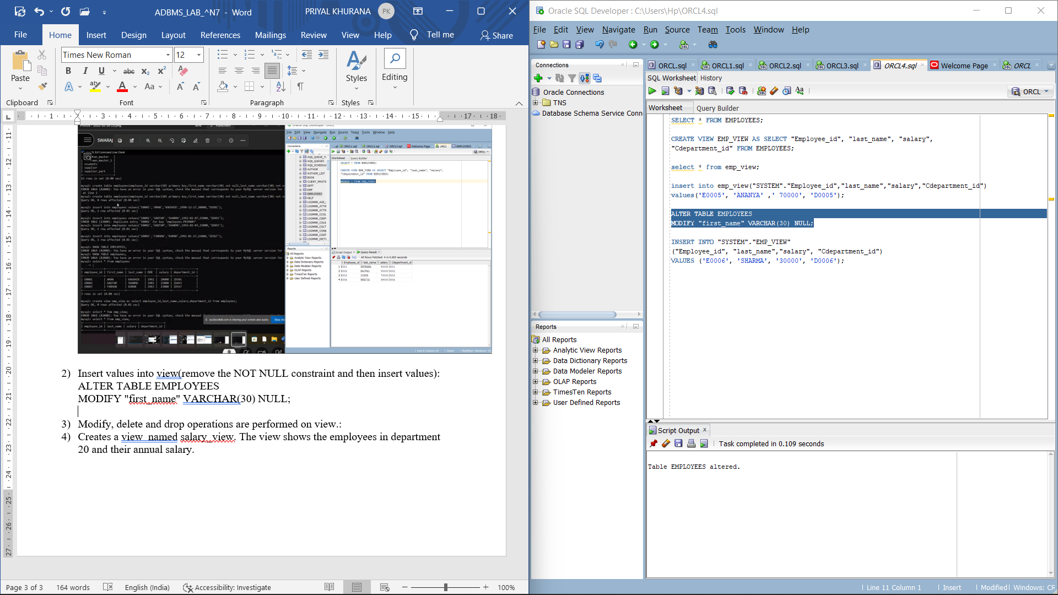

INSERT INTO "SYSTEM"."EMP_VIEW"

("Employee_id", "last_name","salary", "Cdepartment_id")

VALUES ('E0006', 'SHARMA', '30000', 'D0006');

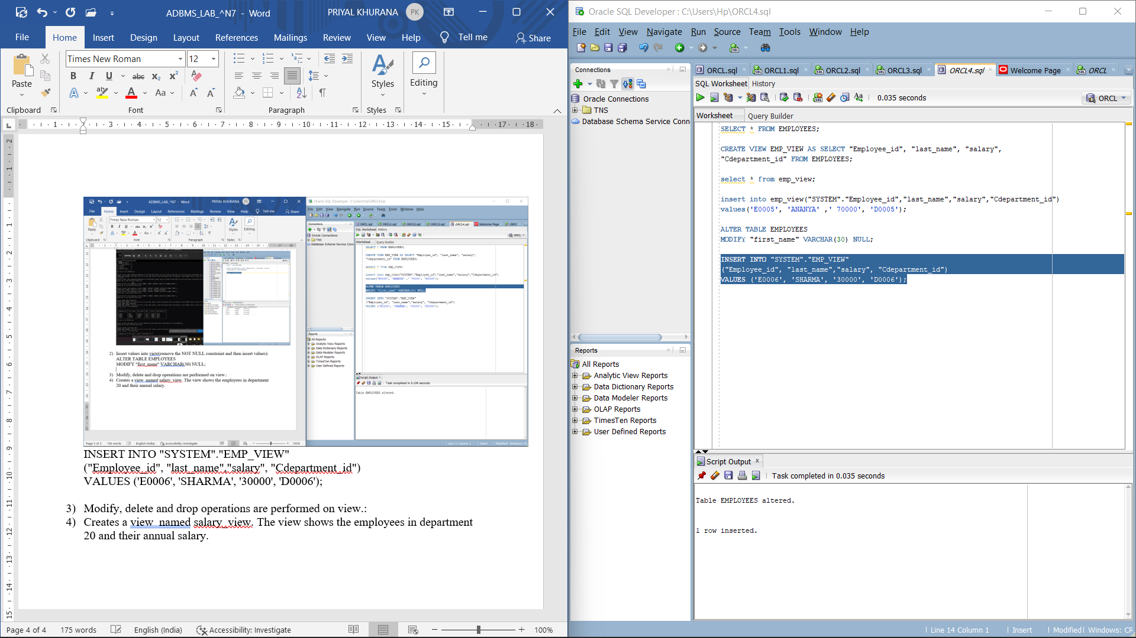

1. Modify, delete and drop operations are performed on view.:

Command: update emp_view set "salary"=45000

where "last_name"='BHATIA';

select * from emp_view;

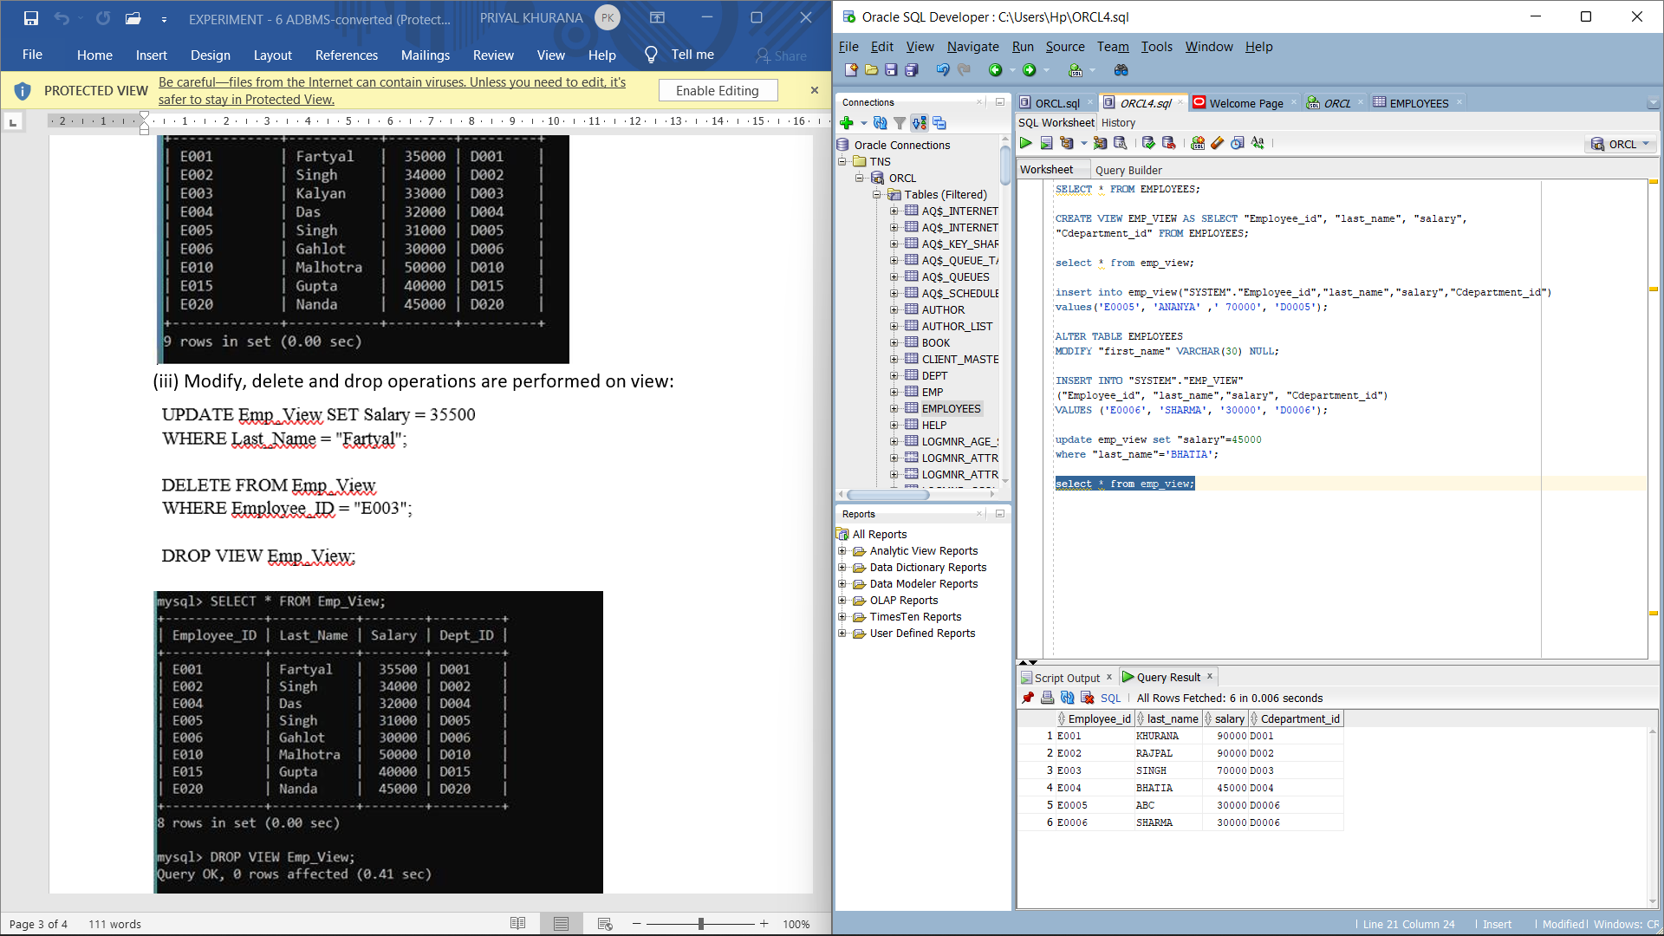

Command: Delete From Emp_View

Where "Employee_id"='E003';

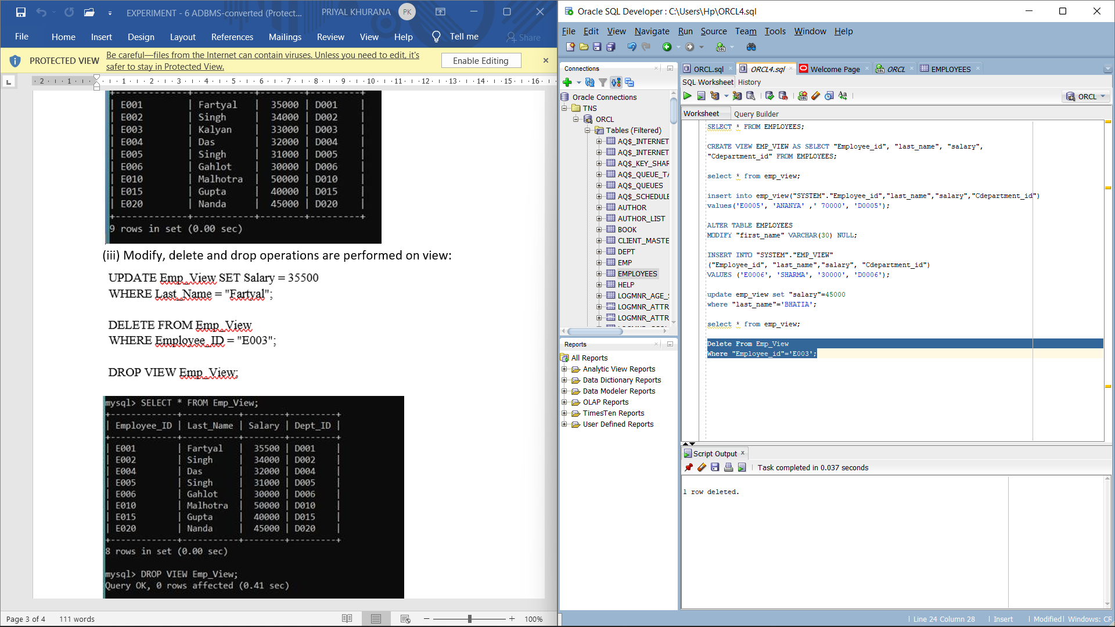

Command:

Drop View Emp_View;

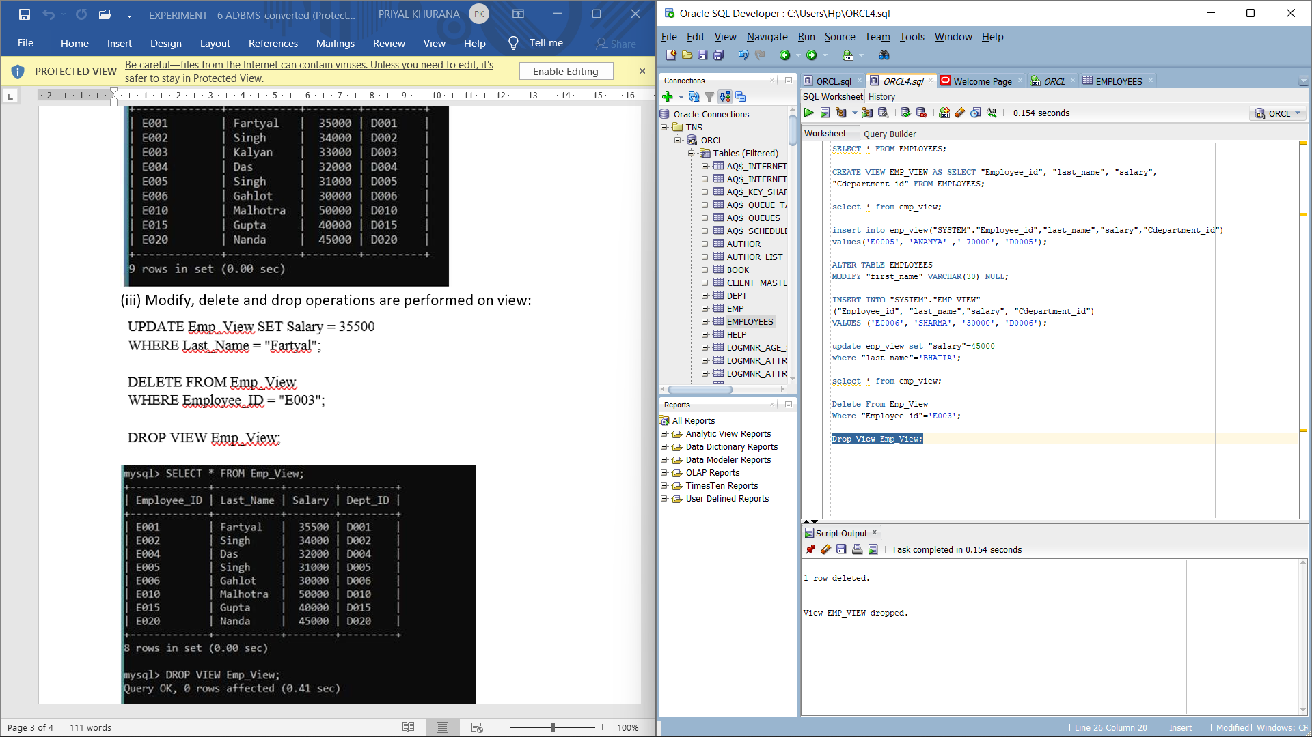

1. Creates a view  named salary_view. The view shows the employees in department 20 and their annual salary.

Command:

Create View Salary_View AS

Select "Employee_id","first_name","last_name","salary" From Employees

Where "Cdepartment_id"='D004';

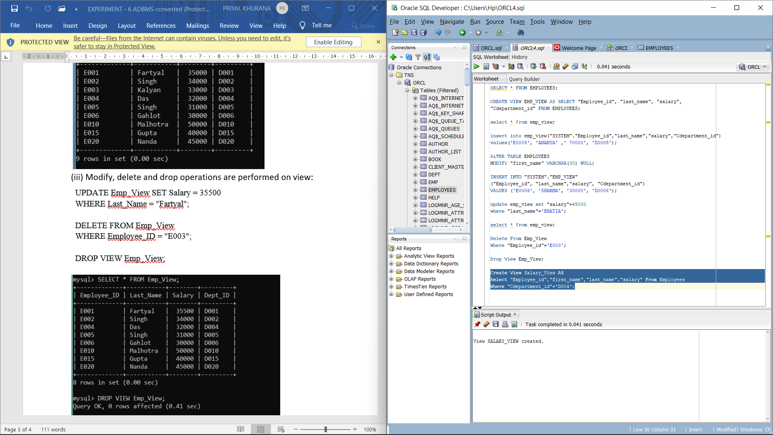

**EXPERIMENT-7**

Title: To understand the concepts of PL/SQL programming.

Objective: Students will be able to implement the basic concepts of Pl/SQL.

Question 1) Write a PL/SQL code to accept the value of A, B & C display which is greater.

* + Code

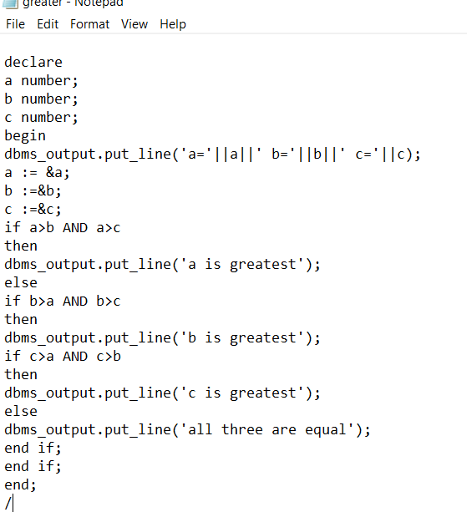

* + Output

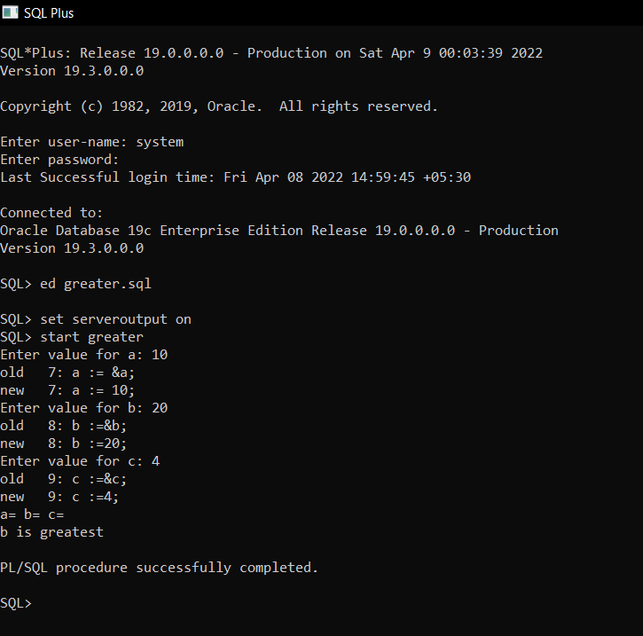

Question 2) Using PL/SQL Statements create a simple loop that display message “Welcome to PL/SQL Programming” 20 times.

* + Code

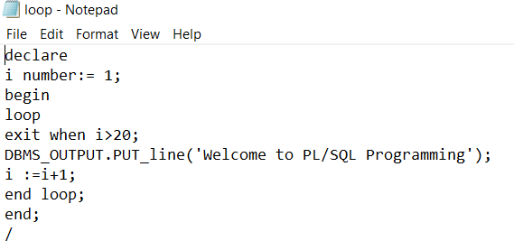

* + Output

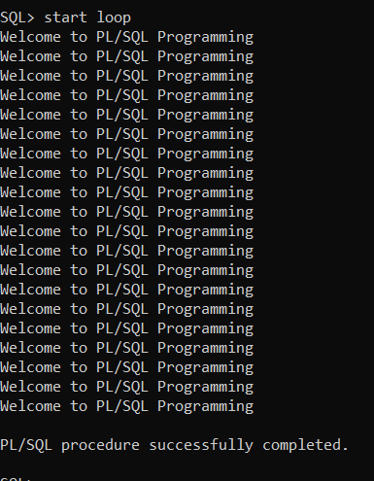

Question 3) Write a PL/SQL code block to find the factorial of a number.

* + Code

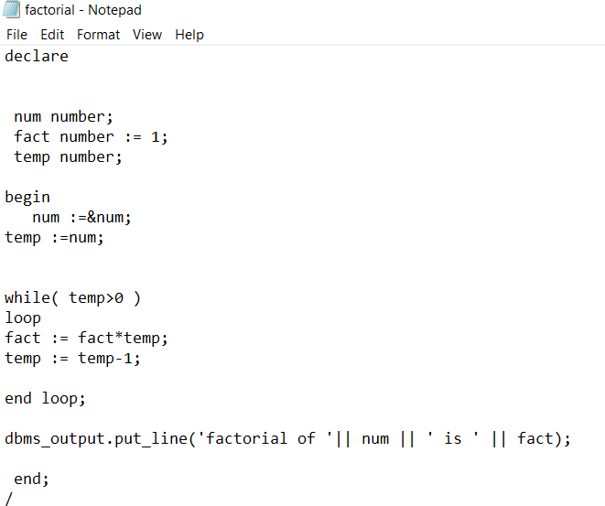

* + Output

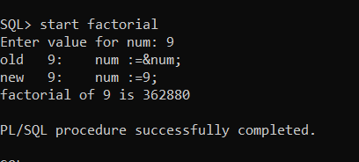

Question 4) Write a PL/SQL program to generate Fibonacci series.

* + Code

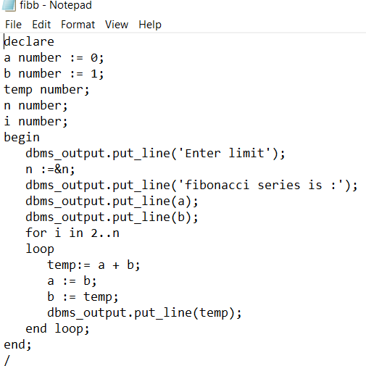

* + Output

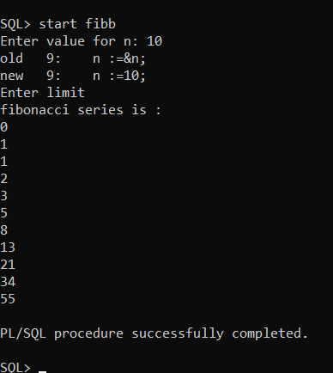

Question 5) Write a PL/SQL code to find the sum of first N numbers.

* + Code

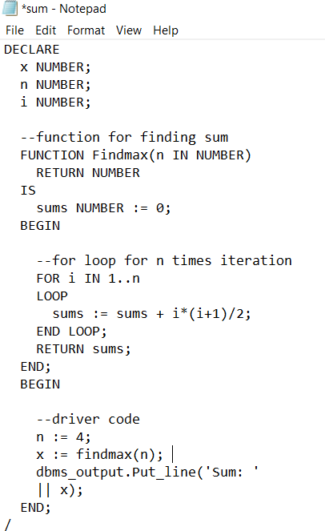

* + Output:

